

**IoT Powered Smart Security Robot with Android App, Night Vision and Enhanced Threat Detection**

**A Thesis**

**Presented to the Faculty of the College of Engineering**

**AMA Computer College**

Santiago Campus

In Partial Fulfillment of the Requirements for the Degree of   
Bachelor of Science in Computer Engineering  
(BSCpE)

By

**VALENTINO, ALEXIS M.**

**LOPEZ JR., ALBERTO D.**

**ESTOCAPIO, SIENNA MAE M.**

**JAVONILLO, LAICA MERZ B.**

2023

|  |  |  |  |
| --- | --- | --- | --- |
|  | | | |
| **APPROVAL SHEET** | | | |
| This Design Project entitled, “***IOT POWERED SMART SECURITY ROBOT WITH ANDROID APP, NIGHT VISION AND ENHANCED THREAT DETECTION***”, prepared and submitted by Alexis M. Valentino, Alberto D. Lopez Jr., Sienna Mae M. Estocapio, Laica Merz B. Javonillo in partial fulfillment of the course requirements for the degree of BACHELOR OF SCIENCE IN COMPUTER ENGINEERING. | | | |
| **ENGR. JEFFREY LEONEN** | | | |
|  | | | Adviser |
| **MARY ROSE CRUZ** | **LUNIE MAE BANGSARA** | | |
| Member | Member | | |
| **EMMANUEL TRINIDAD** | | | |
| Member | | | |
| Accepted as partial fulfillment of the course requirements for the degree in BACHELOR OF SCIENCE IN COMPUTER ENGINEERING. | | | |
| **ENGR. SHERYL JOY RASPADO** | | | |
|  | | Dean, College of Engineering | |
|  | | Date: ___________ | |

|  |  |
| --- | --- |
|  | |
| **ACKNOWLEDGEMENT** | |
| We are grateful to the AMA Computer College – Santiago Campus for providing us with the opportunity to conduct this research. The valuable life lessons we learned from this experience, such as patience, perseverance, teamwork, resilience, cooperation, and the endless pursuit of knowledge, will stay with us for the rest of our lives.  We are especially grateful to Engr. Jeffrey Leonen for his invaluable guidance, support, advice, comments, suggestions, and provisions. His help was essential to the completion and success of this study. It was a great privilege and honor to work and study under his guidance.  We would also like to express our sincere gratitude to our parents for their endless love, prayers, support, and sacrifices. This research would not have been possible without their unselfish love and support.  We give our utmost thanks to Almighty God for giving us the strength, knowledge, ability, and opportunity to undertake this research study. Without His guidance and mercy, we would not have been able to accomplish this research and all of our daily endeavors. To God be the glory!  Finally, we would like to thank all the people who have supported us directly or indirectly in the completion of this research work. Your contributions are greatly appreciated. | |
|  | **The Researchers** |

|  |
| --- |
| **ABSTRACT** |
| Traditional security systems, such as CCTV cameras, often fall short in providing comprehensive coverage, real-time threat detection, and rapid responsiveness. These limitations can create a false sense of security, hindering our ability to effectively prevent crimes and safeguard lives and property.  In response to these challenges, we introduce a groundbreaking security solution: an IoT-powered smart security robot controlled with an Android application, equipped with night vision capabilities, and advanced threat detection functionality. This cutting-edge prototype robot is outfitted with an array of cameras, microprocessors, and sensors, enabling it to detect potential threats in real-time, including firearms, knives and loud sounds.  Moreover, the prototype robot possesses the capability to instantly notify users of detected threats through a combination of audible alarms and email alerts. These notifications include attached screenshots of identified threats (such as guns and knives), audio recordings of loud sounds, precise timestamps, and geolocation data pinpointing the exact location of the detection event.  We firmly believe that this project has the potential to redefine the security landscape and significantly elevate the safety and security of communities. However, we acknowledge that this is a prototype, and further development is necessary before it can be deployed in real-world environments. This research represents a crucial step towards a safer and more secure future. |

**TABLE OF CONTENTS**

Title Page *i*  
Approval Sheet *ii*  
Acknowledgement *iii*  
Abstract *iv*  
Table of Contents *v*  
List of Tables *x*  
List of Figures *xii*

**CHAPTER I. THE PROBLEM AND ITS BACKGROUND**1.1 Introduction 1  
1.2 Background of the Study 2  
1.3 Objectives of the Study  
 1.3.1 General Objective 4  
1.4 Significance of the Study 5  
1.5 Scope and Delimitation  
 a. Scope 6  
 b. Delimitation 7  
1.6 Conceptual Framework or Theoretical Framework 9  
1.7 Operational Definition of Terms 12

**CHAPTER II. REVIEW OF RELATED LITERATURES**2.1 Related Literatures  
 2.1.1 Smart Security Surveillance Using IoT 16  
 2.1.2 Smart Surveillance Robot for Real-Time Monitoring   
 and Control System 17  
 2.1.3 Design and Implementation of Surveillance Robot for   
 Outdoor Security 18  
 2.1.4 Design and Analysis of IoT-Based Intelligent Robot for   
 Real-Time Monitoring and Control 18  
 2.1.5 Low-Cost Smart Security Camera with Night Vision   
 Capability using Raspberry Pi and OpenCv 19  
 2.1.6 Web-based Wireless Controlled Robot for Night Vision   
 Surveillance using Shell Script with Raspberry Pi 20  
 2.1.7 Weapon Detection Using Yolo V3 for Smart   
 Surveillance System 21  
 2.1.8 Surveillance System for Detection of Suspicious Human   
 Activities at War Field 21  
 2.1.9 Vision Based Surveillance Robot for Military Applications 22  
 2.1.10 Design of Small Mobile Robot Remotely Controlled by   
 an Android Operating System via Bluetooth and NFC   
 Communication 23  
 2.1.11 Implementation of Smartphone Environment Remote   
 Control and Monitoring System for Android Operating   
 System-based Robot Platform 24  
 2.1.12 Threat Detection Based on Yolo Network 24  
 2.1.13 Mobile Autonomous Robot for Surveillance Networks 25  
 2.1.14 Novel Real-time Automated Face Classification and   
 Detection System Using Machine Learning Technique 27  
 2.1.15 Convolutional Neural Network Architectures Used in   
 Computer Vision 27  
 2.1.16 Computer Vision Approaches Based on Deep Learning   
 and Neural Networks: Deep Neural Networks for   
 Video Analysis 27  
 2.1.17 Object Identification for Computer Vision Using Image   
 Segmentation 28  
 2.1.18 Open-area Concealed-weapon Detection System 29  
 2.1.19 IoT Based Weapons Detection System for Surveillance   
 and Security using YOLOV4 29  
 2.1.20 Weapon Detection Using Artificial Intelligence and   
 Deep Learning for Security Applications 30

**CHAPTER III. METHODOLOGY**3.1 General Method Used 32  
3.2 Project Development Model  
 3.2.1 Research and Development Methods of Research 32  
3.3 Design Phase 33  
3.4 Fabrication Phase 34  
3.5 Evaluation Phase 35  
3.6 Project Design 35  
3.7 Operational Flow 36  
3.8 Description of Material and Software Used in the Study 40  
3.9 Project Development 51  
3.10 Testing Methods 52  
3.11 Evaluation Process 52  
3.12 Evaluation Criteria 53  
3.13 Instrument and Technique Used 54  
3.14 Analysis of Data Gathering Methodology 61

**CHAPTER IV. RESULTS AND DISCUSSION**  
4.1 The Developed System 62  
4.2 Data Analysis 64  
4.3 Program Used 65  
4.4 Verification and Testing Result 67  
4.5 Evaluation Results 135

**CHAPTER V. SUMMARY OF FINDINGS, CONCLUSIONS   
AND RECOMMENDATIONS**5.1 Summary of Findings 139  
5.2 Conclusions 140  
5.3 Recommendations 141

**REFERENCES** 143

**APPENDICES** 146  
 Appendix A - Flowchart of the System 147

Appendix B - Program Codes 148  
 Appendix C - Robot Design Schematic 167  
 Appendix D - Evaluation Results 168  
 Appendix E - Bill of Materials 170  
 Appendix F - Evaluation Sheet 171  
 Appendix G - Sample Answered Evaluation Form 172  
 Appendix H - Robot Assembly 191  
 Appendix I - Android Application Development 192  
 Appendix J - Threat Detection Model Training 193  
 Appendix K - Raspberry Pi Coding Integration 194  
 Appendix L - Threat Detection Testing Stage 195  
 Appendix M - Geolocation Development 196  
 Appendix N - Robot’s Movement Demonstration 197  
 Appendix O - Robot’s Autonomous Demonstration 198  
 Appendix P - Robot’s Night Vision Feature 199  
 Appendix Q - Threat Detection Simulation 200  
 Appendix R - Push Notification Email Alert 201  
 Appendix S - Evaluation Photos 202  
 Appendix T - Initial Title Proposal Form 204  
 Appendix U - Research Topic Proposal Form 207  
 Appendix V - Final Defense 211

**LIST OF TABLES**

Table 3.8.1 Electronic Components Used 40  
Table 3.8.2 Software Used 46  
Table 3.8.3 Bill of Materials 50  
Table 3.12.1 Criteria for System Evaluation 53  
Table 3.13.1 Table for Components Unit Testing 54  
Table 3.13.2 Table for Robot Features Integration Testing 57  
Table 3.13.3 Table for Iot Robot Threat Detection and Alert   
 Integration Testing 59  
Table 3.14.1 The Likert Scale 61  
Table 4.4.1 Dc Motor Functionality Unit Test 68  
Table 4.4.2 IR Line Follower Sensor Unit Test 70  
Table 4.4.3 Webcam Functionality Unit Test 72  
Table 4.4.4 Arducam Night Vision Functionality Unit Test 74  
Table 4.4.5 USB WiFi Module Functionality Unit Test 76  
Table 4.4.6 Bluetooth Module Functionality Unit Test 79  
Table 4.4.7 Servo Motor Functionality Unit Test 82  
Table 4.4.8 Battery Functionality and Discharge Unit Test 84  
Table 4.4.9 Powerbank Functionality and Discharge Unit Test 87  
Table 4.4.10 Raspberry Pi Functionality Unit Test 98  
Table 4.4.11 4wd Expansion Board Functionality Unit Test 101  
Table 4.4.12 Android App Controller and 4WD Expansion   
 Board Integration Test 104  
Table 4.4.13 Android App Controller and Raspberry Pi Integration Test 107  
Table 4.4.14 Android App Quick Control Robot Integration Test 111  
Table 4.4.15 Android App Live Control Robot Integration Test 113  
Table 4.4.16 Android App Live Control Line Follower Integration Test 117  
Table 4.4.17 OpenCV and Haar Cascade Integration Test 119  
Table 4.4.18 Threat Detection Integration Test 122  
Table 4.4.19 IoT Robot Alert Integration Test (Trial 1) 126  
Table 4.4.20 IoT Robot Alert Integration Test (Trial 2) 128  
Table 4.4.21 IoT Robot Alert Integration Test (Trial 3) 129  
Table 4.4.22 IoT Robot Alert Integration Test (Trial 4) 132  
Table 4.4.23 IoT Robot Alert Integration Test (Trial 5) 133

**LIST OF FIGURES**

Fig 1.6.1 Conceptual framework of the study 9  
Fig 3.7.1 Robot Functionality 36  
Fig 3.7.2 Threat Detection System 37  
Fig 3.7.3 Threa Detection Visual Flow 37  
Fig 3.7.4 Android Application Flowchart 38  
Fig 3.7.5 Evaluation Sheet for the Proposed System 60  
Fig 4.1.1 Diagram 62  
Fig 4.2.1 Functionalities needed on smart security robot 65  
Fig 4.5.1 Scores breakdown of evaluation results 135  
Fig 4.5.2 The functionality evaluation summary chart 136  
Fig 4.5.3 The reliability evaluation summary chart 136  
Fig 4.5.4 The maintainability evaluation summary chart 137  
Fig 4.5.5 The extensibility evaluation summary chart 137  
Fig 4.5.6 The economic feasibility evaluation summary chart 138  
Fig 4.5.7 Summarization chart 138

**CHAPTER I  
The Problem and Its Background**

***1.1 Introduction***

Security surveillance systems have become an indispensable aspect of modern society. As the prevalence of crime and security threats continues to rise, it is increasingly important to implement reliable and efficient security systems that can effectively address these concerns. Traditional security systems are helpful and possess inherent limitations in terms of their monitoring and threat detection capabilities. However, with the rapid advancements on the Internet of Things (IoT), there is a unique opportunity to develop intelligent security surveillance systems that offer immediate monitoring and real-time threat detection features.

The IoT-powered smart security surveillance robot, featuring real-time threat detection and alerts, Android app integration and night vision capabilities, which represents a state-of-the-art solution that merges the strengths of the Internet of Things (IoT), robotics, and machine learning (ML) to deliver an enhanced security surveillance experience. This innovative system not only provides around-the-clock monitoring but also possesses advanced capabilities such as object and sound detection, and seamless integration with mobile applications.

The primary objective of this study is to investigate the potential of IoT-based security surveillance robots in augmenting the monitoring and threat detection process, while addressing the existing problems and gaps in current surveillance systems. The robot could be used to monitor homes and detect intruders, providing real-time alerts to homeowners through emails not only containing media attachments but also providing precise location data using geolocation services. The robot could also be used to secure offices, and other commercial properties, helping to determine crime and protect assets. Furthermore, the robot's advanced technology and capabilities could also serve as a testbed for researchers and developers working on new AI algorithms, computer vision and machine learning techniques. this research aims to highlight the benefits of integrating various AI-powered detection technologies, explore the practical challenges and potential solutions in implementing such a comprehensive security system, and examine the impact of this cutting-edge technology on both residential and commercial security landscapes.

By examining the design and implementation of an IoT-enabled smart security surveillance robot, this study seeks to make a meaningful contribution to the ongoing conversation about security technology, providing valuable insights that can foster future innovations in this vital field.

***1.2 Background of the Study***

The limitations of traditional surveillance systems have become increasingly apparent in recent years due to the growing complexity of security threats. These systems rely on human intervention for monitoring, threat detection, and response, leading to time-consuming processes and potential errors. Additionally, their inability to quickly adapt to new and emerging threats creates significant security vulnerabilities. This highlights the need for innovative security solutions that effectively address modern challenges.

Despite advancements, current surveillance systems still face issues such as the lack of real-time threat detection capabilities, leading to delayed responses and considerable losses. Moreover, these systems have limited monitoring capabilities, which can result in blind spots and undetected threats.

The emergence of IoT, robotics, and AI technologies offers a unique opportunity to revolutionize the security surveillance domain. By leveraging the interconnectedness of IoT devices, the versatility of robotics, and the intelligence of AI algorithms, it is now possible to design a smart security surveillance robot that can monitor, detect, and respond to diverse threats in real-time.

This study proposes the development of an IoT-powered smart security surveillance robot with real-time threat detection, real time alerts, and Android app integration with night vision capabilities. The advanced system aims to enhance monitoring and threat detection to immediately respond to ever changing threats enabling security personnel to promptly respond to threats instead of relying on traditional systems while maintaining a comprehensive view of the entire area under surveillance.

The motivation for this study stems from the increasing demand for resilient security solutions that can adapt to and mitigate ever-changing threats. The proposed IoT-powered robot integrates advanced technologies such as artificial intelligence, machine learning, computer vision, and wireless communication protocols to create an intelligent system capable of real-time threat detection. This approach not only improves monitoring and detection capabilities but also bridges the gap between human control and systems. Incorporating cutting-edge features like object and sound detection, night vision, and Geolocation further expands the robot's capabilities, making it suitable for various security applications.

***1.3 Objectives of the Study***

***1.3.1 General Objective***

The primary objective of this study is to develop an IoT-powered smart security surveillance robot with real-time threat detection, Android app integration, and night vision capabilities for enhanced monitoring and threat detection. To achieve this, the following specific objectives have been set:

1. To design and develop a hardware and software system for the IoT-powered smart security surveillance robot that leverages advanced technologies such as machine learning, computer vision, robotics, and IoT for real-time monitoring and threat detection.
2. To construct a smart security surveillance robot that seamlessly integrates IoT, robotics, and AI technologies to provide real-time monitoring, threat detection, and response capabilities.
3. To identify and incorporate key features and functionalities in the IoT-powered smart security surveillance robot, such as real-time threat detection, Android app integration, night vision capabilities and Geolocation, to enhance monitoring and threat detection.
4. To integrate the hardware and software components of the IoT-powered smart security surveillance robot with an Android app for remote monitoring and control.
5. To assess the performance and effectiveness of the developed security surveillance robot in detecting threats and monitoring the surroundings, considering features such as weapon sound detection and Geolocation, live video monitoring via Android app, night vision mode, and a rover system for mobility and flexibility.
6. To evaluate the performance of the smart security surveillance robot through comprehensive testing and analysis, focusing on threat detection accuracy, response time, and overall system reliability.
7. To aim to increase the threat detection accuracy of the security surveillance robot by at least 60%.
8. To investigate potential challenges and limitations associated with the implementation of the IoT-enabled smart security surveillance robot and propose possible solutions to address these issues.

***1.4 Significance of the Study***

Below is a list of significant contributions of the study.

* In the global context, the development of an IoT-powered smart security surveillance robot with real-time threat detection, Android app integration, night vision capabilities and Geolocation can contribute to global security and safety. With the increasing rate of crime and security threats worldwide, the study can provide a reliable and efficient security system that can be used in various settings, such as homes, offices, and public places.
* In the economic context, the IoT-powered smart security surveillance robot can provide cost-effective security solutions compared to traditional security systems. The study can contribute to the development of more advanced security systems that can provide real-time monitoring and threat detection capabilities, which can reduce the need for human intervention and increase efficiency.
* In the environmental context, the IoT-powered smart security surveillance robot can reduce the environmental impact of traditional security systems. With the use of advanced technology, the study can provide a more sustainable security solution that can reduce energy consumption and carbon footprint.
* In the societal context, the development of an IoT-powered smart security surveillance robot can contribute to societal safety and security. The study can provide a reliable and efficient security system that can enhance the safety and security of individuals and communities. The integration of an Android app can also provide remote monitoring and control, which can increase accessibility and convenience.

***1.5 Scope and Delimitation***

1. ***Scope***

The scope of the project encompasses the design, development, and evaluation of an IoT Powered Smart Surveillance Robot integrated with an Android App, Night Vision, and Enhanced Threat Detection. The project focuses on an innovative security robot with an intricate set of features. By blending machine learning techniques, real-time data analysis, and mobile app integration, the project aims to bolster security measures and enhance surveillance capabilities. The key features and functionalities of the project will involve the following key aspects:

* Threat Detection: Employing Object detection machine learning algorithms like haar cascade classifiers and Open CV, that identifies potential threats such as concealed firearms, knives and unusual sounds using audio samples and thresholds in real-time. Upon detection, the robot activates an immediate alert system, safeguarding the premises against potential risks.
* Real-time Alerts, Event Logging with Location Data: The system promptly generates and sends detailed email alerts upon identifying threats or unusual occurrences. These notifications include images, audio recordings, and timestamps for accurate event documentation. Emails not only contain media attachments but also provide precise location data using geolocation services. By integrating the geocoder library, the system dynamically fetches latitude and longitude coordinates, creating Google Maps links for quick access to the incident site.
* Mobile App for Remote Monitoring and Control: The innovation lies in the development of a user-friendly mobile application. This app empowers users to remotely monitor the robot's camera feed, steer the robot's movement. And even make it semi-autonomous by using lane detection sensor. The remote-control feature extends the system's reach and responsiveness.
* Night Vision Capabilities: The robot's night vision capabilities enable it to operate effectively even in low-light conditions, improving its surveillance performance during nighttime.

1. ***Delimitation***

While the project aims to create an advanced IoT Powered Smart Surveillance Robot with a comprehensive feature set, the outlined delimitations clarify the specific boundaries and limitations of the project. This approach ensures a targeted and realistic scope, allowing the researchers to achieve meaningful outcomes within the specified constraints.

* Hardware Constraints: The project's implementation is limited by the hardware available, which may affect the robot's overall capabilities and performance. Hardware limitations could impact the quality of surveillance, speed of threat detection, and responsiveness of the remote-control system.
* Limited Threat Classification: While the project focuses on concealed firearm and knife detection, and unusual sound identification, it may not cover an exhaustive range of potential threats or anomalies, limiting its adaptability to diverse security scenarios.
* Network Connectivity: The effectiveness of real-time alerts, remote monitoring, and control depends on stable and reliable network connectivity. Network interruptions could impact the timely delivery of alerts and the responsiveness of the mobile application.
* Integration Challenges: Integrating multiple complex functionalities like threat detection, real-time alerts, and mobile app control can pose challenges in terms of synchronization, performance optimization, and compatibility issues.
* Deployment and Scaling: The project's deployment and scalability aspects are not thoroughly covered. The system's performance in real-world scenarios, along with considerations for managing multiple robots and users, may require further exploration beyond the project's scope.
* Environmental Constraints: The project assumes a controlled environment for surveillance and operation. The focus will be on indoor and controlled outdoor environments, as external factors (e.g., weather, low-light conditions) are not within the project's scope and may affect the robot's performance.
* The project will not cover extensive durability testing, as the primary goal is functionality and proof of concept rather than long-term robustness.

***1.6 Conceptual Framework or Theoretical Framework***

In order to achieve the desired outcome of this study, the design and development of the project were conceptualized by discussing certain methods, requirements, and concepts.

|  |  |  |  |  |
| --- | --- | --- | --- | --- |
| **INPUT** |  | **PROCESS** |  | **OUTPUT** |
| 1. Hardware components (Microprocessor, Cameras, Chassis, etc.) 2. Software components (Machine Learning Algorithms, Computer Vision, Android App, etc.) 3. System Requirements and Specifications 4. Related Literature and Technology Insights |  | 1. Designing Hardware and Software Architecture 2. Integrating IoT, AI, and Robotics Technologies 3. Implementing Real-Time Threat Detection (Object detection, sound Detection, Face Recognition) 4. Developing the Android app for Remote Monitoring and Control 5. Testing and Refining the Robot's Functionalities (Night Vision, Threat Detection, etc.) |  | 1. IoT-Powered Smart Security Surveillance Robot with Real-Time Threat Detection 2. Android App for Remote Monitoring and Control 3. Enhanced Monitoring and Threat Detection Capabilities 4. Improved Security Surveillance Efficiency and Reliability |
|  |  |  |  |  |
| *Figure 1.6.1 Conceptual framework of the study* | | | | |

The development of the IoT-powered smart security robot project is guided by a comprehensive theoretical framework that encompasses three key phases: Input, Process, and Output. This framework outlines the systematic progression of the project, from its conceptualization and design to the realization of enhanced security and surveillance capabilities.

The input phase, the foundation of the project is laid through the integration of essential concepts from electronics, embedded systems, robotics, and programming. These fundamental elements serve as the bedrock upon which the subsequent development stages are built. Through discussions and analysis, the software and hardware requirements necessary for the project's success are identified and refined. This phase sets the stage for the integration of multidisciplinary knowledge into the project's framework.

The heart of the framework lies in the process or the development and integration phase, where various technologies and methodologies converge to shape the project's capabilities. The integration of machine learning techniques, specifically object detection algorithms like Haar cascade classifiers and OpenCV, enables real-time threat detection. These algorithms analyze visual and auditory data to identify potential threats such as concealed firearms, knife and unusual sounds.

Data capture and transmission are facilitated by equipping the robot with an array of sensors and cameras. High-resolution cameras with night vision capabilities allow effective operation in low-light conditions. The captured data is then transmitted through an IoT infrastructure to a smartphone, enabling remote monitoring, live camera feeds, and email alerts.

Advanced threat detection capabilities are realized through image and audio processing. The robot's ability to classify threats based on visual and auditory characteristics is achieved through machine learning models. Real-time data and image transmission between the robot and the host facilitate centralized analysis, empowering users to make informed decisions and respond promptly to detected threats.

The development and testing phase involves the translation of conceptual designs into functional prototypes. Hardware diagrams are designed, prototypes are developed, and verification and validation processes ensure the prototype's accuracy and reliability. The Raspberry Pi serves as the microprocessor, orchestrating the robot's movements and data processing. Software components, including Python, OpenCV library, and Haar Cascade classifiers, enable tasks such as object recognition and audio processing. Moreover, the Java programming language is used for developing the Android application.

The output phase brings the project's components together into an operational framework. Assembled hardware components, encompassing sensors, cameras, actuators, motor drivers, and a rechargeable battery pack, from the robot's physical structure. The software component employs programming languages and development environments to enable real-time threat detection and immediate alert system. Furthermore, the Android app is for remote monitoring and control.

The open-source architecture allows for customization by third-party developers, fostering innovation and diversifying potential applications. The theoretical framework culminates in the achievement of project objectives, encompassing enhanced security measures and surveillance capabilities. The integration of IoT, machine learning, real-time data analysis, and mobile app functionality contributes to the development of a versatile and effective smart security robot system.

The Input-Process-Output-style theoretical framework provides a structured and holistic view of the IoT-powered smart security robot project's progression. It emphasizes the integration of diverse knowledge domains and technological elements, resulting in the creation of an innovative solution that enhances security and surveillance in various settings.

***1.7 Operational Definition of Terms***

* **IoT (Internet of Things)** - The IoT refers to the interconnected network of physical devices, vehicles, buildings, and other objects that are equipped with sensors, software, and connectivity, allowing them to collect and exchange data.
* **IoT-Powered Smart Security Robot** - An innovative robotic system integrated with Internet of Things (IoT) technology designed for enhanced security and surveillance. It includes various sensors, cameras, and mobility mechanisms to gather real-time data from the environment and communicate with external devices through the internet.
* **Smart** - refers to the robot's ability to perform tasks and make decisions on its own, using artificial intelligence and other advanced technologies.
* **Machine Learning Techniques** - Methods that involve the utilization of algorithms and models to enable a system to learn from data and improve its performance over time. In this context, machine learning techniques refer to the implementation of object detection algorithms, such as haar cascade classifiers and OpenCV, for the identification of potential threats and anomalies.
* **Threat Detection** - The process of identifying potential security risks or unusual occurrences in the environment. In this project, threat detection involves the use of object detection algorithms and sound analysis to identify concealed firearms, knife and unusual sounds that could pose a threat.
* **Real-time Data Analysis** - The continuous processing and interpretation of data as it is collected from sensors and cameras in the robot. This analysis occurs in a timely manner, allowing for rapid detection and response to threats or unusual occurrences.
* **Mobile App Integration** - The incorporation of a mobile application into the system, allowing users to remotely interact with the robot. This integration provides functionalities such as live camera feed viewing, semi-autonomous control, and manual steering of the robot's movement.
* **Alert System** - A mechanism within the robot that triggers an instantaneous response upon detecting a potential threat. This response could involve sounding alarms, sending emails not only containing media attachments but also providing precise location data using geolocation services.
* **Remote Monitoring** - The ability of users to observe the robot's camera feed and real-time data remotely through the mobile application. This allows users to monitor the robot's surroundings from a distance.
* **Night Vision Capabilities** - The robot's capacity to capture clear images and data in low-light or dark conditions using specialized sensors or cameras, enhancing its surveillance performance during nighttime scenarios.
* **OpenCV** - is a free and open-source computer vision and machine learning software library. It provides a comprehensive set of tools and algorithms for image and video processing, object detection and recognition, machine learning, and other computer vision tasks. OpenCV was originally developed by Intel and is now maintained by the OpenCV community. It can be used with various programming languages, including C++, Python, Java, and others, making it a popular choice for researchers, engineers, and developers working on computer vision applications.
* **4wd Expansion Board** - is a type of electronic circuit board that is designed to control the movement of a four-wheeled robot or vehicle.
* **4 channel tracking module** - A channel tracking module is a system or software that is used to monitor and track the status or performance of a particular channel or communication path.
* **ArduCam Night Vision**- a high-definition camera, is a type of camera that can capture and record video at a higher resolution than standard definition cameras, with night vision capabilities
* **High-power 370 motors** - is a type of electric motor that uses direct current (DC) to generate rotational motion.
* **Raspberry Pi** – The Raspberry Pi is a very cheap computer that runs Linux, but it also provides a set of GPIO (general purpose input/output) pins, allowing you to control electronic components for physical computing and explore the Internet of Things (IoT). In this project, it serves as the brain of the Robot and the real-time threat detection system. The Raspberry Pi is responsible for coordinating various functions and interactions within the system, including Control and Communication, Data Analysis, Threat Detection, Data Transmission and User Interaction.
* **SG90 servo** - The SG90 (datasheet here) is a 9-gram servo motor that can rotate 0 - 180 degrees (roughly) at a rate of about 0.3 seconds (0.1s/60 degrees). The SG90 is used in low-cost projects, typically with motorized vehicles and robotic arms.

**CHAPTER II**  
**Review of Related Literatures**

This chapter is designed to identify and enumerate several research related to the present study. The purpose of this review is to set the current research project within a conceptual and theoretical context. This includes several citations from journals, patents, thesis, research papers and other reliable literature sources. This chapter also highlighted local literature, foreign literature, local studies, and foreign studies.

***2.1* *Related Literatures***

***2.1.1* *Smart Security Surveillance using IoT***

With the advancement of technology and ICT, a radical change in life is reflecting all around. In this 21st century, with the gift of the Internet, Internet of Things (IoT) has become an integral part of our everyday life. Today IoT not only enables sensations of life but also imparts new genre of innovations. It has been found that IoT plays a significant role in achieving security. In this proposed research using IoT for Smart Security Surveillance System aimed at enhancing the security of home with the help of IoT. The research intends to develop the smartest version of doorbell with more security, flexibility and connectivity. In this work, with the help of sensor and camera, the system detects motion in front of the door and capture pictures which are sent to the user's cell phone along with the picture in the email inbox and a detection message. In addition, a push button for the guest interaction is also considered. The user is able to see what is happening in front of the door in real time sitting on the Internet. A camera module is deployed to capture the picture of the visitor and stream a video on the basis of passive infra-red (PIR) sensor and the button. In the future, further AI will be added to the system for recognizing and identifying the gesture of the visitor using CV. (S. Akter, R. A. Sima, M. S. Ullah and S. A. Hossain, 2018 7th International Conference on Reliability, Infocom Technologies and Optimization (Trends and Future Directions) (ICRITO), 2018, pp. 659-663)

[(https://ieeexplore.ieee.org/document/8748703)](https://ieeexplore.ieee.org/document/8748703)

***2.1.2* *Smart Surveillance Robot for Real-Time Monitoring and Control System***

The current ongoing revolution of Internet of Things (IoT) is now integrated with Robotics in various diverse fields of everyday life is making up a new era i.e., Internet of Robotics (IoR). The Internet of Robotics is in the mature stage of development and is currently surrounded by various challenges to be solved for more implementations, i.e., design, security, sensors, and long-range communication systems. The main objective of this paper is to propose an Internet-of-Things-based Internet Robot, i.e., InterBot 1.0. InterBot 1.0 is efficient in terms of real-time environmental monitoring in terms of temperature, humidity, and gas sensing and is equipped with long-range communication system via 2.4 GHz 6-channel remote and also short range via HC-05 (Bluetooth module). InterBot 1.0 is IoT-based via ESP8266, and all the data can be viewed in live graphs via ThingSpeak.com. The Results state the efficiency of Interbot 1.0 in monitoring real-time environments. (Bhateja, V., Nguyen, B., Nguyen, N., Satapathy, S., Le, DN. (eds) Information Systems Design and Intelligent Applications. Advances in Intelligent Systems and Computing, vol 672. Springer, Singapore.)

[(https://doi.org/10.1007/978-981-10-7512-4_23)](https://link.springer.com/chapter/10.1007/978-981-10-7512-4_23)

***2.1.3* *Design and Implementation of Surveillance Robot for Outdoor Security***

This paper presents us a modern approach for surveillance of outdoor security. This robot has the ability to detect a human whether he/she is authorized or not using RFID tag and also detects metal bombs using metal detector sensor. Wireless camera mounted on the robot provides us continuous streaming of the defined outdoor area and a stepper motor is used for the rotation of the wireless camera in 360-degree direction. Surveillance is done even in complete darkness by using Infrared lighting. The heart of our paper is Arduino Uno microcontroller, used to control the entire functioning of the robot. It's an analysis of the signal from the RF receiver and displays the corresponding message. IR detector is used for obstacle detection. Two DC motors are interfaced at the receiving end of the microcontroller, which controls the movement of the robotic vehicle. GSM module is used to get the message about human and metal detection. This robot replaces human being for security purpose. (S. Meghana, T. V. Nikhil, R. Murali, S. Sanjana, R. Vidhya and K. J. Mohammed," 2017 2nd IEEE International Conference on Recent Trends in Electronics, Information & Communication Technology (RTEICT), 2017, pp. 1679-1682.)

[(https://ieeexplore.ieee.org/abstract/document/8256885)](https://ieeexplore.ieee.org/abstract/document/8256885)

***2.1.4 Design and Analysis of IoT-Based Intelligent Robot for Real-Time Monitoring and Control***

Nowadays development of IoT applications with robotics is an ongoing revaluation. This paper mainly focuses on the security, remote surveillance, and monitoring of our homes done by the surveillance robots. Remote surveillance has become the most important research topic over the past decade. Through this paper we put forward a surveillance robot that can be used in domestic areas and many other places. Robots are becoming important in our day-to-day life activities as they reduce human labor and probability of error. We can control robots manually or they can be automatic based on the need of people. This paper focuses on design and implementation of mobile robot for obstacle detection and avoidance in a real-time basis. (M. Kumari, A. Kumar and R. Singhal 2020 International Conference on Power Electronics & IoT Applications in Renewable Energy and its Control (PARC), 2020, pp. 549-552.)

[(https://doi: 10.1109/PARC49193.2020.236673.)](https://ieeexplore.ieee.org/document/9087236)

***2.1.5* *Low-Cost Smart Security Camera with Night Vision Capability using Raspberry Pi and OpenCv***

In order to further maintain peace and provide security to people nowadays, Closed-circuit television (CCTV) surveillance system is being utilized. This study focused on the design and implementation of a low-cost smart security camera with night vision capability using Raspberry Pi (RPI) and OpenCV. The system was designed to be used inside a warehouse facility. It has human detection and smoke detection capability that can provide precaution to potential crimes and potential fire. The credit card size Raspberry Pi (RPI) with Open-Source Computer Vision (OpenCV) software handles the image processing, control algorithms for the alarms and sends captured pictures to user's email via Wi-Fi. As part of its alarm system, it will play the recorded sounds: “intruder” or “smoke detected” when there is a detection. The system uses an ordinary webcam, but its IR filter was removed in order to have night vision capability. (W. F. Abaya, J. Basa, M. Sy, A. C. Abad and E. P. Dadios , 2014 International Conference on Humanoid, Nanotechnology, Information Technology, Communication and Control, Environment and Management (HNICEM), 2014, pp. 1-6.)

[(https://doi: 10.1109/HNICEM.2014.7016253.)](https://ieeexplore.ieee.org/document/7016253)

***2.1.6* *Web-based Wireless Controlled Robot for Night Vision Surveillance using Shell Script with Raspberry Pi***

The convenience for most people is to have the ability to control or view details of surveillance made by a robotic system even when they are not at home. In this paper, we design an efficient robot that is capable of video surveillance even at night. The method consists of a web based wireless controlled night vision surveillance robot using Shell script with raspberry pi. The web page has video screen for surveillance and buttons to control robot and camera. For proper surveillance at night, a night vision camera has been implemented. The web page is the command control center for the robot, which can be run in both computer and mobile phone (IOS/Android). The signal, which is generated from web page, are sent to Raspberry pi through Wi-Fi and Raspberry pi receives these signals according to Shell Script written in Raspberry pi. Therefore, the commands are processed and the robot is directed with user directive. The Video Streaming is done using MJPG streamer program that gets MJPEG data and the movement of the robot is controlled by Shell Script which sends it through a HTTP session. The result shows that the video streamed up to 15 frames per second. (Salman, H., Acheampong, S., Xu, H. (2019). Web-Based Wireless Controlled Robot for Night Vision Surveillance Using Shell Script with Raspberry Pi. In: Barolli, L., Javaid, N., Ikeda, M., Takizawa, M. (eds) Complex, Intelligent, and Software Intensive Systems. CISIS 2018. Advances in Intelligent Systems and Computing, vol 772. Springer, Cham.)

([https://doi.org/10.1007/978-3-319-93659-8_49)](https://link.springer.com/chapter/10.1007/978-3-319-93659-8_49)

***2.1.7* *Weapon Detection Using Yolo V3 for Smart Surveillance System***

Every year, a large amount of population reconciles gun-related violence all over the world. In this work, we develop a computer-based fully automated system to identify basic armaments, particularly handguns and rifles. Recent work in the field of deep learning and transfer learning has demonstrated significant progress in the areas of object detection and recognition. We have implemented YOLO V3 “You Only Look Once” object detection model by training it on our customized dataset. The training results confirm that YOLO V3 outperforms YOLO V2 and traditional convolutional neural network (CNN). Additionally, intensive GPUs or high computation resources were not required in our approach as we used transfer learning for training our model. Applying this model in our surveillance system, we can attempt to save human life and accomplish reduction in the rate of manslaughter or mass killing. Additionally, our proposed system can also be implemented in high-end surveillance and security robots to detect a weapon or unsafe assets to avoid any kind of assault or risk to human life. (Sanam Narejo, Bishwajeet Pandey, Doris Esenarro vargas, Ciro Rodriguez, M. Rizwan Anjum, Mathematical Problems in Engineering, vol. 2021, Article ID 9975700, 9 pages, 2021.

([https://doi.org/10.1155/2021/9975700](https://www.hindawi.com/journals/mpe/2021/9975700/))

***2.1.8* *Surveillance System for Detection of Suspicious Human Activities at War Field***

War field surveillance system plays vital role in security of every Nation. Major problems related are surveillance at national borders. Manual monitoring is relatively difficult in case of the borders where the area is too big; specifically, during night the majority of the attacks are executed by rivals where the human vision is not capable to identify enemy location. Therefor intelligent system needs to be developed which will automatically identify survival of enemy in less light situation or night. We put forward intelligent war field surveillance system consist of raspberry pi processor interfaced with night vision camera capable of sensing environment, intelligent decision making, commanding capability and performing action on the environment. The Internet of things is used to inform concern authority about enemy status. This system includes night vision camera and raspberry pi module which can transmit videos of the war field sequentially to prevent any hurt and loss to human life. The system will be used as proper machine for the defense sector to decrease the loss of human life and also useful to decrease infiltrations at border regions. It works on the principle of optical flow algorithm for movement detection. The developed algorithm is implemented in real time by motion based moving object detection method. (P. A. Dhulekar, S. T. Gandhe, N. Sawale, V. Shinde and S. Khute, 2018 International Conference on Advances in Communication and Computing Technology (ICACCT), 2018, pp. 357-360)

([doi: 10.1109/ICACCT.2018.8529632.)](https://ieeexplore.ieee.org/document/8529632)

# ***2.1.9* *Vision Based Surveillance Robot for Military Applications***

Security and monitoring are extremely important in our current society. An efficient monitoring system aids in the analysis of stranded places where humans are unable to access. We intend to construct a surveillance robot that can conduct both active and passive surveillance, with an autonomous patrol mode and a manual mode that alerts the operator when motion is detected. The surveillance system can travel within the surveillance area, allowing more areas of interest to be viewed with the least amount of surveillance equipment possible on a limited budget. Furthermore, acquiring relevant data becomes much easier than surveillance monitoring is adaptable with numerous sensors like humidity/ digital temperature/ sonic/ air quality/ smoke sensors, etc., that may be used for diverse applications. Using the internet as a communication medium, the robotic car can function as both an autonomous and a manually operated vehicle. This multimodal robot was designed to sense the presence of an enemy, capture it on camera, and broadcast it live to an authorised person. Surveillance plays a big role while we're operating on the border, and there's a robot for that. This paper shows how to build a smart surveillance robot for military use utilising a Raspberry Pi for security. A Raspberry Pi field delivers a wireless command, which is received by an authorised user on a web page, and the robot moves as a result. The Raspberry Pi camera is used to stream the video. The Raspberry Pi is programmed in the Python programming language. The video streamed at a rate of up to 15 frames per second, according to the results of the trial. (K. Janani, S. Gobhinath, K. V. Santhosh Kumar, S. Roshni and A. Rajesh, "Vision Based Surveillance Robot for Military Applications," 2022 8th International Conference on Advanced Computing and Communication Systems (ICACCS), Coimbatore, India, 2022, pp. 462-466,)

(doi: 10.1109/ICACCS54159.2022.9785152.)

***2.1.10 Design of Small Mobile Robot Remotely Controlled by an Android Operating System via Bluetooth and NFC Communication***

In this paper, the small mobile robot for use in block type IoT (Internet of things) education robot aimed for children and infants is designed. As the robot moves on real world structure built by blocks, the virtual robot on the augmented reality displayed on the screen moves at the same time. Since the real world and virtual world should match precisely, accurate position and velocity estimation is important. The algorithm using two RGB sensors is applied for low-cost design. In addition, NFC modules built inside some blocks are used to adjust the cumulative position error between the real robot position and position of robot on the augmented reality. (K. -R. Kim, S. -H. Jeong, W. -Y. Kim, Y. Jeon, K. -S. Kim and J. -H. Hong, 2017 14th International Conference on Ubiquitous Robots and Ambient Intelligence (URAI), 2017, pp. 913-915)

(<https://ieeexplore.ieee.org/document/7992864/)>

***2.1.11* *Implementation of Smartphone Environment Remote Control and Monitoring System for Android Operating System-based Robot Platform***

In this work, Android operating system-based robot platform and smart phone operated control and monitoring system are introduced. To implement this work, Cortex-A8 series S5PV210 embedded processor and Android operating system are correlated. The robot has an autonomous and manual travel and is controlled by only smart phone. In the Android OS (Operating System), the camera image is compressed to JPEG format and the image file is delivered to a smart phone through 802.11x wireless LAN communication which utilizes TCP/IP communication socket programming. Later, the transferred image data are converted into BMP format, which enables a real time image display. (Sung Wook Moon, Young Jin Kim, Ho Jun Myeong, Chang Soo Kim, Nam Ju Cha and Dong Hwan Kim, 2011 8th International Conference on Ubiquitous Robots and Ambient Intelligence (URAI), 2011, pp. 211-214)

[(doi: 10.1109/URAI.2011.6145963.)](https://ieeexplore.ieee.org/document/6145963?arnumber=6145963)

***2.1.12 Threat Detection Based on Yolo Network***

Object detection based on deep learning has achieved very good performances. However, there are many problems with images in real-world shooting such as noise, blurring and rotating jitter, etc. These problems have an important impact on object detection. Using traffic signs as an example, we established image degradation models which are based on YOLO network and combined traditional image processing methods to simulate the problems existing in real-world shooting. After establishing the different degradation models, we compared the effects of different degradation models on object detection. We used the YOLO network to train a robust model to improve the average precision (AP) of traffic signs detection in real scenes. (C. Liu, Y. Tao, J. Liang, K. Li and Y. Chen, 2018 IEEE 4th Information Technology and Mechatronics Engineering Conference (ITOEC), 2018, pp. 799-803)

[(doi: 10.1109/ITOEC.2018.8740604.)](https://ieeexplore.ieee.org/document/8740604)

# ***2.1.13* *Mobile Autonomous Robot for Surveillance Networks***

The use of automated surveillance systems is common in several application domains, from transport and commerce to military. Surveillance systems evolved through the years: first and second generation systems use fixed or semi-mobile cameras, while third generation systems make use of autonomous robots. This way intelligent surveillance systems turn into distributed systems, and their configuration can vary to take into account particular environmental conditions or to compensate for one or more malfunctioning sensors. This paper describes, a mobile autonomous robot to be used in a surveillance system. Using well-established face-detection and face-recognition methods, can track and follow human faces in the monitored environment. This paper proposes also an experimental evaluation of the real-time performances of the system, under conditions specified in a well-defined reference scenario. (A. Claudi, F. Di Benedetto, G. Dolcini, L. Palazzo and A. F. Dragoni, " Mobile Autonomous Robot for Surveillance Networks," *2012 Sixth UKSim/AMSS European Symposium on Computer Modeling and Simulation*, Malta, Malta, 2012)

([doi: 10.1109/EMS.2012.37.](https://ieeexplore.ieee.org/document/6410123))

# ***2.1.14* *A Novel Real-time Automated Face Classification and Detection System Using Machine Learning Technique***

In recent days, Image classification and detection technique has become an important and more essential in the Image processing research field. Creating effective face detection is an essential aspect of handling the detection mechanism, Tracking mechanism and Validation mechanism. The classical methods used for face detection do not have sufficient output. This research paper presents various studies and how machine learning methods are become to solve many challenges present in the face detection system. The first phase of work has a classification model with support vector machines, decision trees and Hybrid Ensemble Transfer learning algorithm. The second phase of work is investigated with real-the world’s most popular dataset from World Masked Face Image Dataset and Label Faces in the wild (RMFD). Moreover, the experiment, results show how better accuracy and fast computation which has been achieved by Hybrid Ensemble algorithm with SVM and Decision Trees machine learning techniques. This research helps to assist many social applications such as during pandemics like covid-19 and personal identity, it can be verifying the mask-worn persons. (A. J. Naga Bhavani, G. Bhanu Sree, A. Yasaswini, B. Brahmam, P. K and A. D. Kumar, "A Novel Real-time Automated Face Classification and Detection system using Machine Learning Technique," *2023 Second International Conference on Electronics and Renewable Systems (ICEARS)*, Tuticorin, India, 2023, pp. 1119-1122)

([doi: 10.1109/ICEARS56392.2023.10085500.](https://ieeexplore.ieee.org/document/10085500))

# ***2.1.15 Convolutional Neural Network Architectures Used in Computer Vision***

Studies on computer vision have gained momentum especially with the development of convolutional neural networks (CNN). In addition, the creation of better data sets in terms of quality and quantity, providing access to these data sets, developments in computational power and parallel programming are other issues that affect the achievement of high levels of accuracy. In this study, the concept of computer vision, the factors that make computer vision difficult, the studies that have been done in computer vision until today are summarized. The algorithms developed for this purpose are examined and the studies done in the last five years are analyzed and presented comparatively. With this study, it is aimed to provide a general perspective for future studies. (F. Can and C. Eyüpoğlu, "Convolutional Neural Network Architectures Used in Computer Vision," *2021 5th International Symposium on Multidisciplinary Studies and Innovative Technologies (ISMSIT)*, Ankara, Turkey, 2021. pp. 305-311,)

(doi: 10.1109/ISMSIT52890.2021.9604557.)

# ***2.1.16* *Computer Vision Approaches Based on Deep Learning and Neural Networks: Deep Neural Networks for Video Analysis***

Deep architectures with convolution structure have been found highly effective and commonly used in computer vision. With the introduction of Graphics Processing Unit (GPU) for general purpose issues, there has been an increasing attention towards exploiting GPU processing power for deep learning algorithms. Also, large amount of data online has made it possible to train deep neural networks efficiently. The aim of this paper is to perform a systematic mapping study, in order to investigate existing research about implementations of computer vision approaches based on deep learning algorithms and Convolutional Neural Networks (CNN). We selected a total of 119 papers, which were classified according to field of interest, network type, learning paradigm, research and contribution type. Our study demonstrates that this field is a promising area for research. After careful studying we propose three different research directions related to: improving existing CNN implementations, using Recurrent Neural Networks (RNNs) and finally relying on unsupervised learning paradigm to train NNs. (E. Nishani and B. Çiço, "Computer vision approaches based on deep learning and neural networks: Deep neural networks for video analysis of human pose estimation," *2017 6th Mediterranean Conference on Embedded Computing (MECO)*, Bar, Montenegro, 2017, pp. 1-4)

([doi: 10.1109/MECO.2017.7977207.](https://ieeexplore.ieee.org/document/7977207))

# ***2.1.17 Object Identification for Computer Vision Using Image Segmentation***

Object detection for computer vision is one of the key factors for scene understanding. It is still a challenge today to accurately determine an object from a background where similar shaped objects are present in a large number. In this paper we proposed a method for object detection from such chaotic background by using image segmentation and graph partitioning. We build a “feature set” from the original object and then we train the system using the “feature set” and graph partitioning on the chaotic image. Testing is done on computer manipulated images and real world images. In both the cases our system identified the search object among other similar objects successfully. (D. Barik and M. Mondal, "Object identification for computer vision using image segmentation," *2010 2nd International Conference on Education Technology and Computer*, Shanghai, China, 2010, pp. V2-170-V2-172,)

([doi: 10.1109/ICETC.2010.5529412.](https://ieeexplore.ieee.org/document/5529412))

***2.1.18 Open-area Concealed-weapon Detection System***

Concealed Weapon Detection (CWD) has become a significant challenge to present day security needs; individuals carrying weapons into airplanes, schools, and secured establishments are threat to public security. Although controlled screening, of people for concealed weapons, has been employed in many establishments, procedures and equipment are designed to work in restricted environments like airport passport control, military checkpoints, hospitals, school and university entrance. Furthermore, screening systems do not effectively decipher between threat and non-threat metal objects, thus leading to a high rate of false alarms which can become a liability to daily operational needs of establishments. Therefore, the design and development of a new CWD system to operate in a large open area environment with large numbers of people reduced incidences of false alarms and increased location accuracy is essential. ([P. Pati](https://www.spiedigitallibrary.org/profile/Prasanta.Pati-117774) and P. Mather "Open-area concealed-weapon detection system", Proc. SPIE 8017, Detection and Sensing of Mines, Explosive Objects, and Obscured Targets XVI, 801702 (23 May 2011)

(<https://doi.org/10.1117/12.883879)>

# ***2.1.19 IoT Based Weapons Detection System for Surveillance and Security using YOLOV4***

Due to the increase in crime and terrorism in most parts of the world, security surveillance is becoming increasingly important. A computer vision-based system for detecting weapons for real-time security surveillance is designed in this work. For identification, detection, and notifying the appropriate authorities, the system employs the YOLO V4 (You Only Look Once) algorithm. This neural network can be trained using images, videos, and live streaming videos. This model incorporates Internet-of-Things (IoT) smart devices that are interconnected and automated in weapon detection. This model's accuracy varies depending on the quality of the images and videos used in the detection process. Here, the proposed research work has discovered that the detection process is affected by the type of hardware that has been utilized to run the algorithm, ranging from low-quality image/video detection with 70% accuracy to high-quality image/video detection with 95% accuracy. (A. Singh, T. Anand, S. Sharma and P. Singh, "IoT Based Weapons Detection System for Surveillance and Security Using YOLOV4," *2021 6th International Conference on Communication and Electronics Systems (ICCES)*, Coimbatre, India, 2021, pp. 488-493.)

([doi: 10.1109/ICCES51350.2021.9489224.](https://ieeexplore.ieee.org/document/9489224))

# ***2.1.20 Weapon Detection Using Artificial Intelligence and Deep Learning for Security Applications***

Security is always a main concern in every domain, due to a rise in crime rate in a crowded event or suspicious lonely areas. Abnormal detection and monitoring have major applications of computer vision to tackle various problems. Due to growing demand in the protection of safety, security and personal properties, needs and deployment of video surveillance systems can recognize and interpret the scene and anomaly events play a vital role in intelligence monitoring. This paper implements automatic gun (or) weapon detection using a convolution neural network (CNN) based SSD and Faster RCNN algorithms. Proposed implementation uses two types of datasets. One dataset, which had pre-labelled images and the other one is a set of images, which were labelled manually. Results are tabulated, both algorithms achieve good accuracy, but their application in real situations can be based on the trade-off between speed and accuracy. (H. Jain, A. Vikram, Mohana, A. Kashyap and A. Jain, "Weapon Detection using Artificial Intelligence and Deep Learning for Security Applications," *2020 International Conference on Electronics and Sustainable Communication Systems (ICESC)*, Coimbatore, India, 2020, pp. 193-198)

([doi: 10.1109/ICESC48915.2020.9155832.](https://ieeexplore.ieee.org/document/9155832))

**CHAPTER III**

**Methodology**

This chapter presented the designs, materials, procedures and statistical procedures and analysis used in this study. This will also provide the outlines of the project’s methodology, the research and development method, project design, operation flow, material descriptions, project development, testing and evaluation methods.

***3.1 General Method Used***

The researchers aimed to provide an international standard ISO2510 that provided functional suitability and performance efficiency, which represents the performance relativity to the number of resources used under stated conditions such as time behavior, resource utilization, and capacity, and to which the product or system that meets stated and implied needs under specified conditions.

***3.2 Project Development Model***

***3.2.1 Research and Development Methods of Research***

Research and development involve systematic exploration across different stages, such as Basic Research, Applied Research, and Development (Mahdjoubi, 2009). This approach operates on the belief that science forms the foundation of knowledge, which then leads to technological advancements and economic growth. In this project, the focus was on creating an IoT Powered Smart Security Robot, complete with an Android App, Night Vision, and Enhanced Threat Detection. To achieve this, the researchers followed a step-by-step process, refining the project at each stage to ensure a seamless system. A standout feature of this project was the integration of an advanced AI-based threat detection system using OpenCV, a versatile open-source computer vision library. At the heart of this integration lies the Haar Cascade classifier, a crucial technique that enables precise identification of objects. This AI mechanism, intricately woven into OpenCV, empowered the robot to analyze real-time visual data, recognize potential threats using Haar Cascade's algorithms, and promptly send alerts. The project's various phases, including design, construction, and comprehensive assessment of the robot, contributed to its exceptional performance. By leveraging OpenCV capabilities, including Haar Cascade classifier, and leveraging advanced AI techniques, the researchers significantly improved the robot's surveillance capabilities and has improved the efficiency and reliability of the system. This integration, enhanced by Haar Cascade's object detection capabilities, has fueled the project's innovation, leading to significant advances in IoT-powered monitoring and has resulted in a highly efficient system that is poised to make a significant impact in the field of advanced threat detection.

***3.3 Design Phase***

During the design phase of the IOT-powered smart security robot project involves conceptualizing the system’s architecture and functionalities. It encompasses the planning and specification of various components, technologies, and requirements that will contribute to the development of the robot.

Identify the project's objectives and scope, focusing on enhancing security and surveillance capabilities using IoT and smart technologies. Gather detailed requirements and design the overall structure of the smart security system, including hardware, software, sensors, cameras, microcontrollers, mobile app features, threat detection algorithms, and communication protocols. Define the data flow between different components, outlining how data will be captured, processed, and transmitted.

***3.4 Fabrication Phase***

During the fabrication phase, it involves the physical implementation of the design specifications developed during the design phase. It encompasses the assembly of hardware components, the development of software modules, and the making of the physical robot prototype.

Gather the required hardware components such as sensors, cameras, microphones, motor drivers, battery packs, and the Raspberry Pi microcontroller board. Assemble the hardware components onto a chassis to create the physical robot platform. Mount the sensors and cameras onto the robot chassis according to the design specifications. Establish the necessary electrical connections between the sensors, cameras, and the microcontroller.

Develop software modules for threat detection using selected machine learning algorithms (e.g., Haar cascade classifiers and OpenCV). Create software for real-time data analysis, image processing, and sound recognition. Develop the mobile application's user interface and functionality based on the design specifications. Implement features for remote monitoring, live camera feed display, semi-autonomous control, and manual steering.

Integrate the software modules with the hardware components, ensuring proper data flow and communication. Conduct thorough testing of each subsystem, including threat detection, sensor functionality, camera feed transmission, and mobile app interaction. Integrate night vision capabilities by configuring the cameras to capture infrared imagery in low-light conditions. Test the night vision feature to ensure effective operation during nighttime scenarios.

Verify the functionality and performance of the robot prototype against the design specifications. Fine-tune algorithms, sensor configurations, and software functionalities as needed.

***3.5 Evaluation Phase***

During the Evaluation Phase, the researchers conducted comprehensive tests on the robot's hardware and software. The researchers ensured smooth integration of the Android app for remote control and assessed night vision capabilities in low-light conditions. The core focus of the Evaluation Phase was testing the Enhanced Threat Detection system. The researchers simulated various threat scenarios to gauge accuracy and response time, ensuring timely push notifications. Throughout the evaluation, valuable feedback from real-world testing refined algorithms and functionalities. The system was fine-tuned for optimized performance. Power consumption and battery life were assessed to ensure extended operation and continuous functionality. User testing played a vital role, with feedback enhancing usability and user experience. The researchers incorporated relevant improvements to make the robot more intuitive and user-friendly.

***3.6 Project Design***

The project involves the design and development of an IoT-powered smart security robot system with advanced threat detection, real-time alerts, and night vision capabilities. The system integrates machine learning algorithms for identifying potential threats, utilizes sensors and cameras for data capture, and communicates through an IoT infrastructure to a mobile app for remote monitoring and control. The robot's hardware assembly includes Raspberry pi, 4wd Expansion board, sensors, cameras, motors and actuators, while software development encompasses real-time data analysis, threat detection algorithms, and mobile app features. The resulting system aims to enhance security and surveillance by providing users with the ability to monitor and control using android app and receive alerts through email. While the robot detects and responds to potential threats in real-time using advanced technologies.

|  |
| --- |
| ***3.7*** ***Operational Flow*** |
| *Figure 3.7.1* *Robot Functionality* |

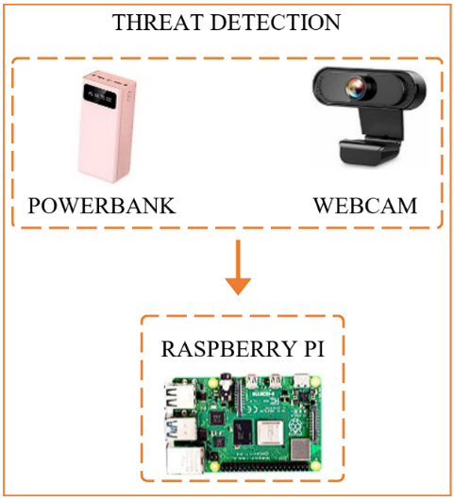

*Figure 3.7.2 Threat Detection System*

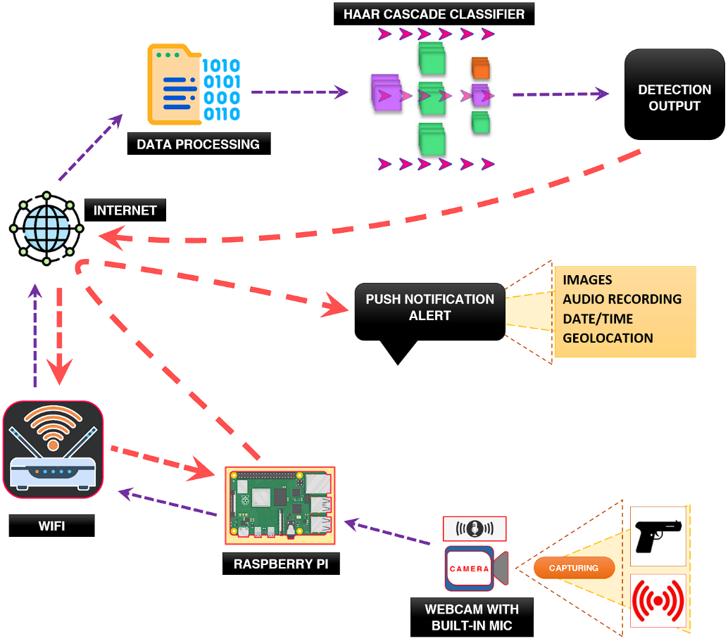

*Figure 3.7.3 Threat Detection Visual Flow*

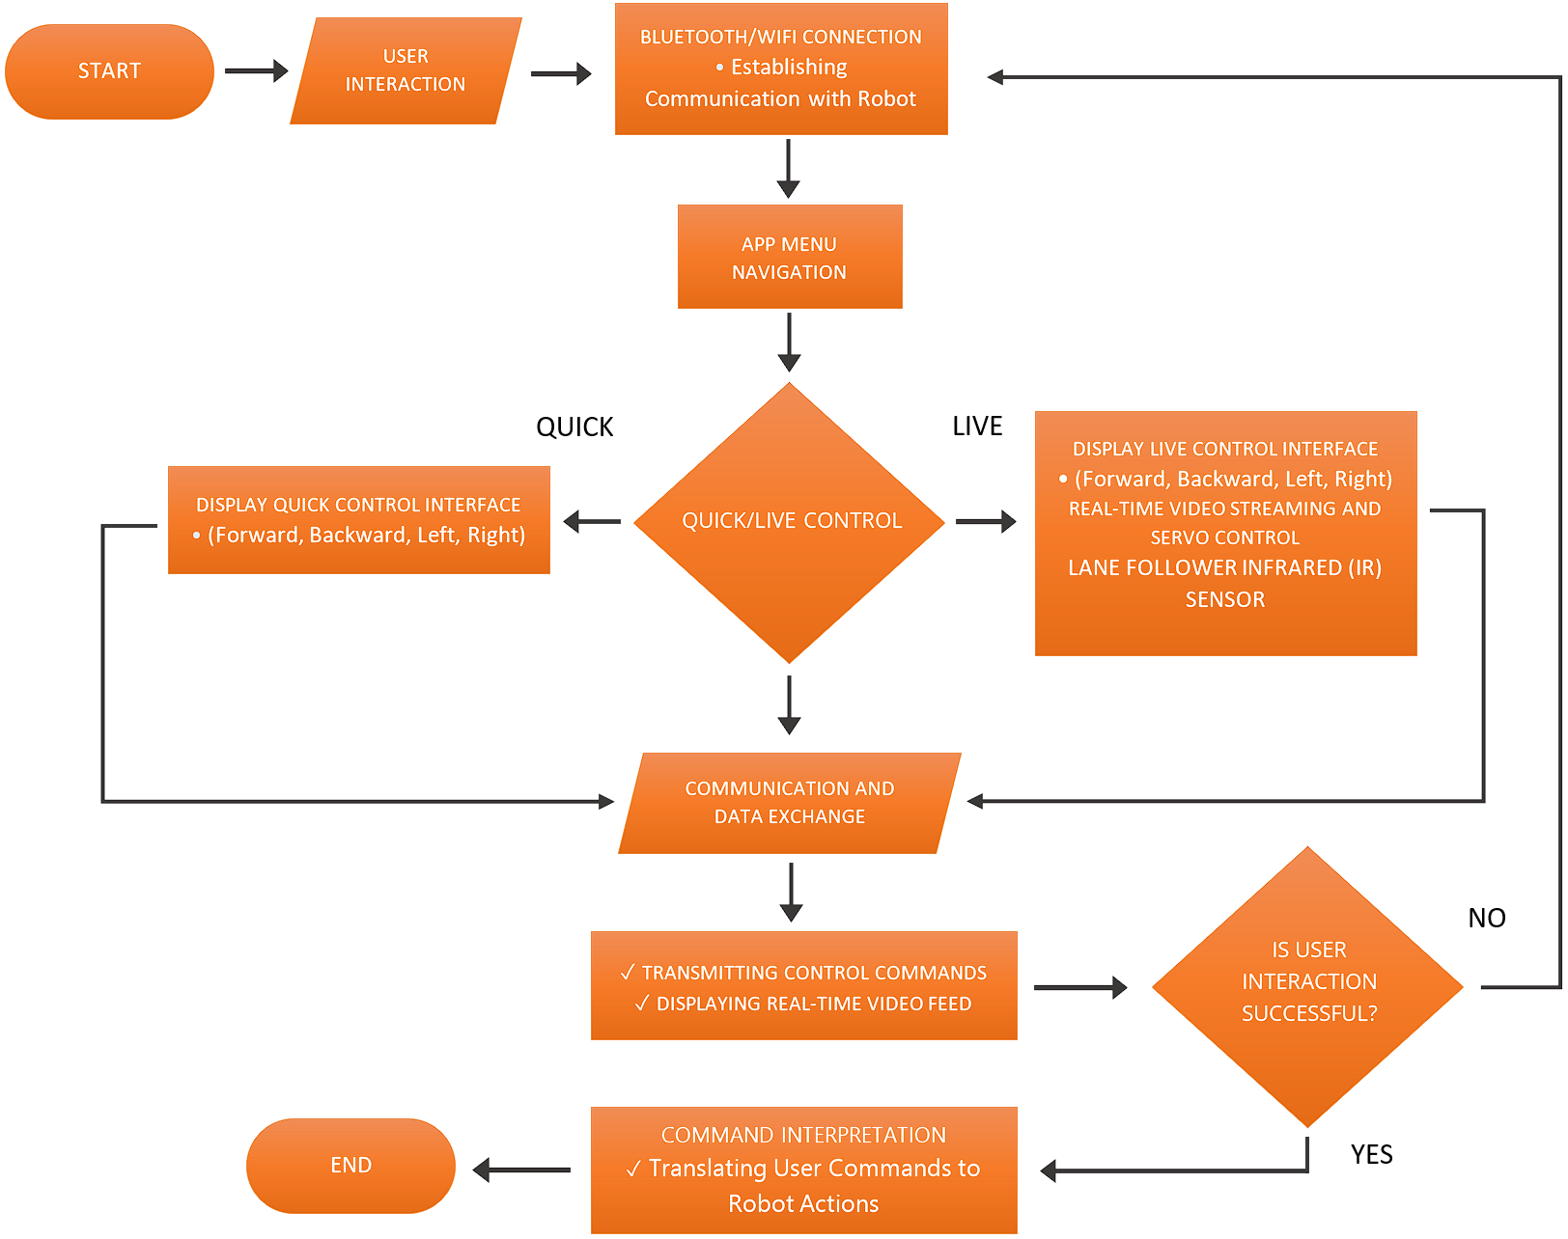

*Figure 3.7.4 Android Application Flowchart*

***FIG 3.7.1, FIG 3.7.2 AND FIG 3.7.3***

Robot Functionality refers to the ability of the robot to move and navigate in its environment. The mechanism includes ground-based robot providing stability and efficient movement on flat surfaces. As illustrated in the Operational Flow, Servo, Bluetooth and Wi-Fi module, dc motor and night vision arducam is interconnected to 4WD expansion board powered by a battery. Similarly, the 4WD expansion board is linked to the Raspberry pi. The communication between 4WD expansion board and Raspberry pi is supported by GPIO. Moreover, in threat detection a power bank and Webcam are connected to another raspberry pi that will ensure an accurate threat detection mode, this shows that operational flow smoothly works with the coordination of the materials.

In addition, when it comes to Threat Detection Visual Flow the center of it is internet, that is where IOT is derived. When the raspberry pi is connected to the Wi-Fi, the webcam with built-in mic will be able to detect objects and sounds, most specifically concealed firearms, knife and unusual sounds. After accurate detection it will deliver push notification alert through email containing captured images, sound recordings, accurate date and timestamps and geolocation. Realistically speaking, behind these methods there is data processing, Haar cascade algorithm as an accurate classifier that provides precise detection output

***FIG 3.7.4***

The Android App Flowchart illustrates the communication between the robot and the user who will control the App. First, you will start up the robot by turning on the power button; the user’s interaction will follow. In a way that the user will open the app and connect to the robot’s Bluetooth and Wi-Fi, and it will show the app menu navigation. There is this display quick control interface for (forward, backward, right and left) and the other one is live control interface for (forward, backward, left, right and real – time video streaming and servo control). Communication and data exchange takes place, transmitting commands and displaying live video feeds. Lastly, the robot responds to the commands.

***3.8 Description of Material and Software Used in the Study***

TABLE 3.8.1   
ELECTRONIC COMPONENTS USED

|  |  |  |
| --- | --- | --- |
| Component | Image | Component Purpose |
| Raspberry Pi 4B |  | The smart security robot project utilizes two Raspberry Pi boards in conjunction with a 4WD expansion board for optimized performance. One Raspberry Pi serves as the Robot Controller, managing motor control, navigation, and real-time communication with the Android app. It interfaces with the 4WD expansion board, which supports the DC and servo motors for precise movement.  The second Raspberry Pi focuses on surveillance tasks, such as camera interfaces, image processing, and advanced threat detection algorithms. Together, these components create a highly capable and responsive smart surveillance robot with enhanced security and monitoring capabilities. |
| 4WD Expansion Board |  | The 4WD expansion board serves as a specialized motor controller in the smart security robot project, directly connected to the Raspberry Pi via GPIO pins. Its primary purpose is to enhance the robot's mobility and control. The expansion board provides precise motor control for the DC and servo motors, responsible for driving and steering the robot's wheels. It manages the power distribution to the motors, ensuring optimal performance. By facilitating seamless communication between the Raspberry Pi and the motors, the 4WD expansion board enhances the robot's stability, agility, and responsiveness during navigation, making it a vital component for an effective and capable smart surveillance system. |
| Night Vision ArduCam | USB Camera | The Night Vision ArduCam in the smart security robot project serves the purpose of providing enhanced visibility and surveillance capabilities in low-light or dark conditions. |
| Webcam |  | The webcam in the smart security robot project captures live video and provides real-time visual data for observing surroundings through the Android app. Users can remotely monitor areas with effective surveillance and security. Additionally, the webcam integrates with advanced algorithms to detect potential threats. The combination of the webcam's live video and night vision capabilities enhances the robot's capabilities, making it a powerful tool for security and monitoring applications. |
| IR Line Follower |  | The Line Follower IR sensor in the project enables the robot to autonomously follow a predefined path or track marked by a contrasting line. This sensor helps the robot navigate and stay on course by detecting the changes in color or reflectivity between the line and the surrounding surface. |
| Chassis |  | The robot chassis provides a strong and stable foundation for all the robot's components. It holds the Raspberry Pi, cameras, sensors, motors, and other electronics securely. The chassis protects sensitive parts from damage and ensures smooth movement. It allows customization and easy maintenance, making it essential for the smart security robot's functionality and performance. |
| DC Motor |  | The DC motors in the smart security robot enable movement and navigation. They control the wheels for forward, backward, left, and right turns with precise maneuverability. |
| Servo Motor |  | A servo motor is a self-contained electrical device, that rotates parts of a machine with high efficiency and with great precision. |
| Bluetooth Module |  | The Bluetooth module in the smart security robot enables wireless communication with the Android app. It allows users to remotely control the robot. With its low power usage and easy pairing, the Bluetooth module provides efficient connectivity. Its compatibility with smartphones enhances the overall functionality and user experience of the smart security system. |
| Battery |  | The battery in the smart security robot provides portable and self-contained power. The battery powers motors, cameras, sensors, and other electronics. With efficient power management and rechargeable capability, it ensures the robot's independence and effectiveness in surveillance tasks. |
| MicroSD Card |  | The MicroSD card on a Raspberry Pi is like its brain and storage. It holds the operating system and user data, allowing the computer to start up and run applications. |
| Powerbank |  | The powerbank in the smart security robot serves two main purposes: it powers the other Raspberry Pi, making it a portable and reliable power source for the entire system, and it allows users to extend the robot's operating time or recharge its battery while it's actively monitoring. This ensures continuous surveillance even in locations without direct power, making the robot versatile for various environments. |
| TABLE 3.8.2  SOFTWARE USED | | |
| Application | **Image** | **Application Purpose** |
| Python Programming Language |  | The Python programming language is vital for the smart security robot project. It's versatile and easy to use, perfect for IoT development and integrating with hardware like the Raspberry Pi. Python enables precise robot control, data processing, and real-time communication with the Android app. Its extensive library support allows for complex algorithms for threat detection and image processing. Additionally, Python's flexibility enables quick development of new features, making it essential for creating an efficient smart surveillance robot. |
| OpenCV |  | OpenCV in the smart security robot enhances its vision capabilities. It processes camera data using powerful tools for image and video analysis. This helps the robot detect objects, track motion, and perform advanced threat identification. OpenCV also provides valuable data insights for effective surveillance and monitoring. Overall, it's a vital tool that boosts the robot's security and threat detection capabilities. |
| Haar Cascade |  | Haar Cascade in the smart security robot enables real-time object detection from its camera feeds. It quickly identifies specific objects or patterns using machine learning in OpenCV. This includes anomaly detection, enhancing the robot's ability to respond to potential threats and ensuring effective surveillance in various scenarios. |
| Android Studio |  | Android Studio's purpose is to create the Android app that acts as the control center for the smart security robot. It allows developers to design a user-friendly interface, establish real-time communication with the robot, and display sensor data and camera feeds. Users can remotely control the robot and monitor live feeds during surveillance. With compatibility for various Android devices and security features, Android Studio ensures an interactive and efficient user experience for the smart security robot. |
| Visual Studio Code | File, type, vscode Icon in vscode | Visual Studio Code (VS Code) serves as the Integrated Development Environment (IDE) for the smart security robot project. Its purpose is to provide a user-friendly and feature-rich environment for software development and programming tasks. |

TABLE 3.8.3   
BILL OF MATERIALS

|  |  |  |  |
| --- | --- | --- | --- |
| **Description** | **Unit Price** | **Quantity** | **Total Price** |
| **Raspberry Pi 4B** | **₱5,811.00** | **2** | **₱11,622** |
| **4WD Expansion Board** | **₱1534.58** | **1** | **₱1534.58** |
| **Night Vision Arducam** | **₱1917.68** | **1** | **₱1917.68** |
| **Webcam** | **₱527.00** | **1** | **₱527.00** |
| **Chassis** | **₱3446.00** | **1** | **₱3446.00** |
| **DC Motor** | **₱468.00** | **2** | **₱936.00** |
| **Servo Motor** | **₱439.00** | **1** | **₱439.00** |
| **Bluetooth Module** | **₱276.00** | **1** | **₱276.00** |
| **IR Line Follower** | **₱300.00** | **1** | **₱300.00** |
| **Battery** | **₱157.00** | **1** | **₱157.00** |
| **Micro SD Card** | **₱185.00** | **2** | **₱370.00** |
| **USB External WIFI Module** | **₱578.00** | **1** | **₱578.00** |
| **Power Bank** | **₱1482.00** | **1** | **₱1482.00** |
| Total Cost: | | | **₱23,585.26** |

*The table presents the overall material cost of the proposed system spent for its development.*

***3.9 Project Development***

TABLE 3.9.1 GANTT CHART

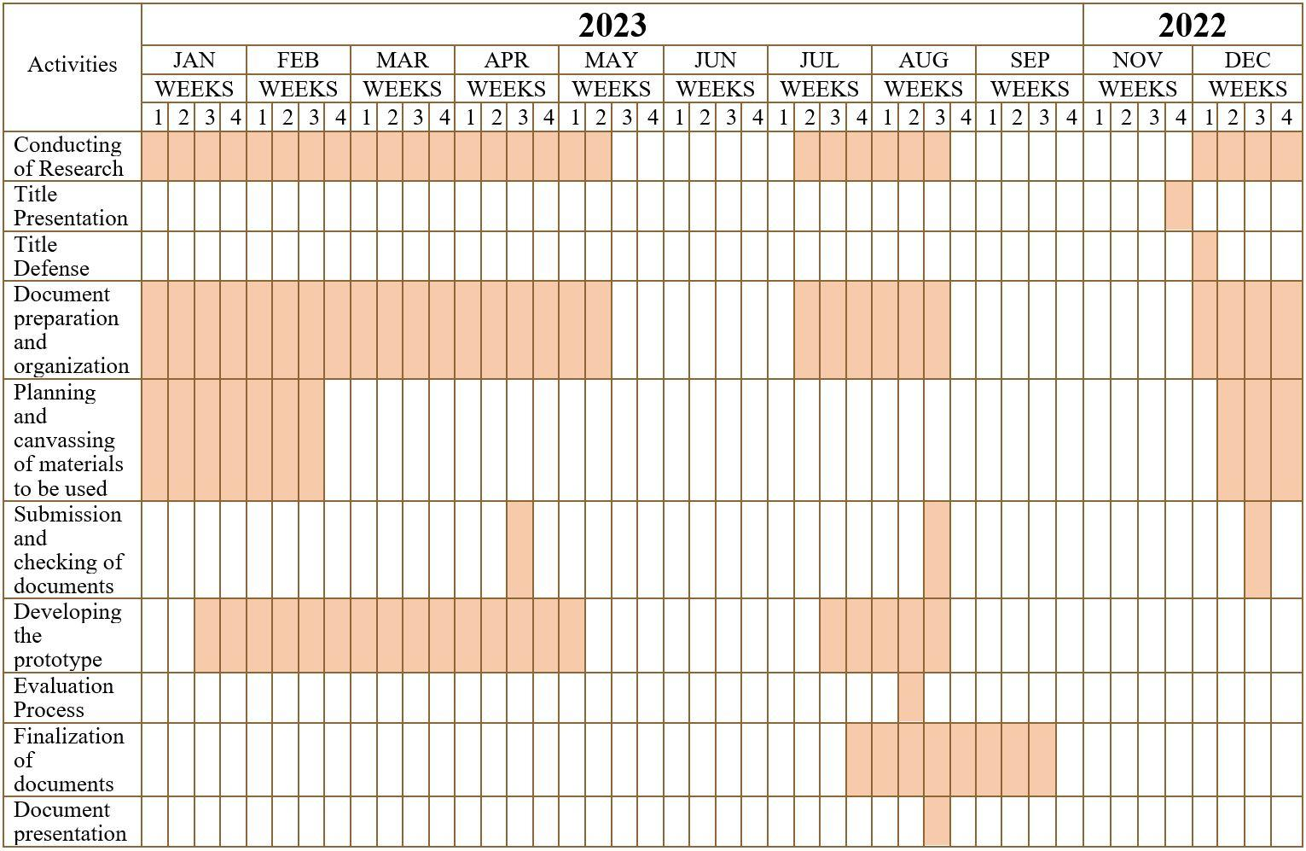 The researchers started conducting research about their project from the 1st week of December to the 2nd week of May. They Presented the title at 4th week of November and Defended the title at first week of December. As a result, the adviser chose the project, “IoT Powered Smart Security Robot with Android App, Night Vision and Enhanced Threat Detection”. The researchers worked on the project's documentation for almost 8 months. The Researchers planned and canvassed materials to be used around the 2nd week of December 3rd week of February, and for the additional tools are bought in the 3rd to last week of July. They submitted their documents every 3rd week of April, August and December. The duration of developing the prototype is from the 3rd week of January to 2nd week of May, they continued around 3rd week of July to 3rd week of August. Moreover, the Evaluation process happened around the 2nd week of August. The last thing they did was to finalize the documents on the 4th week of July and 3rd week of September and the project for the preparation for their final title defense from chapter 1 to 5, the researchers started to make their prototype. For the documents presentation they made it through the 3rd week of August. Finally, they finished the prototype on the 2nd week of August.

***3.10 Testing Methods***

The researchers conducted a self-testing method to test the project to see if it is operating and functional. The first thing to do is to turn on the robot and once it responds, with the use of the developed android app it can connect to the robot’s Bluetooth and Wi-Fi; when it’s successfully connected the person can view live control and monitoring. In addition, you will turn on threat detection and it is effective for the robot to roam around to accurately detect potential threats or hazards, most specifically firearms, knife and unusual sounds and once it detected a threat it will cause sound alarm. Moreover, it will send alerts through email containing images, audio recordings, geolocation with the help of Google Map API and accurate date and time stamp. Lastly, it proves that this study shows an immediate response.

***3.11 Evaluation Process***

To be able to check the quality and consistency of the system, the researchers needed an evaluation process. This process helped them determine the weakness of the system. They gave an evaluation sheet to evaluate the project system. The researchers presented first their project before the evaluation. To determine the weakness and functionality of the device, the researchers conducted evaluation from the following respondents:

*A. Security Professionals C. Technology Specialists*

*B. Office Workers D. Homeowners*

***3.12 Evaluation Criteria***

The criteria that the respondents observed and considered during the evaluation of the system are in table 3.12.1.

TABLE 3.12.1 CRITERIA FOR SYSTEM EVALUATION

|  |  |
| --- | --- |
| **Criteria** | **Indicator** |
| Functionality | Evaluate the robot's ability to execute commands accurately through the Android app for smooth movement control. |
| Assess the effectiveness of the night vision capabilities in providing clear visibility and image capture in low-light conditions. |
| Reliability | Measure the consistency of threat detection accuracy and the reliability of the push notification alert system in real-world scenarios. |
| The system performs with minimal or without errors during its operations |
| Maintainability | Assess the ease of accessing and servicing internal components for routine maintenance tasks. |
| Test the feasibility of replacing modular components to minimize downtime during maintenance |
| Extensibility | Determine the system's flexibility for integrating additional hardware components or functionalities in the future. |
| Assess the ease of software updates and compatibility with potential enhancements or upgrades. |
| Economic Feasibility | The proposed system offers long-term usage and can be considered as a good investment |
| The total cost of the system is a practically worth of its performance |

* 1. ***Instrument and Technique Used***

1. ***Unit Test***

Unit testing involves the testing of individual components, or units, in the research project to ensure they function accurately and reliably in isolation. It helps identify errors and contributes to overall research quality.

|  |  |  |  |  |  |  |
| --- | --- | --- | --- | --- | --- | --- |
| TABLE 3.13.1 TABLE FOR COMPONENTS UNIT TESTING | | | | | | |
| **Components** | **Description** | **Test ID** | **Date** | **Pass** | **Fail** | **N/A** |
| DC Motor | Perform the tests at different speeds and loads to ensure that the motor performs as expected under a variety of conditions. | DCMFUT-01 |  |  |  |  |
| IR Line Follower Sensor | To verify that the sensor is able to detect a line and output a signal accordingly, and to ensure that it is operating properly and will meet the performance requirements. | IRLFSUT-01 |  |  |  |  |
| Webcam | To verify that the Webcam is able to capture images and videos of good quality, and to ensure that it is operating properly and will meet the performance requirements. | WFUT-01 |  |  |  |  |
| Arducam Night Vision | To verify that the Arducam Night Vision is able to capture images and videos in low-light conditions, and to ensure that it is operating properly and will meet the performance requirements. | ANVFUT-01 |  |  |  |  |
| USB WIFI Module | To verify that the USB Wi-Fi Module is able to connect to a wireless network and transmit data, and that it does so reliably and efficiently. | USBWMFUT-01 |  |  |  |  |
| Bluetooth Module | To verify that the Bluetooth Module is able to establish a connection with other devices and transmit data, and that it does so reliably and efficiently. | BMFUT-01 |  |  |  |  |
| Servo Motor | To verify that the Servo Motor is able to rotate to a specific angle within a reasonable amount of time and with a high degree of accuracy. | SMFUT-01 |  |  |  |  |
| Battery | To verify that the battery pack is able to provide the required voltage and current, and that it does so reliably and safely. | BFDUT-01 |  |  |  |  |
| Powerbank | To verify that the Powerbank is able to distribute power, and to ensure that the Powerbank is operating properly and that it will meet the performance requirements. | PBFDUT-01 |  |  |  |  |
| Raspberry Pi | To verify that the Raspberry Pi is able to boot up and run software, and to ensure that it is operating properly and will meet the performance requirements. | RPFUT-01 |  |  |  |  |
| 4WD Expansion Board | To verify that the 4WD Expansion board is able to control motors and sensors, and to ensure that the 4WD Expansion board is operating properly and that it will meet the performance requirements. | 4WDEBFUT-01 |  |  |  |  |

1. ***Integration Test***

Integration testing verifies that various components, processes, and tools used in a research project work together effectively and reliably to ensure the quality and validity of research findings.

|  |  |  |  |  |  |  |
| --- | --- | --- | --- | --- | --- | --- |
| TABLE 3.13.2 TABLE FOR ROBOT FEATURES INTEGRATION TESTING | | | | | | |
| **Test Name** | **Description** | **Test ID** | **Date** | **Pass** | **Fail** | **N/A** |
| Android App Controller and 4WD Expansion Board | The test also helps to detect any potential problems that could prevent the Android App Controller and 4WD Expansion Board from working together. | AAC4WDEBIT-01 |  |  |  |  |
| Android App Controller and Raspberry Pi | Ensures that the Android App Controller and Raspberry Pi can be used together to create a functional system. The test also helps to identify any potential problems with the Android App Controller or Raspberry Pi that could prevent them from working together. | AACRPIT-01 |  |  |  |  |
| Android App Quick Control Robot | Ensures that the Android App Quick Control and the Smart Security Robot can be used together to create a functional system. The test also helps to identify any potential problems with the Android App or Smart Security Robot that could prevent them from working together properly. | AAQCRIT-01 |  |  |  |  |
| Android App Live Control Robot | To verify that the Android App is able to control the movements of the Smart Security Robot and to ensure that the live camera view and basic movement controls are working properly. | AALCRIT-01 |  |  |  |  |
| Android App Live Control Line Follower | To ensure this smart security robot is able to navigate a predetermined path by following a black line. | AALCLFIT-01 |  |  |  |  |
| OpenCV and Haar Cascade | To ensures that the OpenCV library and the Haar Cascade classifier can be used together to detect objects in images. | OCVHCIT-01 |  |  |  |  |
| Threat Detection | To verify that the system can detect threats such as guns, knives, and loud sounds, and generate an alarm and email alert with the relevant information. | TDIT-01 |  |  |  |  |

|  |  |  |  |  |  |  |
| --- | --- | --- | --- | --- | --- | --- |
| TABLE 3.13.3 TABLE FOR IOT ROBOT THREAT DETECTION AND ALERT INTEGRATION TESTING | | | | | | |
| **Integration Test ID** | **Description** | **Action** | **Pass** | **Fail** | **N/A** | **Date of Testing** |
| IOTR-IT **TRIAL 1** | Check the interaction of the Smart Security Robot's real-time push notification email alerts. |  |  |  |  |  |
| IOTR-IT **TRIAL 2** | Check the interaction of the Smart Security Robot's real-time push notification email alerts. |  |  |  |  |  |
| IOTR-IT **TRIAL 3** | Check the interaction of the Smart Security Robot's real-time push notification email alerts. |  |  |  |  |  |
| IOTR-IT **TRIAL 4** | Check the interaction of the Smart Security Robot's real-time push notification email alerts. |  |  |  |  |  |
| IOTR-IT **TRIAL 5** | Check the interaction of the Smart Security Robot's real-time push notification email alerts. |  |  |  |  |  |

*Figure 3.7.5 Evaluation Sheet for the Proposed System*

***3.14 Analysis of Data Gathering Methodology***

After the evaluation of the responders in the evaluation process, the researchers tallied the data that they gathered using the Likert Scale as seen in Table 3.14.1. A Likert scale is simply a statement that the respondent is asked to evaluate according to any kind of subjective or objective criteria., generally, the level of agreement or disagreement is measured. This can help the researchers to determine the capability of their system. The data must be thoroughly checked to fulfill the strict formal axioms of the project.

TABLE 3.14.1   
THE LIKERT SCALE

|  |  |  |
| --- | --- | --- |
| **Rating** | **Scale** | **Range** |
| 5 | Outstanding | 4.5 - 5.0 |
| 4 | Above Satisfactory | 3.5 - 4.5 |
| 3 | Satisfactory | 2.5 - 3.5 |
| 2 | Below Satisfactory | 1.5 - 2.5 |
| 1 | Needs Improvement | 1.0 - 1.50 |

**CHAPTER IV  
Results and Discussion**

This chapter presents the detailed discussion of the developed system/project and shows the results of the evaluation sheet for the proposed system. This also provides a detailed technical discussion of the developed project giving emphasis on both hardware, software, and integration of both.

***4.1 The Developed System***

|  |
| --- |
| *Figure 4.1.1 Diagram* |

First the researcher discusses how the flow of the system is made of and its shows in fig. 4.1.1 Diagrams. Ensure that the power source is connected to the 4WD expansion board of the robot and turn it on, as a result, the Raspberry Pi microprocessor, DC motors, night vision camera, servo, and sensors will receive power. Locate and turn on the second Raspberry Pi, mounted on top of the robot using its own power source. Thereafter it automatically launches the software responsible for threat detection, data analysis and real time alerts. Now On your Android device, Open the app and establish a connection between your Android device and the robot. This can be achieved through Wi-Fi or Bluetooth, depending on the connectivity options available. Within the app, access the remote-control interface and choose between quick control that steers the robot's movement using on-screen controls only and the live control that feeds a live video feed through the arducam night vision camera including controls for the servos movement and steering of the robot. Alternatively, you can enable the semi-autonomous mode, allowing the robot to make decisions based on lane detection to roam around. Upon detecting a threat and receiving an alert through email, open the alert notification to access the associated images, audio recordings, timestamps, and geolocation. Evaluate the situation and decide regarding appropriate action or further escalation. If operating in low-light conditions, enable the night vision mode on the robot. This will activate the night vision camera module, allowing the robot to capture and transmit clear images even in darkness. When finished using the robot, ensure that all operations, including motors and cameras, are turned off. Safely shut down both Raspberry Pi microprocessors to prevent data corruption or damage.

***4.2 Data Analysis***

The researchers used a quantitative research method to analyze the data, using observation, textual, evaluation or visual analysis and interviews with individuals or a group. After finishing the hardware and software development phase of the prototype, the hardware and software underwent alpha and beta testing to assess the functionality of the proposed IOT Powered smart security robot using the researchers-made instruments. Alpha and beta testing of the hardware and software play an important role in the software development life cycle. With its usage, the developer should produce a system with no discrepancy. Based on the survey, errors or bugs in software cost the US economy 0.6 % of its gross domestic product, 80% of software company cost is in finding and fixing errors.

The purpose of this study was to develop a workable/improvise prototype security robot that can help users to immediately respond to ever changing threats in their homes or office premises instead of relying on traditional surveillance systems. Using pre-survey questionnaires inputs from participants selected pre-determined functions that would be needed for the proposed Iot powered smart security surveillance robot As shown in table 1, participants selected four core functions they want to see when the surveillance robot is developed, these functions Threat Detection, Real time alerts, Android App for remote monitoring and control and Night Vision capabilities.

Considering the need to test the software and hardware itself, the security robot went through the process of alpha and beta testing. Alpha testing involves testing the different key features and functions. Within this phase, the researchers encountered issues on the threat detection feature because it's hard to train a machine learning model that learns to recognize a specific object like firearms and knives that uses computer vision techniques and object detection algorithms. Similarly, the real time alerts that sends a captured image, recordings, event logging and location has network connectivity and API errors, So the researcher decided to use OpenCV and cascade as a classifier for computer vision as it is way easier than Tensorflow and Yolov3. And for the real time alerts we’ve used opencage api for geocoder and gmail api.

|  |  |
| --- | --- |
| **DEVICE** | **FUNCTIONALITY** |
| IOT Powered Smart Security Robot with Android app, Night Vision and Enhanced Threat Detection. | * Threat Detection * Real-time Alerts * Mobile App for Remote Monitoring and Control * Night Vision Capabilities |
| *Figure 4.2.1 Functionalities needed on smart security robot* | |

***4.3 Program Used***

The researcher chose Raspberry pi and Python programming language because it was easier to use, has more modules for machine learning, more maintained by developers and it is easier to debug if there is a problem in the system. When the research program is finished, the IOT Powered smart security surveillance robot is constructed.

This are the Function of the system and the manual of how the system works:

***FUNCTIONS***

1. **Threat Detection –** using audio samples and thresholds, object identification machine learning algorithms, including haar cascade classifiers and Open CV, may quickly identify possible hazards like concealed weapons and strange sounds. When a threat is found, the robot immediately initiates an alert system to protect the area.
2. **Real-time Alerts, Event Logging with Location Data** – When threats or unusual sounds are detected, the system instantly creates and delivers thorough email alerts. These alerts contain pictures, audio files, and timestamps to provide precise event documentation. In addition to media files, emails can give accurate location information by employing geolocation services. The system automatically retrieves latitude and longitude coordinates by integrating the geocoder library, generating Google Maps links for rapid access to the incident site.
3. **Android App for Remote Monitoring and Control** – With the use of this app, users may remotely control the robot's movement and view the camera feed. Using a lane detecting sensor, you could even make it partially autonomous. The system's reach and responsiveness are increased by the remote-control feature.
4. **Night Vision** – The robot's night vision capabilities allow it to function efficiently even in dim lighting, which enhances the effectiveness of its nightly monitoring.

***MANUAL***

1. Ensure that the power source is connected to the 4WD expansion board of the robot and turn it on, As a result, the Raspberry Pi microprocessor, DC motors, night vision camera, servo, and sensors will receive power.
2. Locate and turn on the second Raspberry Pi, mounted on top of the robot using its own power source. Thereafter it automatically launches the software responsible for threat detection, data analysis and real time alerts.
3. Now On your Android device, Open the app and establish a connection between your Android device and the robot. This can be achieved through Wi-Fi or Bluetooth, depending on the connectivity options available.
4. access the remote-control interface and choose between quick control that steers the robot's movement using on-screen controls only and the live control that feeds a live video feed through the arducam night vision camera including controls for the servos movement and steering of the robot
5. Alternatively, you can enable the semi-autonomous mode, allowing the robot to make decisions based on lane detection to roam around.
6. Upon detecting a threat and receiving an alert through email, open the alert notification to access the associated images, audio recordings, timestamps, and geolocation.
7. If operating in low-light conditions, enable the night vision mode on the robot. This will activate the night vision camera module, allowing the robot to capture and transmit clear images even in darkness.

***4.4 Verification and Testing Result***

|  |  |  |  |  |  |
| --- | --- | --- | --- | --- | --- |
| ***Unit Test***  Unit testing involves the testing of individual components, or units, in the research project to ensure they function accurately and reliably in isolation. It helps identify errors and contributes to overall research quality. | | | | | |
| TABLE 4.4.1 DC MOTOR FUNCTIONALITY UNIT TEST | | | | | |
| **Test Name:**  DC Motor Functionality Unit Test | | **Test ID:**  DCMFUT-01 |  | | |
| **Description:** Perform the tests at different speeds and loads to ensure that the motor performs as expected under a variety of conditions. | | |
| **Date:** 02-17-23 | | |
| **Test Step** | **Action** | **Expected Outcome** | **Pass** | **Fail** | **N/A** |
| Functional Testing | Test the motor's functionality under various scenarios, including startup, continuous running, and stopping. | Motor functions as expected in different scenarios and responds reliably to commands. | ✓ |  |  |
| Ensure that the motor operates reliably with consistent performance. | Motor consistently performs its intended functions without unexpected behavior. | ✓ |  |  |
| Power and Motor Direction | Connect the DC motor to the power supply and controller board. | Motor and controller are connected correctly. | ✓ |  |  |
| Apply power to the motor, allowing it to spin in the default direction. | The motor spins in the default direction. | ✓ |  |  |
| Reverse the polarity of the power supply to change the motor's direction. | The motor reverses its direction. | ✓ |  |  |
| Speed Control | Connect the motor to a motor controller capable of speed control. | Motor is properly connected to the controller. | ✓ |  |  |
| Gradually increase the motor's speed using the controller. | The motor accelerates smoothly within its specified speed range. | ✓ |  |  |
| Gradually decrease the motor's speed using the controller. | The motor decelerates smoothly within its specified speed range. | ✓ |  |  |
| Stop Functionality | Apply power to the motor and start it. | Motor is powered on and operational. | ✓ |  |  |
| Use the controller or a physical switch to stop the motor. | The motor stops promptly and safely when commanded. | ✓ |  |  |
| Load Handling Test | Gradually increase the load on the motor shaft (e.g., by attaching small weights) while it's running. | The motor handles increased load within its specified capacity, and its speed decreases proportionally. | ✓ |  |  |
| Observe how the motor responds to the increased load and how it adjusts its speed. | The motor adapts to the increased load by slowing down as expected. | ✓ |  |  |
| Overload Protection | Apply excessive load or resistance to the motor shaft while it's running. | Motor and controller protect against overload by reducing power or stopping the motor. | ✓ |  |  |
| Monitor how the motor and controller respond to the overload. | The motor power is reduced or the motor stops to protect against overload. | ✓ |  |  |
| Noise and Vibration | Run the motor and observe the noise and vibrations it generates. | Noise and vibrations are within acceptable limits and do not exceed specified standards. | ✓ |  |  |
| Compare the noise and vibration levels to acceptable standards or specifications. | Noise and vibrations meet specified standards for the motor. | ✓ |  |  |
|  | | | | | |
| The DC Motor Functionality Unit Test in Table 4.4.1 is a critical step in ensuring that the motor performs as expected under a variety of conditions. The tests are performed at different speeds and loads to verify that the motor can start and stop smoothly, maintain a constant speed, and accelerate and decelerate quickly. The tests also verify that the motor can withstand the load and vibration that it will experience in the real world. | | | | | |
| TABLE 4.4.2 IR LINE FOLLOWER SENSOR UNIT TEST | | | | | |
| **Test Name:**  IR Line Follower Sensor Unit Test | | **Test ID:** IRLFSUT-01 |  | | |
| **Description:** To verify that the sensor is able to detect a line and output a signal accordingly, and to ensure that it is operating properly and will meet the performance requirements. | | |
| **Date:** 02-17-23 | | |
| **Test Step** | **Action** | **Expected Outcome** | **Pass** | **Fail** | **N/A** |
| Power and Sensor Connection | Connect the IR Line Follower Sensor to the power supply and microcontroller. | Sensor is correctly wired and powered. | ✓ |  |  |
| Apply power to the sensor. | The sensor receives power and initializes. | ✓ |  |  |
| Calibration and Threshold Setup | Configure the microcontroller to calibrate the sensor by reading the ambient light level. | The microcontroller successfully calibrates the sensor. | ✓ |  |  |
| Adjust the sensor's threshold values based on the calibration to distinguish between line and background. | Threshold values are set accurately for line detection. | ✓ |  |  |
| Line Detection - Over Line | Place the sensor over a black line on a white surface, ensuring it straddles the line. | The sensor detects the black line as expected. | ✓ |  |  |
| Line Detection - On the Line | Position the sensor directly on the black line. | The sensor detects the black line accurately. | ✓ |  |  |
| Line Detection – Off the Line | Move the sensor completely off the black line and onto the white surface. | The sensor correctly identifies that it's off the line. | ✓ |  |  |
| Line Following - Follow Line | Place the sensor at the start of a winding black line path and instruct the microcontroller to follow it. | The sensor accurately follows the black line's path. | ✓ |  |  |
| Line Following - Lost Line | Introduce a scenario where the sensor momentarily loses the line (e.g., a gap in the line). | The sensor recognizes the lost line and attempts to reacquire it. | ✓ |  |  |
| Speed and Response Time | Expose the sensor to varying lighting conditions (e.g., changes in ambient light, shadows). | The sensor remains reliable and adjusts to changing lighting conditions effectively. | ✓ |  |  |
| Reflective Surface Handling | Place the sensor over a reflective surface (e.g., glass or polished metal). | The sensor accurately detects the line without interference from reflective surfaces. | ✓ |  |  |
|  | | | | | |
| The IR Line Follower Sensor Unit Test in Table 4.4.2 is a critical step in ensuring that the sensor is able to detect a line and output a signal accordingly. The test verifies that the sensor can detect a line of any width and color, and that it can output a signal that is proportional to the distance to the line. The test also ensures that the sensor is operating properly and will meet the performance requirements, such as the sensitivity, accuracy, and repeatability. | | | | | |
| TABLE 4.4.3 WEBCAM FUNCTIONALITY UNIT TEST | | | | | |
| **Test Name:** Webcam Functionality Unit Test | | **Test ID:** WFUT-01 |  | | |
| **Description:** To verify that the Webcam is able to capture images and videos of good quality, and to ensure that it is operating properly and will meet the performance requirements. | | |
| **Date:** 02-17-23 | | |
| **Test Step** | **Action** | **Expected Outcome** | **Pass** | **Fail** | **N/A** |
| Power and Connection | Connect the webcam to the computer or device using the appropriate interface (e.g., USB). | Webcam is correctly connected and powered. | ✓ |  |  |
| Verify that the computer recognizes the webcam as a connected device. | The computer detects and recognizes the webcam. | ✓ |  |  |
| Video Capture - Basic Functionality | Launch the webcam software or application. | The webcam software or application starts successfully. | ✓ |  |  |
| Initiate video capture by pressing the record or start button. | The webcam begins capturing video without errors. | ✓ |  |  |
| Observe the live video feed from the webcam on the computer screen. | The live video feed is displayed clearly and in real-time. | ✓ |  |  |
| Resolution and Frame Rate | Access the webcam settings and select different resolutions and frame rates. | The webcam allows the user to adjust resolution and frame rate settings. | ✓ |  |  |
| Record video at different resolution and frame rate settings. | Video recordings are captured with the selected resolution and frame rate settings. | ✓ |  |  |
| Audio Capture - Basic Functionality | Test the webcam's built-in microphone or external microphone attachment. | The microphone captures audio clearly and synchronizes with video. | ✓ |  |  |
| Record a video with audio and ensure that sound is captured and played back correctly. | Audio is captured and synchronized with the video without issues. | ✓ |  |  |
| Auto-Focus and Zoom | Verify if the webcam supports auto-focus or zoom functionality. | Auto-focus and zoom features are available if supported. | ✓ |  |  |
| Test auto-focus and zoom by adjusting the camera's focus or zoom settings during video capture. | Auto-focus and zoom adjustments work smoothly during video capture. | ✓ |  |  |
|  | | | | | |
| The Webcam Functionality Unit Test in Table 4.4.3 is a critical step in ensuring that the Webcam is able to capture images and videos of good quality. The test verifies that the Webcam can capture clear and sharp images and videos, with accurate colors and good contrast. The test also ensures that the Webcam is operating properly and will meet the performance requirements, such as the resolution, frame rate, and field of view. | | | | | |
| TABLE 4.4.4 ARDUCAM NIGHT VISION FUNCTIONALITY UNIT TEST | | | | | |
| **Test Name:** Arducam Night Vision Functionality Unit Test | | **Test ID:** ANVFUT-01 | USB Camera | | |
| **Description:** To verify that the Arducam Night Vision is able to capture images and videos in low-light conditions, and to ensure that it is operating properly and will meet the performance requirements. | | |
| **Date:** 02-17-23 | | |
| **Test Step** | **Action** | **Expected Outcome** | **Pass** | **Fail** | **N/A** |
| Power and Connection | Connect the Arducam USB Night Vision module to a USB port on a computer or device. | The module is correctly connected and powered. | ✓ |  |  |
| Ensure that the computer or device recognizes the Arducam module as a connected USB device. | The computer or device detects and recognizes the Arducam module. | ✓ |  |  |
| Night Vision Mode Activation | Enable the night vision mode using the module's controls or software settings. | Night vision mode is activated without errors. | ✓ |  |  |
| Observe the live video feed from the Arducam module in low-light or dark conditions. | The module provides clear and well-exposed night vision video. | ✓ |  |  |
| Resolution and Frame Rate | Access the Arducam module's settings and select different resolutions and frame rates. | The module allows the user to adjust resolution and frame rate settings. | ✓ |  |  |
| Record video at different resolution and frame rate settings while in night vision mode. | Video recordings are captured with the selected settings in night vision mode. | ✓ |  |  |
| Infrared (IR) Illumination | Test the IR illumination functionality by activating and deactivating the IR LEDs. | IR LEDs switch on and off as intended, providing illumination in night vision mode. | ✓ |  |  |
| Auto-Focus and Zoom | Verify if the Arducam module supports auto-focus or zoom functionality. | Auto-focus and zoom features are available if supported. | ✓ |  |  |
| Test auto-focus and zoom by adjusting the camera's focus or zoom settings during video capture. | Auto-focus and zoom adjustments work smoothly in night vision mode. | ✓ |  |  |
| Low-Light Performance | Test the Arducam module's performance in low-light and dark conditions. | The module provides clear and well-exposed video in low-light and dark conditions. | ✓ |  |  |
| Noise Reduction | Expose the Arducam module to noisy environments (e.g., background noise) during night vision video capture. | The module minimizes background noise effectively in night vision mode. | ✓ |  |  |
|  | | | | | |
| The Arducam Night Vision Functionality Unit Test in Table 4.4.4 is a critical step in ensuring that the Arducam Night Vision can capture images and videos in low-light conditions. The test verifies that the Arducam Night Vision can capture clear and sharp images and videos in dark environments, and that it can automatically adjust its settings to compensate for changes in lighting conditions. The test also ensures that the Arducam Night Vision is operating properly and will meet the performance requirements, such as power and connection, night vision mode activation, resolution and frame rate, infrared (IR) illumination, auto-focus and zoom, low-light performance, and noise reduction. | | | | | |
| TABLE 4.4.5  USB WIFI MODULE FUNCTIONALITY UNIT TEST | | | | | |
| **Test Name:** USB WIFI Module Functionality Unit Test | | **Test ID:** USBWMFUT-01 | MERCUSYS MU6H AC650 HIGH GAIN WI-FI USB ADAPTER – Makotek Computer Sales Inc | | |
| **Description:** To verify that the USB Wi-Fi Module is able to connect to a wireless network and transmit data, and that it does so reliably and efficiently. | | |
| **Date:** 02-17-23 | | |
| **Test Step** | **Action** | **Expected Outcome** | **Pass** | **Fail** | **N/A** |
| Power and Connection | Connect the USB WiFi module to an available USB port on a computer or device. | The module is correctly connected and powered. | ✓ |  |  |
| Ensure that the computer or device recognizes the USB WiFi module as a connected USB device. | The computer or device detects and recognizes the USB WiFi module. | ✓ |  |  |
| Driver Installation | Verify if the USB WiFi module requires driver installation (common for some models on Windows). | The required drivers are successfully installed if needed. | ✓ |  |  |
| Confirm that the computer recognizes the module as a network device with the appropriate drivers (if applicable). | The module appears as a recognized network device in the computer's settings (if applicable). | ✓ |  |  |
| Wireless Network Connection | Scan for available wireless networks using the computer or device's WiFi settings. | The USB WiFi module correctly identifies nearby WiFi networks. | ✓ |  |  |
| Connect to a known WiFi network using the USB WiFi module. | The module establishes a successful connection to the selected WiFi network. | ✓ |  |  |
| Internet Access and Speed Test | Open a web browser or use an internet-dependent application to confirm internet access. | The computer or device can access the internet through the USB WiFi module. | ✓ |  |  |
| Perform a speed test to assess the data transfer rate over the WiFi connection. | The module provides stable and adequate internet speeds for normal usage. | ✓ |  |  |
| Security Features | Configure the USB WiFi module to connect to a secure WPA/WPA2-encrypted network. | The module successfully connects to and secures the WiFi network. | ✓ |  |  |
| Test the module's ability to automatically reconnect to the secured network after disconnection. | The module seamlessly reconnects to the secured network upon disconnection. | ✓ |  |  |
| Range and Signal Strength | Assess the WiFi signal strength and range by moving the computer or device to different locations. | The module provides consistent signal strength and sufficient range within specifications. | ✓ |  |  |
| Compatibility | Test the module's compatibility with different WiFi routers or access points. | The module functions reliably with various WiFi routers and access points. | ✓ |  |  |
|  | | | | | |
| The USB Wi-Fi Module Functionality Unit Test in Table 4.4.5 is a critical step in ensuring the reliable and efficient operation of the USB Wi-Fi Module. This test is also critical to ensure its stability when it is plugged into the Smart Security Robot, as the robot will rely on the module to communicate with other devices and sensors. The test verifies that the module can maintain a connection to the wireless network even in areas with poor signal strength. Additionally, the test verifies that the module can handle multiple simultaneous connections and does not experience any dropped packets. This ensures that the Smart Security Robot will be able to operate reliably and efficiently, even in challenging environments. | | | | | |
| TABLE 4.4.6  BLUETOOTH MODULE FUNCTIONALITY UNIT TEST | | | | | |
| **Test Name:** Bluetooth Module Functionality Unit Test | | **Test ID:** BMFUT-01 |  | | |
| **Description:** To verify that the Bluetooth Module is able to establish a connection with other devices and transmit data, and that it does so reliably and efficiently. | | |
| **Date:** 02-17-23 | | |
| **Test Step** | **Action** | **Expected Outcome** | **Pass** | **Fail** | **N/A** |
| Power and Connection | Connect the Bluetooth module to the appropriate interface (e.g., microcontroller, Arduino). | The module is correctly connected and powered. | ✓ |  |  |
| Ensure that the host device (e.g., microcontroller) recognizes the Bluetooth module as a connected peripheral. | The host device detects and recognizes the Bluetooth module. | ✓ |  |  |
| Bluetooth Pairing | Put the Bluetooth module into pairing mode (typically by holding a specific button or using AT commands). | The module enters pairing mode as expected. | ✓ |  |  |
| Search for available Bluetooth devices on a smartphone or computer and initiate pairing with the module. | The module successfully pairs with the smartphone or computer. | ✓ |  |  |
| Serial Communication (SPP) | Set up a serial communication program (e.g., Arduino's Serial Monitor) on the host device. | The host device is configured for serial communication. | ✓ |  |  |
| Establish a serial connection between the host device and the Bluetooth module using the designated COM port. | The module establishes a reliable serial connection with the host device. | ✓ |  |  |
| Data Transmission | Send data (e.g., text, commands) from the host device to the Bluetooth module over the serial connection. | The module receives and processes data from the host device without errors. | ✓ |  |  |
| Send data from the Bluetooth module to the host device over the serial connection. | The module successfully transmits data to the host device. | ✓ |  |  |
| Bluetooth Range Test | Measure the Bluetooth range by gradually increasing the distance between the host device and the module. | Data transmission remains consistent and reliable within the Bluetooth range. | ✓ |  |  |
| Verify the reliability of data transmission at different distances. | The module maintains a stable connection even in the presence of interference or obstructions. | ✓ |  |  |
| AT Command Testing | Use AT commands to configure various settings on the Bluetooth module (e.g., change device name, PIN, baud rate). | The module responds to AT commands and updates settings accordingly. | ✓ |  |  |
| Confirm that changes made through AT commands are effective in the Bluetooth module's behavior. | Changes made through AT commands are reflected in the module's behavior. | ✓ |  |  |
|  | | | | | |
| In Table 4.4.6 It illustrates the Bluetooth Module Functionality Unit Test, which is a critical step in ensuring the proper functioning of the Bluetooth module in the Smart Security Robot. The test verifies that the module can establish a reliable and efficient connection with other devices, and that it can transmit data without errors. This is essential for the robot to be able to perform its functions, such as robot movement control. | | | | | |
| TABLE 4.4.7 SERVO MOTOR FUNCTIONALITY UNIT TEST | | | | | |
| **Test Name:** Servo Motor Functionality Unit Test | | **Test ID:** SMFUT-01 |  | | |
| **Description:** To verify that the Servo Motor is able to rotate to a specific angle within a reasonable amount of time and with a high degree of accuracy. | | |
| **Date:** 02-17-23 | | |
| **Test Step** | **Action** | **Expected Outcome** | **Pass** | **Fail** | **N/A** |
| Power and Connection | Connect the servo motor to a power supply or controller board following the manufacturer's instructions. | The servo motor is correctly connected and powered. | ✓ |  |  |
| Ensure that the controller board (e.g., Arduino) is properly connected to a power source and control signal pin. | The controller board is powered and connected correctly. | ✓ |  |  |
| Basic Movement | Write a simple program to move the servo motor to its minimum angle (e.g., 0 degrees) using the controller board. | The servo motor smoothly moves to the minimum angle. | ✓ |  |  |
| Write a program to move the servo motor to its maximum angle (e.g., 180 degrees). | The servo motor smoothly moves to the maximum angle. | ✓ |  |  |
| Intermediate Movement | Create a program to move the servo motor to a specific angle (between 0 and 180 degrees) using the controller board. | The servo motor accurately moves to the specified angle. | ✓ |  |  |
| Test the servo motor's ability to hold its position at the specified angle without jitter or drifting. | The servo motor maintains its position without jitter. | ✓ |  |  |
| Speed Control | Verify if the servo motor supports speed control (some models do). | Speed control features are available if supported. | ✓ |  |  |
| Write a program to move the servo motor to a specific angle at a controlled speed (if supported). | The servo motor moves to the angle at the specified speed. | ✓ |  |  |
| Overload Protection | Apply excessive load or resistance to the servo motor's output shaft while it's running. | The servo motor protects against overload by reducing power or stopping. | ✓ |  |  |
| Monitor how the servo motor and controller respond to the overload. | The servo motor power is reduced or the motor stops to protect against overload. | ✓ |  |  |
| Current Draw | Measure the current drawn by the servo motor during various operations (startup, running, stopping). | Current readings align with servo motor specifications and stay within specified limits. | ✓ |  |  |
| Record the current readings and compare them to the servo motor's specifications. | The servo motor's current draw is within specified limits for each operation. | ✓ |  |  |
| Temperature and Heat Dissipation | Operate the servo motor continuously for an extended period. | The servo motor remains within safe temperature limits during continuous operation. | ✓ |  |  |
| Monitor the temperature of the servo motor and its surroundings. | The servo motor's temperature stays within acceptable limits, and no overheating occurs. | ✓ |  |  |
| Noise and Vibration | Run the servo motor and observe the noise and vibrations it generates. | Noise and vibrations are within acceptable limits and do not exceed specified standards. | ✓ |  |  |
| Compare the noise and vibration levels to acceptable standards or specifications. | Noise and vibrations meet specified standards for the servo motor. | ✓ |  |  |
|  | | | | | |
| The Servo Motor Functionality Unit Test in Table 4.4.7 is a critical step in ensuring that the servo motor in the Smart Security Robot can rotate to a specific angle within a reasonable amount of time. The test contains basic movement, intermediate movement, speed control, and overload protection. This is essential for the robot to be able to perform its functions. | | | | | |
| TABLE 4.4.8 BATTERY FUNCTIONALITY AND DISCHARGE UNIT TEST | | | | | |
|  | | | | | |
| **Test Name:** Battery Functionality and Discharge Unit Test | | **Test ID:** BFDUT-01 |  | | |
| **Description:** To verify that the battery pack is able to provide the required voltage and current, and that it does so reliably and safely. | | |
| **Date:** 02-17-23 | | |
| **Test Step** | **Action** | **Expected Outcome** | **Pass** | **Fail** | **N/A** |
| Power Capacity | Fully charge the battery pack following the manufacturer's instructions. | The battery pack reaches a full charge as indicated. | ✓ |  |  |
| Connect the battery pack to a device with a known power requirement (e.g., smartphone). | The battery pack delivers the expected power to the device. | ✓ |  |  |
| Measure the device's operating time with the battery pack until the battery is fully depleted. | The device operates for a duration consistent with the battery pack's capacity specifications. | ✓ |  |  |
| Charging Speed and Efficiency | Connect the battery pack to a charger compatible with its specifications. | The battery pack starts charging as expected. | ✓ |  |  |
| Measure the time it takes for the battery pack to reach 50% charge and 100% charge. | Charging times align with the battery pack's specifications. | ✓ |  |  |
| Record the amount of energy (mAh or Wh) delivered to the battery during charging. | The battery pack achieves charging efficiency within specified limits. | ✓ |  |  |
| Voltage Output Stability | Connect the battery pack to a device with a known voltage requirement (e.g., LED lights). | The battery pack supplies stable voltage within its specified range. | ✓ |  |  |
| Monitor the voltage output while the device is in use and during varying load conditions. | Voltage remains stable, and there are no significant drops or fluctuations during usage. | ✓ |  |  |
| Temperature and Heat Dissipation | Operate the battery pack continuously and monitor its temperature. | The battery pack remains within safe temperature limits during operation. | ✓ |  |  |
| Check for any signs of overheating or excessive heat generation. | The battery pack does not overheat and operates safely. | ✓ |  |  |
| 1 hour Drain/Discharge Test | Observe if the battery is still functional or usable after 1 hour of use | The battery can last for 1 hour | ✓ |  |  |
| 2 hours Drain/Discharge Test | Observe if the battery is still functional or usable after 2 hours of use | The battery can last for 2 hours | ✓ |  |  |
| 3 hours Drain/Discharge Test | Observe if the battery is still functional or usable after 3 hours of use | The battery can last for 3 hours | ✓ |  |  |
| 4 hours Drain/Discharge Test | Observe if the battery is still functional or usable after 4 hours of use | The battery can last for 4 hours | ✓ |  |  |
| 5 hours Drain/Discharge Test | Observe if the battery is still functional or usable after 5 hours of use | The battery can last for 5 hours | ✓ |  |  |
| 6 hours Drain/Discharge Test | Observe if the battery is still functional or usable after 6 hours of use | The battery can last for 6 hours | ✓ |  |  |
| 7 hours Drain/Discharge Test | Observe if the battery is still functional or usable after 7 hours of use | The battery can last for 7 hours | ✓ |  |  |
| 8 hours Drain/Discharge Test | Observe if the battery is still functional or usable after 8 hours of use | The battery can last for 8 hours |  | ✓ |  |
|  | | | | | |
| Table 4.4.8 illustrates the Battery Functionality and Discharge Unit Test step, which contains power capacity, charging speed and efficiency, voltage output stability, temperature and heat dissipation, and a 1- to 8-hour drain/discharge test. The test failed at 8 hours, but it is considered an achievement that the robot could last up to 7 hours of operation. | | | | | |
| TABLE 4.4.9  POWERBANK (60,000 MAH) FUNCTIONALITY  AND DISCHARGE UNIT TEST | | | | | |
| **Test Name:** Powerbank Functionality and Discharge Unit Test | | **Test ID:** PBFDUT-01 |  | | |
| **Description:** To verify that the Powerbank is able to distribute power, and to ensure that the Powerbank is operating properly and that it will meet the performance requirements. | | |
| **Date:** 02-17-23 | | |
| **Test Step** | **Action** | **Expected Outcome** | **Pass** | **Fail** | **N/A** |
| Power Capacity | Fully charge the power bank following the manufacturer's instructions. | The power bank reaches a full charge as indicated. | ✓ |  |  |
| Connect the power bank to a device with a known power requirement (e.g., smartphone). | The power bank delivers the expected power to the device. | ✓ |  |  |
| Measure the device's operating time with the power bank until the power bank is fully depleted. | The device operates for a duration consistent with the power bank's capacity specifications. | ✓ |  |  |
|  | Fully charge the power bank following the manufacturer's instructions. | The power bank reaches a full charge as indicated. | ✓ |  |  |
| Charging Speed and Efficiency | Connect the power bank to a charger compatible with its specifications. | The power bank starts charging as expected. | ✓ |  |  |
| Measure the time it takes for the power bank to reach 50% charge and 100% charge. | Charging times align with the power bank's specifications. | ✓ |  |  |
| Record the amount of energy (mAh or Wh) delivered to the power bank during charging. | The power bank achieves charging efficiency within specified limits. | ✓ |  |  |
| Voltage Output Stability | Connect the power bank to a device with a known voltage requirement (e.g., LED lights). | The power bank supplies stable voltage within its specified range. | ✓ |  |  |
| Monitor the voltage output while the device is in use and during varying load conditions. | Voltage remains stable, and there are no significant drops or fluctuations during usage. | ✓ |  |  |
| Overcurrent and Overvoltage Protection | Introduce a load that exceeds the power bank's rated output current (e.g., short circuit). | The power bank shuts off or reduces power output to protect against overcurrent. | ✓ |  |  |
| Apply a voltage higher than the power bank's specifications. | The power bank prevents the output of overvoltage, protecting connected devices. | ✓ |  |  |
| Low Voltage Protection | Discharge the power bank until its voltage reaches a predefined low threshold. | The power bank automatically shuts off or signals low voltage to prevent damage. | ✓ |  |  |
| Observe how the power bank behaves when reaching the low voltage threshold. | The power bank protects itself and connected devices from undervoltage conditions. | ✓ |  |  |
| Temperature and Heat Dissipation | Operate the power bank continuously and monitor its temperature. | The power bank remains within safe temperature limits during operation. | ✓ |  |  |
| Check for any signs of overheating or excessive heat generation. | The power bank does not overheat and operates safely. | ✓ |  |  |
| 1 hour Drain/Discharge Test | Observe if the Powerbank is still functional or usable after 1 hour of intensive use | The Powerbank can last for 1 hour | ✓ |  |  |
| 2 hours Drain/Discharge Test | Observe if the Powerbank is still functional or usable after 2 hours of intensive use | The Powerbank can last for 2 hours | ✓ |  |  |
| 3 hours Drain/Discharge Test | Observe if the Powerbank is still functional or usable after 3 hours of intensive use | The Powerbank can last for 3 hours | ✓ |  |  |
| 4 hours Drain/Discharge Test | Observe if the Powerbank is still functional or usable after 4 hours of intensive use | The Powerbank can last for 4 hours | ✓ |  |  |
| 5 hours Drain/Discharge Test | Observe if the Powerbank is still functional or usable after 5 hours of intensive use | The Powerbank can last for 5 hours | ✓ |  |  |
| 6 hours Drain/Discharge Test | Observe if the Powerbank is still functional or usable after 6 hours of intensive use | The Powerbank can last for 6 hours | ✓ |  |  |
| 7 hours Drain/Discharge Test | Observe if the Powerbank is still functional or usable after 7 hours of intensive use | The Powerbank can last for 7 hours | ✓ |  |  |
| 8 hours Drain/Discharge Test | Observe if the Powerbank is still functional or usable after 8 hours of intensive use | The Powerbank can last for 8 hours | ✓ |  |  |
| 9 hours Drain/Discharge Test | Observe if the Powerbank is still functional or usable after 9 hours of intensive use | The Powerbank can last for 9 hours | ✓ |  |  |
| 10 hours Drain/Discharge Test | Observe if the Powerbank is still functional or usable after 10 hours of intensive use | The Powerbank can last for 10 hours | ✓ |  |  |
| 11 hours Drain/Discharge Test | Observe if the Powerbank is still functional or usable after 11 hours of intensive use | The Powerbank can last for 11 hours | ✓ |  |  |
| 12 hours Drain/Discharge Test | Observe if the Powerbank is still functional or usable after 12 hours of intensive use | The Powerbank can last for 12 hours | ✓ |  |  |
| 13 hours Drain/Discharge Test | Observe if the Powerbank is still functional or usable after 13 hours of intensive use | The Powerbank can last for 13 hours | ✓ |  |  |
| 14 hours Drain/Discharge Test | Observe if the Powerbank is still functional or usable after 14 hours of intensive use | The Powerbank can last for 14 hours | ✓ |  |  |
| 15 hours Drain/Discharge Test | Observe if the Powerbank is still functional or usable after 15 hours of intensive use | The Powerbank can last for 15 hours | ✓ |  |  |
| 16 hours Drain/Discharge Test | Observe if the Powerbank is still functional or usable after 16 hours of intensive use | The Powerbank can last for 16 hours | ✓ |  |  |
| 17 hours Drain/Discharge Test | Observe if the Powerbank is still functional or usable after 17 hours of intensive use | The Powerbank can last for 17 hours | ✓ |  |  |
| 18 hours Drain/Discharge Test | Observe if the Powerbank is still functional or usable after 18 hours of intensive use | The Powerbank can last for 18 hours | ✓ |  |  |
| 19 hours Drain/Discharge Test | Observe if the Powerbank is still functional or usable after 19 hours of intensive use | The Powerbank can last for 19 hours | ✓ |  |  |
| 20 hours Drain/Discharge Test | Observe if the Powerbank is still functional or usable after 20 hours of intensive use | The Powerbank can last for 20 hours | ✓ |  |  |
| 21 hours Drain/Discharge Test | Observe if the Powerbank is still functional or usable after 21 hours of intensive use | The Powerbank can last for 21 hours | ✓ |  |  |
| 22 hours Drain/Discharge Test | Observe if the Powerbank is still functional or usable after 22 hours of intensive use | The Powerbank can last for 22 hours | ✓ |  |  |
| 23 hours Drain/Discharge Test | Observe if the Powerbank is still functional or usable after 23 hours of intensive use | The Powerbank can last for 23 hours | ✓ |  |  |
| 24 hours Drain/Discharge Test | Observe if the Powerbank is still functional or usable after 24 hours of intensive use | The Powerbank can last for 24 hours | ✓ |  |  |
| 25 hours Drain/Discharge Test | Observe if the Powerbank is still functional or usable after 25 hours of intensive use | The Powerbank can last for 25 hours | ✓ |  |  |
| 26 hours Drain/Discharge Test | Observe if the Powerbank is still functional or usable after 26 hours of intensive use | The Powerbank can last for 26 hours | ✓ |  |  |
| 27 hours Drain/Discharge Test | Observe if the Powerbank is still functional or usable after 27 hours of intensive use | The Powerbank can last for 27 hours | ✓ |  |  |
| 28 hours Drain/Discharge Test | Observe if the Powerbank is still functional or usable after 28 hours of intensive use | The Powerbank can last for 28 hours | ✓ |  |  |
| 29 hours Drain/Discharge Test | Observe if the Powerbank is still functional or usable after 29 hours of intensive use | The Powerbank can last for 29 hours | ✓ |  |  |
| 30 hours Drain/Discharge Test | Observe if the Powerbank is still functional or usable after 30 hours of intensive use | The Powerbank can last for 30 hours | ✓ |  |  |
| 31 hours Drain/Discharge Test | Observe if the Powerbank is still functional or usable after 31 hours of intensive use | The Powerbank can last for 31 hours | ✓ |  |  |
| 32 hours Drain/Discharge Test | Observe if the Powerbank is still functional or usable after 32 hours of intensive use | The Powerbank can last for 32 hours | ✓ |  |  |
| 33 hours Drain/Discharge Test | Observe if the Powerbank is still functional or usable after 33 hours of intensive use | The Powerbank can last for 33 hours | ✓ |  |  |
| 34 hours Drain/Discharge Test | Observe if the Powerbank is still functional or usable after 34 hours of intensive use | The Powerbank can last for 34 hours | ✓ |  |  |
| 35 hours Drain/Discharge Test | Observe if the Powerbank is still functional or usable after 35 hours of intensive use | The Powerbank can last for 35 hours | ✓ |  |  |
| 36 hours Drain/Discharge Test | Observe if the Powerbank is still functional or usable after 36 hours of intensive use | The Powerbank can last for 36 hours | ✓ |  |  |
| 37 hours Drain/Discharge Test | Observe if the Powerbank is still functional or usable after 37 hours of intensive use | The Powerbank can last for 37 hours | ✓ |  |  |
| 38 hours Drain/Discharge Test | Observe if the Powerbank is still functional or usable after 38 hours of intensive use | The Powerbank can last for 38 hours | ✓ |  |  |
| 39 hours Drain/Discharge Test | Observe if the Powerbank is still functional or usable after 39 hours of intensive use | The Powerbank can last for 39 hours | ✓ |  |  |
| 40 hours Drain/Discharge Test | Observe if the Powerbank is still functional or usable after 40 hours of intensive use | The Powerbank can last for 40 hours | ✓ |  |  |
| 41 hours Drain/Discharge Test | Observe if the Powerbank is still functional or usable after 41 hours of intensive use | The Powerbank can last for 41 hours | ✓ |  |  |
| 42 hours Drain/Discharge Test | Observe if the Powerbank is still functional or usable after 42 hours of intensive use | The Powerbank can last for 42 hours | ✓ |  |  |
| 43 hours Drain/Discharge Test | Observe if the Powerbank is still functional or usable after 43 hours of intensive use | The Powerbank can last for 43 hours | ✓ |  |  |
| 44 hours Drain/Discharge Test | Observe if the Powerbank is still functional or usable after 44 hours of intensive use | The Powerbank can last for 44 hours | ✓ |  |  |
| 45 hours Drain/Discharge Test | Observe if the Powerbank is still functional or usable after 45 hours of intensive use | The Powerbank can last for 45 hours | ✓ |  |  |
| 46 hours Drain/Discharge Test | Observe if the Powerbank is still functional or usable after 46 hours of intensive use | The Powerbank can last for 46 hours | ✓ |  |  |
| 47 hours Drain/Discharge Test | Observe if the Powerbank is still functional or usable after 47 hours of intensive use | The Powerbank can last for 47 hours | ✓ |  |  |
| 48 hours Drain/Discharge Test | Observe if the Powerbank is still functional or usable after 48 hours of intensive use | The Powerbank can last for 48 hours | ✓ |  |  |
| 49 hours Drain/Discharge Test | Observe if the Powerbank is still functional or usable after 49 hours of intensive use | The Powerbank can last for 49 hours | ✓ |  |  |
| 50 hours Drain/Discharge Test | Observe if the Powerbank is still functional or usable after 50 hours of intensive use | The Powerbank can last for 50 hours | ✓ |  |  |
| 51 hours Drain/Discharge Test | Observe if the Powerbank is still functional or usable after 51 hours of intensive use | The Powerbank can last for 51 hours | ✓ |  |  |
| 52 hours Drain/Discharge Test | Observe if the Powerbank is still functional or usable after 52 hours of intensive use | The Powerbank can last for 52 hours | ✓ |  |  |
| 53 hours Drain/Discharge Test | Observe if the Powerbank is still functional or usable after 53 hours of intensive use | The Powerbank can last for 53 hours | ✓ |  |  |
| 54 hours Drain/Discharge Test | Observe if the Powerbank is still functional or usable after 54 hours of intensive use | The Powerbank can last for 54 hours | ✓ |  |  |
| 55 hours Drain/Discharge Test | Observe if the Powerbank is still functional or usable after 55 hours of intensive use | The Powerbank can last for 55 hours | ✓ |  |  |
| 56 hours Drain/Discharge Test | Observe if the Powerbank is still functional or usable after 56 hours of intensive use | The Powerbank can last for 56 hours | ✓ |  |  |
| 57 hours Drain/Discharge Test | Observe if the Powerbank is still functional or usable after 57 hours of intensive use | The Powerbank can last for 57 hours | ✓ |  |  |
| 58 hours Drain/Discharge Test | Observe if the Powerbank is still functional or usable after 58 hours of intensive use | The Powerbank can last for 58 hours | ✓ |  |  |
| 59 hours Drain/Discharge Test | Observe if the Powerbank is still functional or usable after 59 hours of intensive use | The Powerbank can last for 59 hours | ✓ |  |  |
| 60 hours Drain/Discharge Test | Observe if the Powerbank is still functional or usable after 60 hours of intensive use | The Powerbank can last for 60 hours |  | ✓ |  |
|  | | | | | |
| Table 4.4.9 illustrates the 60,000mAh Powerbank Functionality and Discharge Unit Test, which includes a comprehensive set of tests to ensure the quality and reliability of the powerbank. These tests cover charging speed and efficiency, voltage output stability, overcurrent and overvoltage protection, low voltage protection, temperature and heat dissipation, and a 60-hour drain/discharge test. The drain/discharge test fails at 59 hours, which means that the threat detection microprocessor of the robot could last up to almost 2.5 days on a single charge. This is a significant achievement, as it means that the robot can be deployed for extended periods of time without the need to be recharged. | | | | | |
| TABLE 4.4.10 RASPBERRY PI FUNCTIONALITY UNIT TEST | | | | | |
| **Test Name:** Raspberry Pi Functionality Unit Test | | **Test ID:** RPFUT-01 |  | | |
| **Description:** To verify that the Raspberry Pi is able to boot up and run software, and to ensure that it is operating properly and will meet the performance requirements. | | |
| **Date:** 02-17-23 | | |
| **Test Step** | **Action** | **Expected Outcome** | **Pass** | **Fail** | **N/A** |
| Boot and Basic Functionality | Insert a microSD card with a compatible operating system (e.g., Raspbian) into the Raspberry Pi's microSD card slot. | The Raspberry Pi will be able to boot from the microSD card and start the operating system. | ✓ |  |  |
| Power on the Raspberry Pi. | The Raspberry Pi will boot into the operating system. | ✓ |  |  |
| Verify that the Raspberry Pi boots up successfully, and the OS desktop environment (if installed) appears on the display. | The Raspberry Pi boots up without errors, and the desktop environment is accessible. | ✓ |  |  |
| Network Connectivity | Connect the Raspberry Pi to a network using an Ethernet cable | The Raspberry Pi is successfully connected to the network and can access the internet. | ✓ |  |  |
| Verify that the Raspberry Pi can access the internet and communicate with other devices on the network. | The Raspberry Pi is successfully connected to the network and can access the internet. | ✓ |  |  |
| SSH connectivity from another device to the Raspberry Pi. | SSH client can send and receive commands to the Raspberry Pi | ✓ |  |  |
| USB Ports and Peripherals | Connect USB devices (e.g., keyboard, mouse, USB drive) to the Raspberry Pi's USB ports. | The USB devices will be able to be used to control the Raspberry Pi or transfer files. | ✓ |  |  |
| Verify that the Raspberry Pi recognizes and interacts with the connected USB devices. | The Raspberry Pi will recognize the USB devices. | ✓ |  |  |
| Test the functionality of the keyboard and mouse by opening applications and navigating the OS. | The keyboard and mouse will be able to be used to perform basic tasks, such as typing text and clicking on buttons. | ✓ |  |  |
| Audio Output | Connect speakers or headphones to the Raspberry Pi's audio jack or HDMI (if supported). | The speakers or headphones will be able to play audio from the Raspberry Pi. | ✓ |  |  |
| Play audio or video files with sound (e.g., using a media player or web browser). | Audio output is functional and provides clear, audible sound. | ✓ |  |  |
| Verify that audio is audible and of acceptable quality. | Audio output is functional and provides clear, audible sound. | ✓ |  |  |
| GPIO Pins | Connect LEDs or other simple electronic components to the GPIO pins. | The components will be able to respond to the Raspberry Pi's commands. | ✓ |  |  |
| Write and execute a simple Python script to control the connected components (e.g., blink LEDs). | The connected components will be able to respond to the script's commands. | ✓ |  |  |
| Verify that the Raspberry Pi can control and interact with the connected components through GPIO. | The connected components will be able to respond to the Raspberry Pi's commands. | ✓ |  |  |
| Shutdown and Restart | Properly shut down the Raspberry Pi from the OS desktop environment (e.g., using the shutdown command). | The Raspberry Pi will be shut down safely. | ✓ |  |  |
| Power off the Raspberry Pi, wait a moment, then power it back on. | The Raspberry Pi will restart and boot up without issues. | ✓ |  |  |
| Verify that the Raspberry Pi restarts and boots up without issues after the restart. | The Raspberry Pi will boot up normally. | ✓ |  |  |
|  | | | | | |
| Table 4.4.10 illustrates the Raspberry Pi Functionality Unit Test, a critical step in ensuring that the Raspberry Pi is able to boot up and run software properly and meet the performance requirements. The test contains a comprehensive set of tests to verify the Raspberry Pi's boot and basic functionality, network connectivity, USB ports and peripherals, audio output, GPIO pins, and shutdown and restart. The test results will help to ensure that the Raspberry Pi is reliable and safe to use in a variety of applications. | | | | | |
| TABLE 4.4.11 4WD EXPANSION BOARD FUNCTIONALITY UNIT TEST | | | | | |
| **Test Name:**  4WD Expansion Board Functionality Unit Test | | **Test ID:** 4WDEBFUT-01 |  | | |
| **Description:** To verify that the 4WD Expansion board is able to control motors and sensors, and to ensure that the 4WD Expansion board is operating properly and that it will meet the performance requirements. | | |
| **Date:** 02-17-23 | | |
| **Test Step** | **Action** | **Expected Outcome** | **Pass** | **Fail** | **N/A** |
| Board Initialization | Connect the 4WD expansion board to the Raspberry Pi's GPIO pins and power supply. | The 4WD expansion board's LEDs will indicate that it is powered on. | ✓ |  |  |
| Power on the Raspberry Pi. | The Raspberry Pi will boot up and be ready to use. | ✓ |  |  |
| Verify that the expansion board initializes without errors, and there are no visible hardware issues (e.g., LEDs indicate power). | The expansion board will be able to be used without any problems. | ✓ |  |  |
| Motor Functionality | Connect the motors (e.g., DC motors) to the expansion board's motor control outputs. | The motors will be able to be controlled by the expansion board. | ✓ |  |  |
| Write and execute a Python script to control the motors' movements (e.g., forward, backward, left, right). | The script will be able to control the motors' speed and direction as intended. | ✓ |  |  |
| Verify that the Raspberry Pi can control the motors' speed and direction as intended. | the script will be able to control the motors' speed and direction as intended. | ✓ |  |  |
| IR Line Follower Sensor Functionality | Connect IR Line Follower Sensor to the expansion board’s sensor interfaces. | The sensor will be able to send and receive data from the expansion board. | ✓ |  |  |
| Write and execute a Python script to read data from the sensors (e.g., distance measurements). | The script will be able to read the data from the sensors. | ✓ |  |  |
| Confirm that the Raspberry Pi can successfully collect data from the sensors. | The Raspberry Pi will be able to read the data from the sensors. | ✓ |  |  |
| Error Handling | Introduce a potential error condition (e.g., disconnect a motor or sensor while in operation). | The system will not cause any harm or damage if a motor or sensor is disconnected. | ✓ |  |  |
| Execute a Python script and monitor how the system handles the error condition. | The system will provide an error message to the user if an error is encountered. | ✓ |  |  |
| Verify that the system reacts safely and appropriately to error conditions (e.g., stops motors or provides error messages). | The system handles error conditions without causing damage or malfunction. | ✓ |  |  |
| Shutdown and Cleanup | Properly shut down the Raspberry Pi from the OS (e.g., using the shutdown command). | Raspberry Pi will be turned off in a controlled manner and will not lose any data. | ✓ |  |  |
| Disconnect power from the Raspberry Pi and the 4WD expansion board. | The Raspberry Pi and the 4WD expansion board will no longer be consuming power. | ✓ |  |  |
| Power on the Raspberry Pi and expansion board again to ensure no residual issues from previous tests. | The Raspberry Pi and expansion board will power on without any errors. | ✓ |  |  |
|  | | | | | |
| Table 4.4.11 illustrates the 4WD Expansion Board Functionality Unit Test, which is a critical step in ensuring that the 4WD Expansion Board is able to control motors and sensors properly and meet the performance requirements. The test verifies that the board can control motors and sensors in a variety of conditions, including different speeds, loads, and temperatures. It also ensures that the board is operating within its specified tolerances and that it will not overheat or malfunction. | | | | | |
| ***Integration Test***  Integration testing verifies that various components, processes, and tools used in a research project work together effectively and reliably to ensure the quality and validity of research findings. | | | | | |
| TABLE 4.4.12 ANDROID APP CONTROLLER AND 4WD EXPANSION BOARD  INTEGRATION TEST “BLUETOOTH MODE” | | | | | |
| **Test Name:** Android App Controller and 4WD Expansion Board Integration Test | | **Test ID:** AAC4WDEBIT-01 | **Date:** 05-25-23 | | |
| **Description:** The test also helps to detect any potential problems that could prevent the Android App Controller and 4WD Expansion Board from working together. | | | | | |
| **Test Step** | **Action** | **Expected Outcome** | **Pass** | **Fail** | **N/A** |
| Hardware Setup and Connectivity | Ensure the Android device and the 4WD expansion board are both powered on and functional. | The Android device and the 4WD expansion board will be able to communicate with each other. | ✓ |  |  |
| Verify that the Android device can establish a Bluetooth connection with the 4WD expansion board. | The Android device will be able to pair with the 4WD expansion board. | ✓ |  |  |
| Confirm that the mobile robot's motors are connected to the expansion board and ready for Bluetooth control. | The motors will be able to move the robot in response to commands sent from the Android device. | ✓ |  |  |
| Bluetooth Pairing | Enable Bluetooth on both the Android device and the 4WD expansion board. | Both devices successfully pair, and their Bluetooth connection status is displayed as "paired" in the device settings. | ✓ |  |  |
| Initiate Bluetooth pairing from the Android device and ensure successful pairing with the expansion board. | The Bluetooth pairing process will be initiated from the Android device. | ✓ |  |  |
| Verify that the pairing process completes without errors, and both devices show as paired in the device settings. | The pairing process will complete without any errors or warnings. | ✓ |  |  |
| Basic Movement Control | Launch the mobile app on the Android device, specifically designed for controlling the 4WD robot via Bluetooth. | The app will launch without any errors or warnings. | ✓ |  |  |
| Verify that the Android app can send basic movement commands (e.g., forward, backward, left, right) to the robot. | The app will be able to send the commands to the robot and the robot will respond accordingly. | ✓ |  |  |
| Observe the robot's response to the commands and confirm that it moves accordingly based on Bluetooth input. | The robot will move in the desired direction and at the desired speed when the corresponding commands are sent from the mobile app. | ✓ |  |  |
| Error Handling and Recovery | Introduce potential Bluetooth communication disruptions or hardware issues (e.g., signal loss, motor malfunction). | The mobile app and the robot will be able to detect and notify the user of any disruptions or issues that occur. | ✓ |  |  |
| Monitor how the mobile app and the robot handle and recover from these issues during Bluetooth operation. | The mobile app and the robot will be able to detect and notify the user of any errors that occur during Bluetooth operation. | ✓ |  |  |
| Verify that the mobile app provides error messages or initiates reconnection, and the robot responds appropriately to errors encountered during Bluetooth communication. | Bluetooth connection lost. | ✓ |  |  |
| Security and Authentication Testing | Implement Bluetooth security measures (e.g., pairing PIN, authentication) for secure communication between the Android app and the expansion board. | Only devices that have the correct PIN or other authentication credentials will be able to connect to the expansion board. | ✓ |  |  |
| Test the security mechanisms to ensure secure and authorized access to robot control via Bluetooth. | The Bluetooth connection will only be established with devices that have the correct PIN or other authentication credentials. | ✓ |  |  |
| Attempt unauthorized access or intrusion attempts (e.g., using incorrect PIN) to evaluate the Bluetooth security defenses. | The Bluetooth device will reject the connection attempt. | ✓ |  |  |
|  | | | | | |
| The Android App Controller and 4WD Expansion Board Integration Test in Bluetooth mode, as illustrated in Table 4.4.12, is a critical step in ensuring that the two devices can work together reliably and safely. The test includes a comprehensive set of tests to verify the hardware setup and connectivity, Bluetooth pairing, basic movement control, error handling and recovery, and security and authentication testing. The test also helps to detect potential problems that could prevent the Android App Controller and 4WD Expansion Board from working together, such as interference from other Bluetooth devices or incorrect configuration settings. The results of the test will help to ensure that the Android App Controller and 4WD Expansion Board can be used safely and effectively in the smart security robot. | | | | | |
| TABLE 4.4.13 ANDROID APP CONTROLLER AND RASPBERRY PI  INTEGRATION TEST “WI-FI HOTSPOT MODE” | | | | | |
| **Test Name:** Android App Controller and Raspberry Pi Integration Test | | **Test ID:** AACRPIT-01 | **Date:** 05-25-23 | | |
| **Description:** Ensures that the Android App Controller and Raspberry Pi can be used together to create a functional system. The test also helps to identify any potential problems with the Android App Controller or Raspberry Pi that could prevent them from working together. | | | | | |
| **Test Step** | **Action** | **Expected Outcome** | **Pass** | **Fail** | **N/A** |
| Hardware Setup and Connectivity | Ensure the Android device and the Raspberry Pi are both powered on and functioning correctly. | Android device and Raspberry Pi are powered on and operational. | ✓ |  |  |
| Verify that the Raspberry Pi is broadcasting its hotspot, and the Android device can connect to it automatically. | Android device automatically connects to the Raspberry Pi's hotspot. | ✓ |  |  |
| SSH Connection via App | Launch the Android app on the Android device while it is connected to the Raspberry Pi's hotspot. | Android app is launched. | ✓ |  |  |
| Confirm that the Android app automatically establishes an SSH connection to the Raspberry Pi without user intervention. | Android app establishes an SSH connection to the Raspberry Pi. | ✓ |  |  |
| Validate that the Android app provides access to the Raspberry Pi's command-line interface upon successful connection. | Android app grants access to the Raspberry Pi's command-line interface. | ✓ |  |  |
| Remote Control and Data Retrieval | Develop or install a custom Android app designed to control the Raspberry Pi and retrieve sensor data via SSH. | Custom Android app is developed or installed. | ✓ |  |  |
| Use the Android app to send control commands and request sensor data from the Raspberry Pi over the SSH connection. | Android app sends control commands and retrieves sensor data. | ✓ |  |  |
| Observe the Raspberry Pi's responses and the app's ability to control the Raspberry Pi and display sensor data. | Raspberry Pi responds as expected to control commands and provides sensor data. | ✓ |  |  |
| File Transfer | Integrate a file transfer feature into the Android app to facilitate file exchange with the Raspberry Pi over SSH. | File transfer feature is integrated into the Android app. | ✓ |  |  |
| Use the app to transfer a file (e.g., text document, image) between the Android device and the Raspberry Pi over SSH. | File is successfully transferred between devices. | ✓ |  |  |
| Confirm that the file transfer is successful, and the transferred file is accessible on the Raspberry Pi. | Transferred file is accessible and intact on the Raspberry Pi. | ✓ |  |  |
| Error Handling and Recovery | Introduce potential network interruptions (e.g., hotspot signal loss) or Raspberry Pi failures (e.g., reboots). | Network interruptions and Raspberry Pi failures are introduced. | ✓ |  |  |
| Monitor how the Android app and the Raspberry Pi handle and recover from these issues during SSH operation. | Android app and Raspberry Pi handle errors gracefully and recover as needed. | ✓ |  |  |
| Security and Authentication Testing | Implement security measures, including secure SSH authentication (e.g., SSH keys), for access to the Raspberry Pi. | Security measures, including SSH authentication, are implemented. | ✓ |  |  |
| Test the security mechanisms to ensure secure and authorized access to the Raspberry Pi over SSH. | Secure and authorized access to the Raspberry Pi is verified. | ✓ |  |  |
| Attempt unauthorized access or intrusion attempts to evaluate the SSH security defenses. | Unauthorized access attempts are detected and prevented by security mechanisms. | ✓ |  |  |
|  | | | | | |
| The Android App Controller and Raspberry Pi Integration Test in Wi-Fi Hotspot mode, as illustrated in Table 4.4.13, is a critical step in ensuring that the two devices can be used together to create a functional and reliable system for the Smart Security Robot and its Threat Detection capabilities. The test includes a comprehensive set of tests to verify the hardware setup and connectivity, SSH connection via app, remote control and data retrieval, file transfer, error handling and recovery, and security and authentication testing. The test also helps to identify any potential problems with the Android App Controller or Raspberry Pi that could prevent them from working together, such as incorrect configuration settings, interference from other devices, or hardware defects. The results of the test will help to ensure that the Android App Controller and Raspberry Pi can be used safely and effectively in Smart Security Robot and its Threat Detection capabilities. | | | | | |
| TABLE 4.4.14 ANDROID APP QUICK CONTROL ROBOT INTEGRATION TEST | | | | | |
| **Test Name:** Android App Quick Control Robot Integration Test | | **Test ID:** AAQCRIT-01 | **Date:** 05-25-23 | | |
| **Description:** Ensures that the Android App Quick Control and the Smart Security Robot can be used together to create a functional system. The test also helps to identify any potential problems with the Android App or Smart Security Robot that could prevent them from working together properly. | | | | | |
| **Test Step** | **Action** | **Expected Outcome** | **Pass** | **Fail** | **N/A** |
| App and Robot Setup | Ensure the robot and Android device are both powered on and Bluetooth connections are enabled. | The robot and Android device are ready for connection. | ✓ |  |  |
| Bluetooth Pairing | Open the Android app and initiate a Bluetooth pairing process with the robot. | The app successfully pairs with the robot via Bluetooth. | ✓ |  |  |
| Connection Establishment | Verify that the app establishes a stable Bluetooth connection with the robot. | The app and robot maintain a reliable Bluetooth connection. | ✓ |  |  |
| Basic Movement Control | Use the Android app's control interface to perform the following movements: | The robot responds accurately to control commands. | ✓ |  |  |
| Send a "forward" command. | The robot moves forward as expected. | ✓ |  |  |
| Send a "backward" command. | The robot moves backward as expected. | ✓ |  |  |
| Send a "left" command. | The robot turns left as expected. | ✓ |  |  |
| Send a "right" command. | The robot turns right as expected. | ✓ |  |  |
| Send a "rotate" command to make the robot rotate in place. | The robot rotates in place as expected. | ✓ |  |  |
| Movement Validation | Observe the robot's actual movements and verify that they match the control commands sent from the app. | The robot's movements correspond accurately to the control commands. | ✓ |  |  |
| Speed and Responsiveness | Assess the robot's speed and responsiveness to control commands sent via the app. | The robot responds promptly and moves at an appropriate speed. | ✓ |  |  |
| Connection Stability | Test the Bluetooth connection's stability by moving the Android device and robot to different positions and distances. | The app and robot maintain a stable connection within the expected range. | ✓ |  |  |
|  | | | | | |
| Table 4.4.14 illustrates the Android App Quick Control Robot Integration Test, which is a critical step in ensuring that the two devices can be used together to create a functional and reliable system. The test step includes a comprehensive set of tests to verify the app and robot setup, Bluetooth pairing, connection establishment, basic movement control, movement validation, speed and responsiveness, and connection stability. The test also helps to identify any potential problems with the Android App Quick Control or Smart Security Robot that could prevent them from working together properly, such as incorrect configuration settings, interference from other devices, or hardware defects. The results of the test will help to ensure that the Android App Quick Control and Smart Security Robot can be used safely and effectively in security and surveillance. | | | | | |
| TABLE 4.4.15 ANDROID APP LIVE CONTROL ROBOT INTEGRATION TEST | | | | | |
| **Test Name:** Android App Live Control Robot Integration Test | | **Test ID:** AALCRIT-01 | **Date:** 05-25-23 | | |
| **Description:** To verify that the Android App is able to control the movements of the Smart Security Robot and to ensure that the live camera view and basic movement controls are working properly. | | | | | |
| **Test Step** | **Action** | **Expected Outcome** | **Pass** | **Fail** | **N/A** |
| App and Robot Setup | Ensure the robot and Android device are both powered on. Ensure the robot's camera and servo mechanisms are functional. | The robot and Android device are ready for connection. | ✓ |  |  |
| Bluetooth Pairing (Bluetooth Mode Only) | If Bluetooth mode is selected, initiate a Bluetooth pairing process with the robot. | The app successfully pairs with the robot via Bluetooth. | ✓ |  |  |
| Wi-Fi Hotspot Connection (Wi-Fi Mode Only) | If Wi-Fi hotspot mode is selected, connect the Android device to the robot's Wi-Fi hotspot. | The Android device successfully connects to the robot's hotspot. | ✓ |  |  |
| Connection Establishment | Verify that the app establishes both a stable Bluetooth and Wi-Fi hotspot connection with the robot. | The app maintains reliable connect | ✓ |  |  |
| Basic Movement Control | Use the Android app's control interface to perform the following movements: | The robot responds accurately to control commands. | ✓ |  |  |
| Send a "forward" command. | The robot moves forward as expected. | ✓ |  |  |
| Send a "backward" command. | The robot moves backward as expected. | ✓ |  |  |
| Send a "left" command. | The robot turns left as expected. | ✓ |  |  |
| Send a "right" command. | The robot turns right as expected. | ✓ |  |  |
| Send a "rotate" command to make the robot rotate in place. | The robot rotates in place as expected. | ✓ |  |  |
| Movement Validation | Observe the robot's actual movements and verify that they match the control commands sent from the app. | The robot's movements correspond accurately to the control commands. | ✓ |  |  |
| Speed and Responsiveness | Assess the robot's speed and responsiveness to control commands sent via the app. | The robot responds promptly and moves at an appropriate speed. | ✓ |  |  |
| Live Camera View | Access the live camera view feature in the app to stream video from the robot's camera. | The app displays a live video feed from the robot's camera. | ✓ |  |  |
| Camera Rotation Control | Use the app's camera rotation controls to adjust the camera's angle via the servo mechanism. | The camera angle changes as expected based on user input. | ✓ |  |  |
| User Interface Feedback | Check for real-time feedback on the Android app's interface, such as camera view updates and button states. | The app's interface provides clear and accurate feedback on the robot's status, movements, and camera view. | ✓ |  |  |
| Connection Stability | Test the stability of both the Bluetooth and Wi-Fi hotspot connections by moving the Android device and robot. | Both connections (Bluetooth and Wi-Fi) remain stable within the expected range. | ✓ |  |  |
| Error Handling | Introduce scenarios such as signal interference or temporary connection disruptions and observe the app's behavior. | The app gracefully handles errors, reconnects if needed, and provides appropriate feedback to the user. | ✓ |  |  |
| App and Robot Teardown | Close the Android app and disconnect both the Bluetooth and Wi-Fi hotspot connections with the robot. | The app and robot disconnect without issues. | ✓ |  |  |
|  | | | | | |
| Table 4.4.15 illustrates the Android App Live Control Robot Integration Test, a critical step in ensuring that the Android App and Smart Security Robot can be used together to create a functional and reliable system. The test includes a comprehensive set of tests to verify the app and robot setup, Bluetooth pairing (Bluetooth mode only), Wi-Fi hotspot connection (Wi-Fi mode only), connection establishment, basic movement control, movement validation, speed, and responsiveness. The test also helps identify any potential problems with the Android App or Smart Security Robot that could prevent them from working together properly, such as incorrect configuration settings, interference from other devices, or hardware defects. The results of the test will help ensure that the Android App Live Control and Smart Security Robot can be used safely and effectively for the Smart Security Robot. | | | | | |
| TABLE 4.4.16 ANDROID APP LIVE CONTROL LINE FOLLOWER  INTEGRATION TEST | | | | | |
| **Test Name:** Android App Live Control Line Follower Integration Test | | **Test ID:** AALCLFIT-01 | **Date:** 05-25-23 | | |
| **Description:** To ensure this smart security robot is able to navigate a predetermined path by following a black line. | | | | | |
| **Test Step** | **Action** | **Expected Outcome** | **Pass** | **Fail** | **N/A** |
| App and Robot Setup | Ensure the line follower robot and Android device are both powered on. Ensure the robot's camera and servo mechanisms are functional. | The robot and Android device are ready for connection. | ✓ |  |  |
| Wi-Fi Hotspot Connection | Open the Android app and connect the Android device to the robot's Wi-Fi hotspot. | The Android device successfully connects to the robot's hotspot. | ✓ |  |  |
| Connection Establishment | Verify that the app establishes a stable Wi-Fi hotspot connection with the robot. | The app maintains a reliable connection. | ✓ |  |  |
| Live Camera View | Access the live camera view feature in the app to stream video from the robot's camera. | The app displays a live video feed from the robot's camera. | ✓ |  |  |
| Camera Rotation Control | Use the app's camera rotation controls to adjust the camera's angle via the servo mechanism. | The camera angle changes as expected based on user input. | ✓ |  |  |
| Line Following Mode Activation | Activate the line following mode in the app, which enables the robot to follow a predefined black line path. | The robot enters line following mode and starts tracking the black line. | ✓ |  |  |
| Path Following and Validation | Observe the robot's behavior as it follows the predefined black line path. | The robot successfully tracks the black line path, adjusting its movements as needed. | ✓ |  |  |
| Camera Rotation During Line Following | While the robot is in line following mode, use the app's camera rotation controls to adjust the camera's angle. | The camera angle changes without interrupting the robot's line following process. | ✓ |  |  |
| Live Camera Validation | Verify that the live camera view in the app accurately reflects the robot's perspective as it follows the black line. | The live camera view provides a clear and real-time view of the line follower robot's path. | ✓ |  |  |
| Connection Disconnection | Temporarily disconnect the Wi-Fi hotspot connection between the Android app and the robot. | The Wi-Fi hotspot connection is intentionally disconnected. | ✓ |  |  |
| Autonomous Line Following | Observe the robot's behavior after the disconnection. The robot should continue following the black line autonomously. | The robot continues line following autonomously without interruption. | ✓ |  |  |
| Reconnection Validation | Reconnect the Wi-Fi hotspot connection from the app to the robot. | The app successfully reestablishes the Wi-Fi connection with the robot. | ✓ |  |  |
| App and Robot Teardown | Close the Android app and disconnect the Wi-Fi hotspot connection with the robot. | The app and robot disconnect without issues. | ✓ |  |  |
|  | | | | | |
| The Android App Live Control Line Follower Integration Test, as presented in Table 4.4.16, plays a pivotal role in ensuring the Smart Security Robot's capability to navigate a predefined path by adeptly following a black line. This comprehensive test suite encompasses a wide array of assessments, including the validation of app and robot setup, Wi-Fi hotspot connection, connection establishment, live camera view, camera rotation control, activation of the line-following mode, path following and validation, camera rotation during line following, live camera validation, connection disconnection, autonomous line following, reconnection validation, and the teardown of the app and robot. The test also serves to pinpoint any potential issues that might hinder the seamless collaboration of the robot and the app, such as incorrect configuration settings, interference from other devices, or hardware defects. The results of this test are instrumental in ensuring the safe and effective use of the Smart Security Robot. | | | | | |
| TABLE 4.4.17 OPENCV AND HAAR CASCADE INTEGRATION TEST | | | | | |
| **Test Name:** OpenCV and Haar Cascade Integration Test | | **Test ID:** OCVHCIT-01 | **Date:** 05-25-23 | | |
| **Description:** To ensures that the OpenCV library and the Haar Cascade classifier can be used together to detect objects in images. | | | | | |
| **Test Step** | **Action** | **Expected Outcome** | **Pass** | **Fail** | **N/A** |
| Raspberry Pi and Camera Setup | Ensure that the Raspberry Pi is powered on, and a compatible camera module is connected and functional. | The Raspberry Pi and camera are ready for testing. | ✓ |  |  |
| OpenCV and Haar Cascade Setup | Install the required OpenCV library and Haar Cascade XML file for object detection on the Raspberry Pi. | OpenCV and Haar Cascade are properly configured and ready for integration. | ✓ |  |  |
| Object Detection Test | Execute a Python script on the Raspberry Pi that utilizes OpenCV and the Haar Cascade algorithm for object detection. | The script successfully runs and initializes object detection. | ✓ |  |  |
| Object Placement | Place a predefined object (e.g., a specific toy or item) in the view of the camera at various distances and angles. | The object is placed within the camera's field of view. | ✓ |  |  |
| Object Detection Results | Observe the object detection results in real-time as the Raspberry Pi processes the camera feed. | The Raspberry Pi accurately detects and outlines the object when it's within view. | ✓ |  |  |
| Detection Accuracy | Move the object to different positions and distances, including scenarios with partial occlusion or varying lighting conditions. | The Raspberry Pi maintains accurate object detection under different conditions. | ✓ |  |  |
| Performance Assessment | Assess the performance of the object detection, including detection speed and any lag or delays in processing. | Object detection occurs in near real-time with minimal lag. | ✓ |  |  |
| False Positive Test | Introduce non-target objects or distractions into the camera's view and observe if false positives are generated. | The system avoids false positives and correctly identifies the target object. | ✓ |  |  |
| User Interface | Check if the Raspberry Pi provides a user-friendly interface or feedback, such as highlighting the detected object. | The user interface provides clear and accurate feedback on detected objects. | ✓ |  |  |
| Multiple Object Test | Place multiple instances of the target object or different objects within the camera's view and observe the detection results. | The system accurately detects and distinguishes multiple objects when applicable. | ✓ |  |  |
| Real-world Conditions | Conduct tests under various real-world conditions, such as different lighting, object orientations, and cluttered backgrounds. | The system consistently maintains accurate object detection under challenging conditions. | ✓ |  |  |
| Integration Robustness | Disconnect and reconnect the camera module and restart the Raspberry Pi to test the robustness of the integration. | The integration continues to function properly after disruptions. | ✓ |  |  |
| Integration Teardown | Shutdown the Raspberry Pi and properly disconnect any components. | The test concludes without any issues. | ✓ |  |  |
|  | | | | | |
| The OpenCV and Haar Cascade Integration Test, exemplified in Table 4.4.17, holds a pivotal role in validating the seamless compatibility of the OpenCV library and the Haar Cascade classifier for efficient object detection in images. This comprehensive test suite encompasses a wide array of evaluations, including verification of the Raspberry Pi and camera setup, configuration of OpenCV and the Haar Cascade, object detection accuracy, object placement, performance assessment, assessment of false positives, user interface functionality, testing with multiple objects, evaluation under real-world conditions, integration robustness, and integration teardown. Moreover, the test serves as a diagnostic tool for identifying potential issues within the OpenCV library, the Haar Cascade classifier, or their integration—such as misconfigured settings, interference from other devices, or hardware defects. The results of this test will guarantee the safe and effective utilization of the OpenCV library and the Haar Cascade classifier within the context of the Smart Security Robot. | | | | | |
| TABLE 4.4.18 THREAT DETECTION INTEGRATION TEST | | | | | |
| **Test Name:** Threat Detection Integration Test | | **Test ID:** TDIT-01 | **Date:** 05-25-23 | | |
| **Description:** To verify that the system can detect threats such as guns, knives, and loud sounds, and generate an alarm and email alert with the relevant information. | | | | | |
| **Test Step** | **Action** | **Expected Outcome** | **Pass** | **Fail** | **N/A** |
| System Setup | Ensure that the Threat Detection system is properly set up, including the webcam with a built-in audio mic and the Raspberry Pi with external audio output. | The system is ready for testing. | ✓ |  |  |
| Haar Cascade Classifier Setup | Configure the Haar Cascade Classifier for gun and knife detection within the Raspberry Pi. | The classifier is properly configured for object detection. | ✓ |  |  |
| Sound Detection Setup | Set up sound detection capabilities in the Raspberry Pi, which can identify loud sounds indicative of potential threats. | Sound detection is configured and ready for integration. | ✓ |  |  |
| Real-time Monitoring | Activate real-time monitoring of the webcam's video and audio feed by the Raspberry Pi to detect potential threats. | The Raspberry Pi is actively monitoring the environment. | ✓ |  |  |
| Threat Object Placement | Place objects resembling guns and knives within view of the webcam to simulate potential threats. | Objects are placed within the webcam's field of view. | ✓ |  |  |
| Object Detection Results | Observe the object detection results in real-time as the Raspberry Pi processes the webcam's video feed. | The Raspberry Pi accurately detects and classifies potential threats. | ✓ |  |  |
| Sound Detection Results | Simulate loud sounds that could be indicative of a threat and observe if the Raspberry Pi detects and responds to them. | The Raspberry Pi triggers an alarm and logs the sound event. | ✓ |  |  |
| Real-time Alarm Activation | Trigger a simulated threat event (e.g., object placement or loud sound) and observe the real-time alarm activation. | The Raspberry Pi activates alarms (audio, visual) as expected, with external audio output. | ✓ |  |  |
| Timestamp and Logging | Verify that the Raspberry Pi logs threat detection events with accurate date and timestamps, along with geolocation data if available. | The Raspberry Pi maintains detailed logs of events. | ✓ |  |  |
| Geolocation | If geolocation features are integrated, validate that the Raspberry Pi can provide geolocation data for threat events. | Geolocation information is included in the event logs. | ✓ |  |  |
| Email Notification | Check for real-time email notifications sent to predefined recipients, including:  *1. Dates and timestamps of the threat event.*  *2. Geolocation data*  *3. Screenshot image attachment capturing the detected threat.*  *4. Audio recording attachment for recorded loud sounds.* | Email notifications include all the specified information and attachments. | ✓ |  |  |
| System Robustness | Introduce disruptions like temporary webcam disconnects or audio input issues to assess the Raspberry Pi's robustness and recovery. | The Raspberry Pi recovers gracefully and continues monitoring with external audio output. | ✓ |  |  |
| Integration Teardown | Safely shut down the Threat Detection system, including the webcam and Raspberry Pi, and conclude the test. | The test concludes without any issues. | ✓ |  |  |
|  | | | | | |
| The Threat Detection Integration Test, exemplified in Table 4.4.18, stands as a pivotal procedure in ensuring the system's capability to detect various threats, including firearms, knives, and loud sounds, and subsequently trigger alarms and email alerts with pertinent information. This comprehensive test battery encompasses a range of evaluations, including validation of the system's setup, configuration of the Haar Cascade classifier, fine-tuning of sound detection parameters, real-time monitoring, precise placement of threat objects, scrutiny of object detection outcomes, assessment of sound detection accuracy, real-time alarm activation, and overall performance assessments. Moreover, the test acts as a diagnostic tool for identifying potential system issues, such as misconfigured settings, interference from other devices, or hardware deficiencies. The results of this test will assure the system's secure and efficient utilization for monitoring homes and offices. | | | | | |

|  |  |  |  |  |  |
| --- | --- | --- | --- | --- | --- |
| TABLE 4.4.19  IOT ROBOT THREAT DETECTION AND ALERT INTEGRATION TEST (TRIAL 1) | | | | | |
|  | | | | | |
| **Test Case Name:** | IoT Robot Alert Integration Test | | | **Date:** | 07-25-2023 |
| **Time:** | 10:23 AM |
| **Description:** | Check the interaction of the Smart Security Robot's real-time push notification email alerts. | | | **Trial No.:** | 1 |
| **Action:** | Simulate the presence of a gun-like object within the robot's field of view. | Simulate the presence of a knife-like object within the robot's field of view. | Generate a loud sound using a sound generator near the Smart Security Robot. |  | |
| **Expected Result:** | Receive a push notification with timestamp and geolocation details. An email alert should include a timestamp, geolocation map link, threat description (e.g., "Gun Detected"), and an attached screenshot image capturing the event. | Receive a push notification with timestamp and geolocation details. An email alert should include a timestamp, geolocation map link, threat description (e.g., "Knife Detected"), and an attached screenshot image capturing the event. | Receive a real-time push notification with timestamp and geolocation details. An email alert should include a timestamp, geolocation map link, threat description (e.g., "Loud Sound Detected"), and an attached sound recording capturing the event. |
| **Test ID #:** |  | | | **Remarks:** | |
| 01 | 🗴 | 🗴 | 🗴 | **FAIL** | |
| 02 | 🗴 | 🗴 | 🗴 | **FAIL** | |
| 03 | 🗴 | 🗴 | 🗴 | **FAIL** | |
| 04 | ✓ | ✓ | ✓ | **PASS** | |
| 05 | ✓ | ✓ | ✓ | **PASS** | |
| 06 | ✓ | ✓ | ✓ | **PASS** | |
| 07 | ✓ | ✓ | ✓ | **PASS** | |
| 08 | ✓ | ✓ | ✓ | **PASS** | |
| 09 | ✓ | ✓ | ✓ | **PASS** | |
| 10 | ✓ | ✓ | ✓ | **PASS** | |
| 11 | ✓ | ✓ | 🗴 | **FAIL** | |
| 12 | ✓ | ✓ | ✓ | **PASS** | |
| 13 | ✓ | ✓ | ✓ | **PASS** | |
| 14 | ✓ | ✓ | ✓ | **PASS** | |
| 15 | ✓ | ✓ | ✓ | **PASS** | |
| **Overall Test Results:** | **FAIL** | | | **Legend:** | |
| ✓ | **PASS** |
| 🗴 | **FAIL** |
| N/A | No gathered data |

Table 4.4.19 presents the results of the IoT Robot Alert Integration Test, a comprehensive set of 15 tests designed to assess the system's ability to accurately detect and report alerts for a variety of IoT devices and scenarios. Unfortunately, the overall test result was marked as ‘FAIL’ due to two critical issues: insufficient trained cascade data for guns and knives, and a bug error in the push notification alert API.

The lack of trained cascade data for guns and knives is a particularly significant issue, as it prevents the system from accurately detecting these types of weapons in real time. This could have serious implications for public safety, as it could allow armed individuals to evade detection and carry out attacks.

The bug error in the push notification alert API is also a serious issue, as it prevents the system from reliably sending alerts to users. This means that users may not be aware of critical alerts, even if the system has successfully detected them.

|  |  |  |  |  |  |
| --- | --- | --- | --- | --- | --- |
| TABLE 4.4.20  IOT ROBOT THREAT DETECTION AND ALERT INTEGRATION TEST (TRIAL 2) | | | | | |
|  | | | | | |
| **Test Case Name:** | IoT Robot Alert Integration Test | | | **Date:** | 07-25-2023 |
| **Time:** | 10:36 AM |
| **Description:** | Check the interaction of the Smart Security Robot's real-time push notification email alerts. | | | **Trial No.:** | 2 |
| **Action:** | Simulate the presence of a gun-like object within the robot's field of view. | Simulate the presence of a knife-like object within the robot's field of view. | Generate a loud sound using a sound generator near the Smart Security Robot. |  | |
| **Expected Result:** | Receive a push notification with timestamp and geolocation details. An email alert should include a timestamp, geolocation map link, threat description (e.g., "Gun Detected"), and an attached screenshot image capturing the event. | Receive a push notification with timestamp and geolocation details. An email alert should include a timestamp, geolocation map link, threat description (e.g., "Knife Detected"), and an attached screenshot image capturing the event. | Receive a real-time push notification with timestamp and geolocation details. An email alert should include a timestamp, geolocation map link, threat description (e.g., "Loud Sound Detected"), and an attached sound recording capturing the event. |
| **Test ID #:** |  | | | **Remarks:** | |
| 01 | 🗴 | 🗴 | 🗴 | **FAIL** | |
| 02 | 🗴 | 🗴 | 🗴 | **FAIL** | |
| 03 | 🗴 | 🗴 | ✓ | **FAIL** | |
| 04 | ✓ | ✓ | ✓ | **PASS** | |
| 05 | ✓ | ✓ | ✓ | **PASS** | |
| 06 | 🗴 | ✓ | ✓ | **FAIL** | |
| 07 | ✓ | ✓ | ✓ | **PASS** | |
| 08 | 🗴 | ✓ | ✓ | **FAIL** | |
| 09 | ✓ | ✓ | ✓ | **PASS** | |
| 10 | ✓ | ✓ | ✓ | **PASS** | |
| 11 | ✓ | ✓ | 🗴 | **FAIL** | |
| 12 | ✓ | ✓ | ✓ | **PASS** | |
| 13 | ✓ | ✓ | ✓ | **PASS** | |
| 14 | ✓ | ✓ | ✓ | **PASS** | |
| 15 | ✓ | ✓ | ✓ | **PASS** | |
| **Overall Test Results:** | **FAIL** | | | **Legend:** | |
| ✓ | **PASS** |
| 🗴 | **FAIL** |
| N/A | No gathered data |

Table 4.4.20 presents the results of the IoT Robot Alert Integration Test, a comprehensive set of 15 tests designed to assess the system's ability to accurately detect and report alerts for a variety of IoT devices and scenarios. Unfortunately, the overall test result was marked as ‘FAIL’ due to two critical issues: insufficient trained cascade data for guns and knives, and a bug error in the push notification alert API.

|  |  |  |  |  |  |
| --- | --- | --- | --- | --- | --- |
| TABLE 4.4.21  IOT ROBOT THREAT DETECTION AND ALERT INTEGRATION TEST (TRIAL 3) | | | | | |
|  | | | | | |
| **Test Case Name:** | IoT Robot Alert Integration Test | | | **Date:** | 07-27-2023 |
| **Time:** | 9:45 AM |
| **Description:** | Check the interaction of the Smart Security Robot's real-time push notification email alerts. | | | **Trial No.:** | 3 |
| **Action:** | Simulate the presence of a gun-like object within the robot's field of view. | Simulate the presence of a knife-like object within the robot's field of view. | Generate a loud sound using a sound generator near the Smart Security Robot. |  | |
| **Expected Result:** | Receive a push notification with timestamp and geolocation details. An email alert should include a timestamp, geolocation map link, threat description (e.g., "Gun Detected"), and an attached screenshot image capturing the event. | Receive a push notification with timestamp and geolocation details. An email alert should include a timestamp, geolocation map link, threat description (e.g., "Knife Detected"), and an attached screenshot image capturing the event. | Receive a real-time push notification with timestamp and geolocation details. An email alert should include a timestamp, geolocation map link, threat description (e.g., "Loud Sound Detected"), and an attached sound recording capturing the event. |
| **Test ID #:** |  | | | **Remarks:** | |
| 01 | 🗴 | ✓ | ✓ | **FAIL** | |
| 02 | ✓ | ✓ | 🗴 | **FAIL** | |
| 03 | 🗴 | 🗴 | 🗴 | **FAIL** | |
| 04 | ✓ | ✓ | ✓ | **PASS** | |
| 05 | ✓ | ✓ | ✓ | **PASS** | |
| 06 | 🗴 | ✓ | ✓ | **FAIL** | |
| 07 | ✓ | ✓ | ✓ | **PASS** | |
| 08 | ✓ | 🗴 | ✓ | **FAIL** | |
| 09 | ✓ | ✓ | ✓ | **PASS** | |
| 10 | ✓ | ✓ | ✓ | **PASS** | |
| 11 | ✓ | ✓ | 🗴 | **FAIL** | |
| 12 | ✓ | ✓ | ✓ | **PASS** | |
| 13 | ✓ | ✓ | ✓ | **PASS** | |
| 14 | ✓ | 🗴 | ✓ | **FAIL** | |
| 15 | ✓ | ✓ | ✓ | **PASS** | |
| **Overall Test Results:** | **FAIL** | | | **Legend:** | |
| ✓ | **PASS** |
| 🗴 | **FAIL** |
| N/A | No gathered data |

Table 4.4.21 presents the results of the IoT Robot Alert Integration Test, a comprehensive suite of 15 tests designed to assess the system's ability to accurately detect and report alerts for a variety of IoT devices and scenarios.

While the overall test result was marked as 'FAIL' due to insufficient trained cascade data for guns and knives, as well as a bug error in the push notification alert API, this represents significant improvement over the results of the previous test. The researchers are confident that these issues will be resolved in time for the next integration test, and they are optimistic that the system will then be ready for deployment.

The lack of trained cascade data for guns and knives is a particularly important issue to address, as it prevents the system from accurately detecting these types of weapons in real time. This could have serious implications for safety, as it could allow armed individuals to evade detection and carry out attacks.

The bug error in the push notification alert API is also a serious issue, as it prevents the system from reliably sending alerts to users. This means that users may not be aware of critical alerts, even if the system has successfully detected them.

The researchers are working diligently to address these issues. They are developing new training data for the cascade classifiers, and they are debugging the push notification alert API. They are also working on improving the overall performance and reliability of the system.

|  |  |  |  |  |  |
| --- | --- | --- | --- | --- | --- |
| TABLE 4.4.22  IOT ROBOT THREAT DETECTION AND ALERT INTEGRATION TEST (TRIAL 4) | | | | | |
|  | | | | | |
| **Test Case Name:** | IoT Robot Alert Integration Test | | | **Date:** | 08-08-2023 |
| **Time:** | 2:12 PM |
| **Description:** | Check the interaction of the Smart Security Robot's real-time push notification email alerts. | | | **Trial No.:** | 4 |
| **Action:** | Simulate the presence of a gun-like object within the robot's field of view. | Simulate the presence of a knife-like object within the robot's field of view. | Generate a loud sound using a sound generator near the Smart Security Robot. |  | |
| **Expected Result:** | Receive a push notification with timestamp and geolocation details. An email alert should include a timestamp, geolocation map link, threat description (e.g., "Gun Detected"), and an attached screenshot image capturing the event. | Receive a push notification with timestamp and geolocation details. An email alert should include a timestamp, geolocation map link, threat description (e.g., "Knife Detected"), and an attached screenshot image capturing the event. | Receive a real-time push notification with timestamp and geolocation details. An email alert should include a timestamp, geolocation map link, threat description (e.g., "Loud Sound Detected"), and an attached sound recording capturing the event. |
| **Test ID #:** |  | | | **Remarks:** | |
| 01 | ✓ | ✓ | ✓ | **PASS** | |
| 02 | ✓ | ✓ | ✓ | **PASS** | |
| 03 | ✓ | ✓ | ✓ | **PASS** | |
| 04 | ✓ | ✓ | ✓ | **PASS** | |
| 05 | ✓ | ✓ | ✓ | **PASS** | |
| 06 | ✓ | ✓ | ✓ | **PASS** | |
| 07 | ✓ | ✓ | ✓ | **PASS** | |
| 08 | ✓ | ✓ | ✓ | **PASS** | |
| 09 | ✓ | ✓ | ✓ | **PASS** | |
| 10 | ✓ | ✓ | ✓ | **PASS** | |
| 11 | ✓ | ✓ | ✓ | **PASS** | |
| 12 | ✓ | ✓ | ✓ | **PASS** | |
| 13 | ✓ | ✓ | ✓ | **PASS** | |
| 14 | ✓ | ✓ | ✓ | **PASS** | |
| 15 | ✓ | ✓ | ✓ | **PASS** | |
| **Overall Test Results:** | **PASS** | | | **Legend:** | |
| ✓ | **PASS** |
| 🗴 | **FAIL** |
| N/A | No gathered data |

Table 4.4.22 presents the results of the IoT Robot Alert Integration Test, a comprehensive suite of 15 tests designed to assess the system's ability to accurately detect and report alerts for a variety of IoT devices and scenarios. The overall test result was marked as ‘PASS’ indicating that the system has met the minimum requirements for trained cascade data for guns and knives, and that the push notification alert is successfully generating loud sound alerts using a sound generator near the Smart Security Robot.

While the system has met the minimum requirements, there is still room for improvement in achieving even more accurate detection. The researchers are continuing to develop and train the system's cascade classifiers, and they are working to identify and address any remaining performance issues.

|  |  |  |  |  |  |
| --- | --- | --- | --- | --- | --- |
| TABLE 4.4.23  IOT ROBOT THREAT DETECTION AND ALERT INTEGRATION TEST (TRIAL 5) | | | | | |
|  | | | | | |
| **Test Case Name:** | IoT Robot Alert Integration Test | | | **Date:** | 08-11-2023 |
| **Time:** | 3:46 PM |
| **Description:** | Check the interaction of the Smart Security Robot's real-time push notification email alerts. | | | **Trial No.:** | 5 |
| **Action:** | Simulate the presence of a gun-like object within the robot's field of view. | Simulate the presence of a knife-like object within the robot's field of view. | Generate a loud sound using a sound generator near the Smart Security Robot. |  | |
| **Expected Result:** | Receive a push notification with timestamp and geolocation details. An email alert should include a timestamp, geolocation map link, threat description (e.g., "Gun Detected"), and an attached screenshot image capturing the event. | Receive a push notification with timestamp and geolocation details. An email alert should include a timestamp, geolocation map link, threat description (e.g., "Knife Detected"), and an attached screenshot image capturing the event. | Receive a real-time push notification with timestamp and geolocation details. An email alert should include a timestamp, geolocation map link, threat description (e.g., "Loud Sound Detected"), and an attached sound recording capturing the event. |
| **Test ID #:** |  | | | **Remarks:** | |
| 01 | ✓ | ✓ | ✓ | **PASS** | |
| 02 | ✓ | ✓ | ✓ | **PASS** | |
| 03 | ✓ | ✓ | ✓ | **PASS** | |
| 04 | ✓ | ✓ | ✓ | **PASS** | |
| 05 | ✓ | ✓ | ✓ | **PASS** | |
| 06 | ✓ | ✓ | ✓ | **PASS** | |
| 07 | ✓ | ✓ | ✓ | **PASS** | |
| 08 | ✓ | ✓ | ✓ | **PASS** | |
| 09 | ✓ | ✓ | ✓ | **PASS** | |
| 10 | ✓ | ✓ | ✓ | **PASS** | |
| 11 | ✓ | ✓ | ✓ | **PASS** | |
| 12 | ✓ | ✓ | ✓ | **PASS** | |
| 13 | ✓ | ✓ | ✓ | **PASS** | |
| 14 | ✓ | ✓ | ✓ | **PASS** | |
| 15 | ✓ | ✓ | ✓ | **PASS** | |
| **Overall Test Results:** | **PASS** | | | **Legend:** | |
| ✓ | **PASS** |
| 🗴 | **FAIL** |
| N/A | No gathered data |

In Table 4.4.23, present the results of the IoT Robot Alert Integration Test, which consists of a total of 15 tests. The overall test result is marked as 'PASS'. This signifies that the threat detection real-time alert of the robot is ready for evaluation.

***4.5 Evaluation Results***

In this section, the researchers present the results of the evaluations, including a summary chart of the functionality, reliability, maintainability, extensibility, and economic feasibility of the smart security robot. The results of these criteria show the effectiveness of the robot.

|  |  |  |  |  |  |
| --- | --- | --- | --- | --- | --- |
| **Respondents** | **Functionality** | **Reliability** | **Maintainability** | **Extensibility** | **Economic Feasibility** |
| **1** | 4 | 3.5 | 4 | 4 | 4 |
| **2** | 3.5 | 3.5 | 3 | 4 | 3.5 |
| **3** | 4 | 5 | 5 | 5 | 4 |
| **4** | 4.5 | 5 | 4.5 | 4.5 | 5 |
| **5** | 5 | 3.5 | 4 | 5 | 5 |
| **6** | 4.5 | 3.5 | 4.5 | 4.5 | 4 |
| **7** | 4.5 | 4.5 | 4.5 | 5 | 4.5 |
| **8** | 5 | 4.5 | 4 | 4 | 5 |
| **9** | 4 | 4 | 3.5 | 4.5 | 4 |
| **10** | 5 | 4.5 | 4 | 4 | 5 |
| **11** | 4 | 4 | 4 | 4 | 4 |
| **12** | 5 | 5 | 4 | 5 | 5 |
| **13** | 4.5 | 5 | 5 | 5 | 5 |
| **14** | 5 | 5 | 4 | 3.5 | 4 |
| **15** | 4 | 4 | 3.5 | 4 | 5 |
| **16** | 5 | 5 | 4.5 | 3.5 | 4 |
| **17** | 5 | 5 | 4 | 4.5 | 4 |
| **18** | 4.5 | 4.5 | 3 | 4 | 4 |
| **19** | 5 | 4.5 | 3 | 5 | 3.5 |
| **20** | 5 | 5 | 4.5 | 5 | 5 |
| *Figure 4.5.1 scores breakdown of evaluation results* | | | | | |

Figure 4.5.1 shows the evaluation results of 20 respondents, divided into five criteria such as functionality, reliability, maintainability, extensibility, and economic feasibility. The data is presented in a tabular format, showcasing the detailed ratings provided by the respondents.

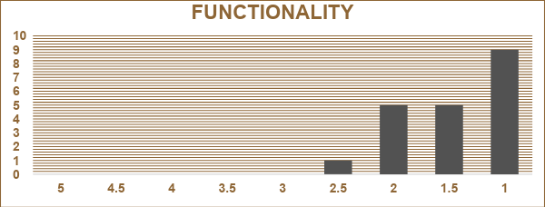

*Figure 4.5.2 The functionality evaluation summary chart*

The functionality in Figure 4.5.2 received an outstanding mean score of 4.55, indicating that it could operate smoothly and efficiently with few or no problems after use.

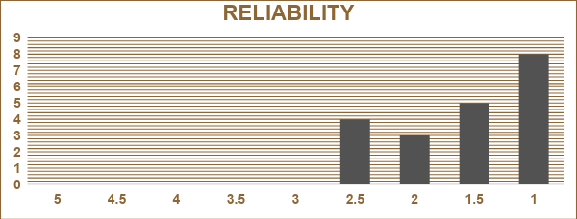

*Figure 4.5.3 The reliability evaluation summary chart*

The robot's reliability in Figure 4.5.3 is above satisfactory, with a mean score of 4.42. This means that it is reliable and performed well with minimal or no issues during operation.

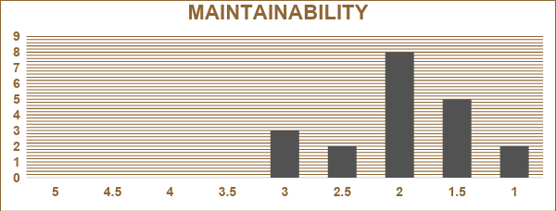

*Figure 4.5.4 The maintainability evaluation summary chart*

The robot's maintainability received a mean score of 4.1, which is above satisfactory. This means that the robot requires only minimal maintenance after its operation.

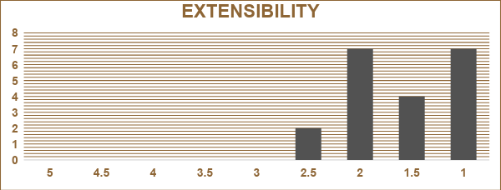  
*Figure 4.5.5 The extensibility evaluation summary chart*

The robot's extensibility got a mean score of 4.4 making it adaptable, user friendly, and future-proof.

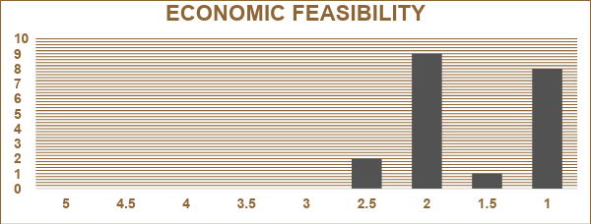

*Figure 4.5.6 The economic feasibility evaluation summary chart*

The robot's economic feasibility is above satisfactory, with a mean score of 4.37. This means that it is likely to be cost-effective in the long term and offer a reasonable price.

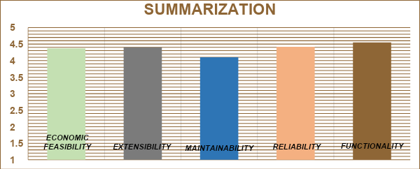

*Figure 4.5.7 Summarization chart*

Figures 4.5.7 illustrate the functionality, reliability, maintainability, extensibility, and economic feasibility of the system. The evaluation sheet shows that the evaluators are highly satisfied. Technology specialists, security personnel, office workers, and homeowners were amazed by the system's ability to help users respond immediately to ever-changing threats in their homes or office premises, rather than relying on traditional surveillance systems.

**CHAPTER V**

**Summary of Findings, Conclusions and Recommendations**

***5.1 Summary of Findings***

This project delves into the design, development, and evaluation of an IoT-powered smart surveillance robot with a diverse array of capabilities. The integration of machine learning algorithms, real-time data analysis, and mobile app functionalities forms the bedrock of this innovative idea, culminating in a pioneering security solution.

The project encapsulates creating a multifunctional security robot equipped with advanced features such as threat detection, real-time alerts with event logging and location data, remote monitoring and control through a user-friendly Android app, and night vision capabilities for improved performance in low-light conditions. This convergence of technologies underscores the project's ambition to bolster security measures and enhance surveillance capabilities. On the other hand, it also has specific boundaries and constraints, such as hardware limitations, limited threat classification, network connectivity considerations, integration challenges, and controlled environmental assumptions. While these constraints help maintain a targeted focus, they also acknowledge the potential impact of external factors on the system's performance.

The project's crowning achievement lies in the strategic integration of OpenCV's Haar Cascade classifier—an advanced AI methodology that empowers the robot's sophisticated threat detection capabilities. This seamless integration results in an exceedingly efficient system, exemplifying the substantial potential of IoT-driven monitoring and elevating the realm of advanced threat detection. Through the project's sequential phases—design, fabrication, and evaluation—a functional IoT-powered smart security robot comes to fruition. Conceptualizing architecture and functionalities, assemblage of hardware components such as Raspberry Pi, Cameras, Chassis components and software modules. It also runs through exhaustive testing, algorithm refinement, and the assimilation of real-world user insights synergistically enhance usability and performance.

The results gathered by the researchers, the functionality of the IOT powered smart security robot has recorded an average of 4.55 out of 5 and people were overwhelmed and awed that this system can help them to immediately respond to threats. For economic feasibility, the researchers computed a total amount of PHP23,585 for bill of materials, which is quite expensive for a middle class.

Notably, the researchers have successfully actualized the proposed setup outlined in the research. The IoT-powered smart security robot harmoniously integrates machine learning, sensors, cameras, mobile app interfaces, and IoT infrastructure, coalescing into a holistic security solution. Ultimately, the project's trajectory aligns with its core mission—advancing security measures and heightening surveillance capabilities through an intricately woven technological marvel.

***5.2 Conclusions***

After conducting some research and evaluation of the system, the researchers found out that the system is above satisfactory. The functionality got an outstanding mean score of 4.55, that means the system requires only minimal maintenance after its operation, carefully placed and it is durable in construction. The reliability of the device is above satisfactory and has a mean score of 4.42 that means the system can be used in any time, place with minimal or without consequences in its functionality and performs with minimal without errors during its operation. The maintainability of the system got a mean score of 4.1 and it is above satisfactory that means the system requires only minimal maintenance after its operation, carefully placed and it is built to last in construction. The mean score of the device is 4.4 for the extensibility that means it can support adaptability, cope with the varying needs of the end-users and can still be integrated with other electronic devices in the future. The mean score is above satisfactory for the economic feasibility for getting 4.37 that means it offers long-term usage and worth it for its performance. Overall, the researchers concluded that the system is functional, reliable, maintainable, extensible, and feasible to the future users of the system.

***5.3 Recommendations***

Based on the evaluation and conclusions, the following are recommended:

1. Continuous Hardware Improvement: Consider investing in upgraded hardware components to enhance the robot's performance, such as more advanced cameras, better sensors, and improved mobility mechanisms. This will contribute to better threat detection accuracy and overall surveillance capabilities.

2. Enhanced Machine Learning and AI Algorithms: Explore the integration of more sophisticated AI algorithms for threat detection, such as deep learning models, which can potentially improve the accuracy, diversity and versatility of the robot's threat identification capabilities.

3. Enhanced User Interface: Further refine the mobile application's user interface and user experience to make it even more intuitive and user-friendly. Incorporate user feedback to ensure that remote monitoring and control are seamless and efficient.

4. Multi-Robot Collaboration: Investigate the feasibility of enabling multiple robots to collaborate and share information in real-time. This could enhance coverage and response capabilities in larger areas, contributing to a more comprehensive security system.

5. Cloud Integration: Consider integrating cloud services to store and process collected data, enabling more advanced analytics and insights. Cloud integration can also facilitate remote access and updates to the robot's software.

6. Autonomous Navigation: Explore the development of advanced navigation capabilities, such as obstacle avoidance and path planning algorithms, to enhance the robot's autonomy and reduce the need for constant manual control.

7. Energy Efficiency: Focus on optimizing the robot's energy consumption to extend its operational duration between recharges or power sources. Energy-efficient components and power management techniques can help increase the robot's autonomy.

***References***

[1] “S. Akter, R. A. Sima, M. S. Ullah and S. A. Hossain, 2018 7th International Conference on Reliability, Infocom Technologies and Optimization (Trends and Future Directions) (ICRITO), 2018, pp. 659-663"

(<https://ieeexplore.ieee.org/document/8748703>)

[2] “Bhateja, V., Nguyen, B., Nguyen, N., Satapathy, S., Le, DN. (eds) Information Systems Design and Intelligent Applications. Advances in Intelligent Systems and Computing, vol 672. Springer, Singapore.”

[(https://doi.org/10.1007/978-981-10-7512-4_23)](https://link.springer.com/chapter/10.1007/978-981-10-7512-4_23)

[3] “S. Meghana, T. V. Nikhil, R. Murali, S. Sanjana, R. Vidhya and K. J. Mohammed," 2017 2nd IEEE International Conference on Recent Trends in Electronics, Information & Communication Technology (RTEICT), 2017, pp. 1679-1682.”

[(https://ieeexplore.ieee.org/abstract/document/8256885)](https://ieeexplore.ieee.org/abstract/document/8256885)

[4] “M. Kumari, A. Kumar and R. Singhal 2020 International Conference on Power Electronics & IoT Applications in Renewable Energy and its Control (PARC), 2020, pp. 549-552.”

[(https://doi: 10.1109/PARC49193.2020.236673.)](https://ieeexplore.ieee.org/document/9087236)

[5] “W. F. Abaya, J. Basa, M. Sy, A. C. Abad and E. P. Dadios , 2014 International Conference on Humanoid, Nanotechnology, Information Technology, Communication and Control, Environment and Management (HNICEM), 2014, pp. 1-6.”

[(https://doi: 10.1109/HNICEM.2014.7016253.)](https://ieeexplore.ieee.org/document/7016253)

[6] “Salman, H., Acheampong, S., Xu, H. (2019). Web-Based Wireless Controlled Robot for Night Vision Surveillance Using Shell Script with Raspberry Pi. In: Barolli, L., Javaid, N., Ikeda, M., Takizawa, M. (eds) Complex, Intelligent, and Software Intensive Systems. CISIS 2018. Advances in Intelligent Systems and Computing, vol 772. Springer, Cham.”

([https://doi.org/10.1007/978-3-319-93659-8_49)](https://link.springer.com/chapter/10.1007/978-3-319-93659-8_49)

[7] “Sanam Narejo, Bishwajeet Pandey, Doris Esenarro vargas, Ciro Rodriguez, M. Rizwan Anjum, Mathematical Problems in Engineering, vol. 2021, Article ID 9975700, 9 pages, 2021.”

([https://doi.org/10.1155/2021/9975700](https://www.hindawi.com/journals/mpe/2021/9975700/))

[8] “P. A. Dhulekar, S. T. Gandhe, N. Sawale, V. Shinde and S. Khute, 2018 International Conference on Advances in Communication and Computing Technology (ICACCT), 2018, pp. 357-360"

([doi: 10.1109/ICACCT.2018.8529632.)](https://ieeexplore.ieee.org/document/8529632)

[9] “K. Janani, S. Gobhinath, K. V. Santhosh Kumar, S. Roshni and A. Rajesh, "Vision Based Surveillance Robot for Military Applications," 2022 8th International Conference on Advanced Computing and Communication Systems (ICACCS), Coimbatore, India, 2022, pp. 462-466,”

(doi: 10.1109/ICACCS54159.2022.9785152.)

[10] “K. -R. Kim, S. -H. Jeong, W. -Y. Kim, Y. Jeon, K. -S. Kim and J. -H. Hong, 2017 14th International Conference on Ubiquitous Robots and Ambient Intelligence (URAI), 2017, pp. 913-915"

(<https://ieeexplore.ieee.org/document/7992864/)>

[11] “Sung Wook Moon, Young Jin Kim, Ho Jun Myeong, Chang Soo Kim, Nam Ju Cha and Dong Hwan Kim, 2011 8th International Conference on Ubiquitous Robots and Ambient Intelligence (URAI), 2011, pp. 211-214"

[(doi: 10.1109/URAI.2011.6145963.)](https://ieeexplore.ieee.org/document/6145963?arnumber=6145963)

[12] “C. Liu, Y. Tao, J. Liang, K. Li and Y. Chen, 2018 IEEE 4th Information Technology and Mechatronics Engineering Conference (ITOEC), 2018, pp. 799-803"

[(doi: 10.1109/ITOEC.2018.8740604.)](https://ieeexplore.ieee.org/document/8740604)

[13] “A. Claudi, F. Di Benedetto, G. Dolcini, L. Palazzo and A. F. Dragoni, " Mobile Autonomous Robot for Surveillance Networks," *2012 Sixth UKSim/AMSS European Symposium on Computer Modeling and Simulation*, Malta, Malta, 2012”

([doi: 10.1109/EMS.2012.37.](https://ieeexplore.ieee.org/document/6410123))

[14] “A. J. Naga Bhavani, G. Bhanu Sree, A. Yasaswini, B. Brahmam, P. K and A. D. Kumar, "A Novel Real-time Automated Face Classification and Detection system using Machine Learning Technique," *2023 Second International Conference on Electronics and Renewable Systems (ICEARS)*, Tuticorin, India, 2023, pp. 1119-1122"

([doi: 10.1109/ICEARS56392.2023.10085500.](https://ieeexplore.ieee.org/document/10085500))

[15] “F. Can and C. Eyüpoğlu, "Convolutional Neural Network Architectures Used in Computer Vision," *2021 5th International Symposium on Multidisciplinary Studies and Innovative Technologies (ISMSIT)*, Ankara, Turkey, 2021. pp. 305-311,”

(doi: 10.1109/ISMSIT52890.2021.9604557.)

[16] “E. Nishani and B. Çiço, "Computer vision approaches based on deep learning and neural networks: Deep neural networks for video analysis of human pose estimation," *2017 6th Mediterranean Conference on Embedded Computing (MECO)*, Bar, Montenegro, 2017, pp. 1-4"

([doi: 10.1109/MECO.2017.7977207.](https://ieeexplore.ieee.org/document/7977207))

[17] “D. Barik and M. Mondal, "Object identification for computer vision using image segmentation," 2010 2nd International Conference on Education Technology and Computer, Shanghai, China, 2010, pp. V2-170-V2-172,”

([doi: 10.1109/ICETC.2010.5529412.](https://ieeexplore.ieee.org/document/5529412))

[18] “[P. Pati](https://www.spiedigitallibrary.org/profile/Prasanta.Pati-117774) and P. Mather "Open-area concealed-weapon detection system", Proc. SPIE 8017, Detection and Sensing of Mines, Explosive Objects, and Obscured Targets XVI, 801702 (23 May 2011)”

(<https://doi.org/10.1117/12.883879)>

[19] “A. Singh, T. Anand, S. Sharma and P. Singh, "IoT Based Weapons Detection System for Surveillance and Security Using YOLOV4," *2021 6th International Conference on Communication and Electronics Systems (ICCES)*, Coimbatre, India, 2021, pp. 488-493.”

([doi: 10.1109/ICCES51350.2021.9489224.](https://ieeexplore.ieee.org/document/9489224))

[20] “H. Jain, A. Vikram, Mohana, A. Kashyap and A. Jain, "Weapon Detection using Artificial Intelligence and Deep Learning for Security Applications," *2020 International Conference on Electronics and Sustainable Communication Systems (ICESC)*, Coimbatore, India, 2020, pp. 193-198"

([doi: 10.1109/ICESC48915.2020.9155832.](https://ieeexplore.ieee.org/document/9155832))

**APPENDICES**

**APPENDIX A**

Flowchart of the System

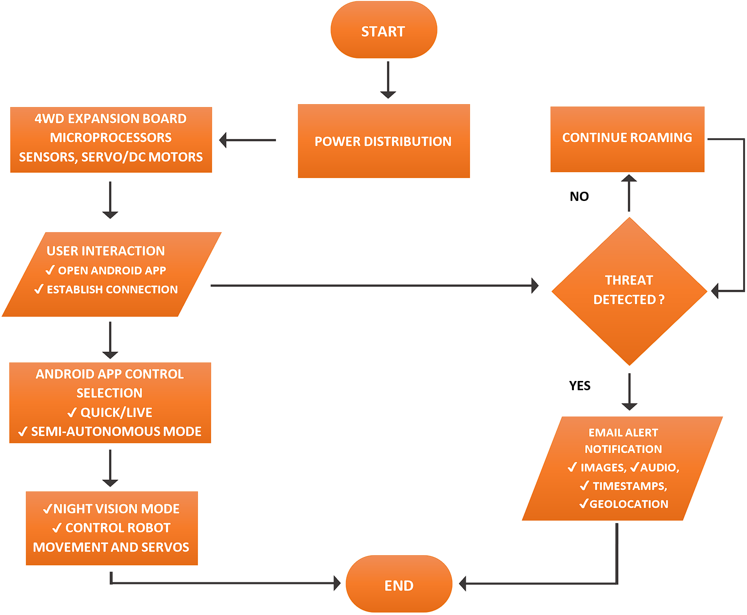

**APPENDIX B**

Program Codes

**Threat Detection and Real-Time Alerts**

*detectionmain.py*

1. **import** pickle
2. **from** email.mime.multipart **import** MIMEMultipart
3. **from** email.mime.text **import** MIMEText
4. **from** email.mime.image **import** MIMEImage
5. **from email.mime.audio import MIMEAudio**
6. **import** datetime
7. **import** pygame
8. **import** os
9. **import** smtplib
10. **import sounddevice as sd**
11. **import** soundfile **as** sf
12. **import** time
13. **import** threading
14. **import** cv2
15. **import numpy as np**
16. **import** imutils
17. **import** socket
18. **import** geocoder

21. FROM_EMAIL = 'f6866666@gmail.com'
22. FROM_PASSWORD = 'tmuzflheoopzrgcd'
23. TO_EMAIL = 'alexis01valentino@gmail.com'

26. face_cascade = cv2.CascadeClassifier('haarcascade_frontalface_default.xml')
27. gun_cascade = cv2.CascadeClassifier('cascade.xml')
28. camera = cv2.VideoCapture(0)

31. firstFrame = None
32. gun_exist = False
33. alarm_active = False
34. unknown_face_detected = False
35. **unknown_face_image = None**

38. pygame.init()
39. alarm_sound = pygame.mixer.Sound('alarm.wav')

42. gun_detection_counter = 0
43. loud_sound_counter = 0

46. device_info = sd.query_devices(device=2)
47. samplerate = device_info['default_samplerate']
48. duration = 3 *# seconds*
49. device = sd.default.device

52. frame = None
53. known_face_encodings = []
54. known_face_names = []
55. **unknown_face_detected = False**
56. unknown_face_image = None
57. alarm_triggered = False


61. *# Gun detection*
62. **def** gun_detection_thread():
63. **global** gun_exist
64. **global** frame
65. **global gun_detection_counter**
66. gun_alarm_time = None
67. **while** True:
68. **if** frame **is** **not** None:
69. *# Resize the frame and convert it to grayscale*
70. **resized_frame = cv2.resize(frame, (500, 500))**
71. gray = cv2.cvtColor(resized_frame, cv2.COLOR_BGR2GRAY)

74. *# Detect guns in the frame using the cascade classifier*
75. **guns = gun_cascade.detectMultiScale(gray, 1.3, 5, minSize=(100, 100))**

78. *# Set the gun_exist flag if guns are detected*
79. **if** len(guns) > 0:
80. **gun_exist = True**
81. gun_detection_counter += 1
82. **if** gun_alarm_time **is** None **or** time.time() - gun_alarm_time >= 3:
83. *# Alarm if gun detected for the first time or after 3 seconds*
84. **print**("Gun detected!")
85. **for i in range(5):**
86. *# Continuously alarm for at least 5 seconds*
87. **print**("ALARM!")
88. time.sleep(1)
89. gun_alarm_time = time.time()
90. **else:**
91. gun_exist = False
92. gun_detection_counter = 0
93. gun_alarm_time = None

96. *# Draw a blue rectangle around each detected gun*
97. **for** (x, y, w, h) **in** guns:
98. frame = cv2.rectangle(frame, (x, y), (x + w, y + h), (255, 0, 0), 2)
99. roi_gray = gray[y:y + h, x:x + w]
100. **roi_color = frame[y:y + h, x:x + w]**

103. time.sleep(0.1)
105. ***# Sound detection***
106. **def** calculate_rms(samples):
107. **return** np.sqrt(np.mean(np.nan_to_num(samples)**2))

110. **def loud_sound_detection_thread():**
111. **global** loud_sound_detected
112. **global** loud_sound_counter
113. **global** alarm_sound
114. **global** alarm_active
115. **rms_threshold = 0.4 *# Set the threshold for RMS***

118. **while** True:
119. samples = sd.rec(int(duration * samplerate), device=device, channels=1)
120. **sd.wait()**
121. rms_value = calculate_rms(samples)

124. *# Check if sound is loud enough and not the alarm sound*
125. **if rms_value > rms_threshold and not alarm_active:**
126. **print**("loud sound detected")
127. loud_sound_counter += 1
128. **else**:
129. loud_sound_counter = 0

132. time.sleep(0.1)

135. ***#Face recognition***
136. **def** face_recognition_thread():
137. **global** frame
138. **global** known_face_encodings
139. **global** known_face_names
140. **global unknown_face_detected**
141. **global** unknown_face_image
142. **global** alarm_triggered

145. ***# Set the threshold for face recognition***
146. face_recognition_threshold = 0.1

149. *# Store the last recognized face distance and name*
150. **last_face_distance = None**
151. last_face_name = None

154. *# Set alarm_triggered flag to False initially*
155. **alarm_triggered = False**

158. **while** True:
159. **if** frame **is** **not** None:
160. **small_frame = cv2.resize(frame, (0, 0), fx=0.1, fy=0.1)**
161. rgb_small_frame = cv2.cvtColor(small_frame, cv2.COLOR_BGR2RGB)
162. face_locations = face_recognition.face_locations(rgb_small_frame)
163. face_encodings = face_recognition.face_encodings(rgb_small_frame, face_locations)

166. **if** len(face_encodings) > 0:
167. *# Track faces using face_distance() function*
168. face_distances = []
169. **for** face_encoding **in** face_encodings:
170. **face_distances.append(face_recognition.face_distance(known_face_encodings, face_encoding))**

173. *# Find the closest match for each face*
174. best_match_names = []
175. **for distances in face_distances:**
176. **if** len(distances) > 0: *# Check if the distances list is not empty*
177. best_match_index = np.argmin(distances)
178. **if** distances[best_match_index] < face_recognition_threshold:
179. best_match_names.append(known_face_names[best_match_index])
180. **else:**
181. best_match_names.append("Unknown")
182. **else**:
183. best_match_names.append("Unknown")
185. ***# Update the last recognized face distance and name***
186. **if** last_face_distance **is** None:
187. last_face_distance = face_distances[0]
188. last_face_name = best_match_names[0]
189. **else**:
190. **for i in range(len(face_distances)):**
191. **if** face_distances[i][0] < last_face_distance[0]:
192. last_face_distance = face_distances[i]
193. last_face_name = best_match_names[i]

196. *# Draw a rectangle and label for each detected face*
197. **for** (top, right, bottom, left), name **in** zip(face_locations, best_match_names):
198. top *= 4
199. right *= 4
200. **bottom *= 4**
201. left *= 4

204. *# Draw a rectangle around the face*
205. **cv2.rectangle(frame, (left, top), (right, bottom), (0, 255, 0), 2)**

208. *# Draw a label with the name below the face*
209. cv2.rectangle(frame, (left, bottom - 35), (right, bottom), (0, 255, 0), cv2.FILLED)
210. **font = cv2.FONT_HERSHEY_DUPLEX**
211. cv2.putText(frame, name, (left + 6, bottom - 6), font, 1.0, (255, 255, 255), 1)
213. *# Set off the alarm if an unknown face is detected*
214. **if** "Unknown" **in** best_match_names:
215. **if not alarm_triggered: *# Check if the alarm has not been triggered before***
216. **print**('unknown face detected')
217. unknown_face_detected = True
218. unknown_face_image = frame.copy()
219. *# Set off the alarm*
220. **alarm_thread()**
221. alarm_triggered = True *# Set the alarm triggered flag to True*
222. **else**:
223. **print**('known face detected')
224. unknown_face_detected = False
225. **alarm_triggered = False *# Reset the alarm triggered flag***
226. **else**:
227. **print**('no threat detected')
229. time.sleep(0.1)
231. *# Alarm*
232. **def** alarm_thread():
233. **global** alarm_active
234. **global** unknown_face_detected

237. sound_duration = 2 *# Assuming the sound file has a 2-second duration*
238. loop_count = int(5 / sound_duration) - 1 *# Calculate the loop count for a 5-second alarm*

241. **while** True:
242. **if** unknown_face_detected **and** **not** alarm_active:
243. alarm_sound.play(loop_count)
244. alarm_active = True
245. **time.sleep(5)**
246. alarm_sound.stop()
247. alarm_active = False
248. unknown_face_detected = False
249. time.sleep(0.1)

252. **def** email_sending_thread():
253. **global** gun_detection_counter
254. **global** loud_sound_counter
255. **global unknown_face_detected**
256. **global** unknown_face_image

259. **while** True:
260. **if gun_detection_counter == 1 or loud_sound_counter == 1 or unknown_face_detected:**
261. *# Record audio*
262. samples = sd.rec(int(duration * samplerate), device=device, channels=1)
263. sd.wait()

266. screenshot = "screenshot.jpg"
267. cv2.imwrite(screenshot, frame)
268. filename = "recording.wav"
269. sf.write(filename, samples, int(samplerate))
270. **msg = MIMEMultipart()**
271. msg['From'] = FROM_EMAIL
272. msg['To'] = TO_EMAIL
273. msg['Subject'] = 'Threat Detected'

276. *# Get the device's public IP address using the socket library*
277. public_ip = socket.gethostbyname(socket.gethostname())

280. **try:**
281. *# Use geocoder to get latitude and longitude of the IP address*
282. g = geocoder.ip(public_ip)
283. latitude = g.latlng[0]
284. longitude = g.latlng[1]

287. *# Construct a Google Maps link with the obtained coordinates*
288. google_maps_link = f"https://www.google.com/maps/place/{latitude},{longitude}"
289. location_info = f"Location: {google_maps_link}" *# Use the Google Maps link as location*
290. **except Exception as e:**
291. location_info = "Location: Unavailable"

294. text = MIMEText(
295. **"Threat detected at " + datetime.datetime.now().strftime("%A %d %B %Y %I:%M:%S %p") + "\n" + location_info)**
296. msg.attach(text)

299. *# Attach the screenshot*
300. **with open(screenshot, 'rb') as f:**
301. img = MIMEImage(f.read())
302. img.add_header('Content-Disposition', 'attachment', filename="screenshot.jpg")
303. msg.attach(img)

306. *# Attach the audio recording*
307. **with** open(filename, 'rb') **as** f:
308. audio = MIMEAudio(f.read())
309. audio.add_header('Content-Disposition', 'attachment', filename="recording.wav")
310. **msg.attach(audio)**

313. *# Attach unknown face screenshot if applicable*
314. **if** unknown_face_detected:
315. **unknown_screenshot = "unknown_screenshot.jpg"**
316. cv2.imwrite(unknown_screenshot, unknown_face_image)
317. **with** open(unknown_screenshot, 'rb') **as** f:
318. img_unknown = MIMEImage(f.read())
319. img_unknown.add_header('Content-Disposition', 'attachment', filename="unknown_screenshot.jpg")
320. **msg.attach(img_unknown)**

323. **try**:
324. server = smtplib.SMTP('smtp.gmail.com', 587)
325. **server.starttls()**
326. server.login(FROM_EMAIL, FROM_PASSWORD)
327. server.sendmail(FROM_EMAIL, TO_EMAIL, msg.as_string())
328. server.quit()
329. **print**("Email sent successfully")
330. **except Exception as e:**
331. **print**("Error sending email:", str(e))

334. time.sleep(0.1)


338. **def** detect_faces_opencv(camera):
339. **global** frame
340. **while True:**
341. ret, frame = camera.read()
342. **if** **not** ret:
343. **print**("Error: Failed to read camera frame")
344. **break**
345. **gray = cv2.cvtColor(frame, cv2.COLOR_BGR2GRAY)**
346. faces = face_cascade.detectMultiScale(gray, scaleFactor=1.1, minNeighbors=5, minSize=(30, 30))
348. **if** len(faces) == 0:
349. **print**("No faces detected")
350. **continue**
352. *# Draw a rectangle around each detected face*
353. **for** (x, y, w, h) **in** faces:
354. cv2.rectangle(frame, (x, y), (x + w, y + h), (0, 255, 0), 2)


358. *# Create threads and start them*
359. t1 = threading.Thread(target=gun_detection_thread)
360. **t2 = threading.Thread(target=loud_sound_detection_thread)**
361. t3 = threading.Thread(target=email_sending_thread)
362. t4 = threading.Thread(target=face_recognition_thread)
363. t5 = threading.Thread(target=alarm_thread)
364. t6 = threading.Thread(target=detect_faces_opencv, args=(camera,))


368. t1.start()
369. t2.start()
370. **t3.start()**
371. t4.start()
372. t5.start()
373. t6.start()



378. **while** True:
379. ret, frame = camera.read()

382. **if** **not** ret: *# Check if the camera frame is valid*
383. **print**("Error: Failed to read camera frame")
384. **break**
386. frame = imutils.resize(frame, width=500)

389. **if** firstFrame **is** None:
390. **firstFrame = frame.copy()**
391. **continue**

394. cv2.putText(frame, datetime.datetime.now().strftime("%A %d %B %Y %I:%M:%S %p"), (10, frame.shape[0] - 10), cv2.FONT_HERSHEY_SIMPLEX, 0.35, (0, 0, 255), 1)

397. cv2.imshow("Security Feed", frame)
398. key = cv2.waitKey(1) & 0xFF

401. **if** key == ord('q'):
402. **break**

405. **if gun_detection_counter > 0 or loud_sound_counter > 0:**
406. **if** **not** alarm_active:
407. alarm_sound.play(-1)
408. alarm_active = True
409. **elif** alarm_active:
410. **alarm_sound.stop()**
411. alarm_active = False

414. **if** key == ord('s'):
415. **if alarm_active:**
416. alarm_sound.stop()
417. alarm_active = False
419. *# Wait for threads to finish before closing*
420. **t1.join()**
421. t2.join()
422. t3.join()
423. t4.join()
424. t5.join()
425. **t6.join()**
427. camera.release()
428. cv2.destroyAllWindows()
429. pygame.quit()

**Android Application Quick and Live Control via Bluetooth and Wifi Hotspot Connections**

**Android Manifest XML Code**

*androidmanifest.xml*

1. **<uses-permission** android:name="android.permission.INTERNET" **/>**
2. **<uses-permission** android:name="android.permission.ACCESS_WIFI_STATE" **/>**
3. **<uses-permission** android:name="android.permission.CHANGE_WIFI_STATE" **/>**
4. **<uses-permission** android:name="android.permission.BLUETOOTH" **/>**
5. **<uses-permission android:name="android.permission.BLUETOOTH_ADMIN" />**
6. **<uses-permission** android:name="android.permission.BLUETOOTH_CONNECT" **/>**

**Wifi Hotspot Auto Connect**

*wifimanager.java*

1. WifiManager wifiManager = (WifiManager) getSystemService(Context.WIFI_SERVICE);
2. wifiManager.setWifiEnabled(**true**); *// Enable Wi-Fi*
4. WifiConfiguration wifiConfig = **new** WifiConfiguration();
5. **wifiConfig.SSID = "Bagsik";**
6. wifiConfig.preSharedKey = "bootlegsystems";
8. **int** netId = wifiManager.addNetwork(wifiConfig);
9. wifiManager.disconnect();
10. **wifiManager.enableNetwork(netId, true);**
11. wifiManager.reconnect();

**Bluetooth Auto Connect**

*btauto.java*

1. BluetoothAdapter bluetoothAdapter = BluetoothAdapter.getDefaultAdapter();
2. BluetoothDevice piBluetoothDevice = bluetoothAdapter.getRemoteDevice("@raspi_getmac:8080");
4. *// Create a BluetoothSocket and connect to the Raspberry Pi*
5. **BluetoothSocket socket = piBluetoothDevice.createRfcommSocketToServiceRecord(UUID.fromString("bagsik_auto"));**
6. socket.connect();

**Android App Quick Control**

*android_main_quickctrl.java*

1. **import** android.bluetooth.BluetoothAdapter;
2. **import** android.bluetooth.BluetoothDevice;
3. **import** android.bluetooth.BluetoothSocket;
4. **import** android.content.Context;
5. **import android.net.wifi.WifiConfiguration;**
6. **import** android.net.wifi.WifiManager;
7. **import** android.os.Bundle;
8. **import** android.view.View;
9. **import** android.widget.Button;
10. **import androidx.appcompat.app.AppCompatActivity;**
12. **import** java.io.IOException;
13. **import** java.io.OutputStream;
14. **import** java.util.UUID;
16. **public** **class** RobotControlActivity **extends** AppCompatActivity {
18. **private** **static** **final** String RPI_HOTSPOT_SSID = "Your_RPi_Hotspot_SSID";
19. **private** **static** **final** String RPI_HOTSPOT_PASSWORD = "Your_Password";
20. **private static final String RPI_BLUETOOTH_MAC = "Raspberry_Pi_Bluetooth_MAC_Address";**
21. **private** **static** **final** UUID RPI_BLUETOOTH_UUID = UUID.fromString("Your_UUID");
23. **private** WifiManager wifiManager;
24. **private** BluetoothAdapter bluetoothAdapter;
25. **private BluetoothSocket bluetoothSocket;**
26. **private** OutputStream outputStream;
28. @Override
29. **protected** **void** onCreate(Bundle savedInstanceState) {
30. **super.onCreate(savedInstanceState);**
31. setContentView(R.layout.activity_robot_control);
33. wifiManager = (WifiManager) getSystemService(Context.WIFI_SERVICE);
34. bluetoothAdapter = BluetoothAdapter.getDefaultAdapter();
36. Button connectWifiButton = findViewById(R.id.connectWifiButton);
37. Button connectBluetoothButton = findViewById(R.id.connectBluetoothButton);
38. Button forwardButton = findViewById(R.id.forwardButton);
39. Button backwardButton = findViewById(R.id.backwardButton);
40. **Button leftButton = findViewById(R.id.leftButton);**
41. Button rightButton = findViewById(R.id.rightButton);
42. Button stopButton = findViewById(R.id.stopButton);
44. connectWifiButton.setOnClickListener(**new** View.OnClickListener() {
45. **@Override**
46. **public** **void** onClick(View v) {
47. connectToWifi();
48. }
49. });
51. connectBluetoothButton.setOnClickListener(**new** View.OnClickListener() {
52. @Override
53. **public** **void** onClick(View v) {
54. connectToBluetooth();
55. **}**
56. });
58. forwardButton.setOnClickListener(**new** View.OnClickListener() {
59. @Override
60. **public void onClick(View v) {**
61. sendCommand("FORWARD");
62. }
63. });
65. **backwardButton.setOnClickListener(new View.OnClickListener() {**
66. @Override
67. **public** **void** onClick(View v) {
68. sendCommand("BACKWARD");
69. }
70. **});**
72. leftButton.setOnClickListener(**new** View.OnClickListener() {
73. @Override
74. **public** **void** onClick(View v) {
75. **sendCommand("LEFT");**
76. }
77. });
79. rightButton.setOnClickListener(**new** View.OnClickListener() {
80. **@Override**
81. **public** **void** onClick(View v) {
82. sendCommand("RIGHT");
83. }
84. });
86. stopButton.setOnClickListener(**new** View.OnClickListener() {
87. @Override
88. **public** **void** onClick(View v) {
89. sendCommand("STOP");
90. **}**
91. });
92. }
94. **private** **void** connectToWifi() {
95. **wifiManager.setWifiEnabled(true);**
96. WifiConfiguration wifiConfig = **new** WifiConfiguration();
97. wifiConfig.SSID = RPI_HOTSPOT_SSID;
98. wifiConfig.preSharedKey = RPI_HOTSPOT_PASSWORD;
99. **int** netId = wifiManager.addNetwork(wifiConfig);
100. **wifiManager.disconnect();**
101. wifiManager.enableNetwork(netId, **true**);
102. wifiManager.reconnect();
103. }
105. **private void connectToBluetooth() {**
106. BluetoothDevice piBluetoothDevice = bluetoothAdapter.getRemoteDevice(RPI_BLUETOOTH_MAC);
108. **try** {
109. bluetoothSocket = piBluetoothDevice.createRfcommSocketToServiceRecord(RPI_BLUETOOTH_UUID);
110. **bluetoothSocket.connect();**
111. outputStream = bluetoothSocket.getOutputStream();
112. } **catch** (IOException e) {
113. e.printStackTrace();
114. }
115. **}**
117. **private** **void** sendCommand(String command) {
118. **try** {
119. **if** (outputStream != **null**) {
120. **outputStream.write(command.getBytes());**
121. }
122. } **catch** (IOException e) {
123. e.printStackTrace();
124. }
125. **}**
126. }

**Realtime Video Stream (Android App Live Control)**

**ExoPlayer XML**

*exoplayer.xml*

1. **<uses-permission** android:name="android.permission.INTERNET" **/>**
2. **<uses-feature** android:name="android.hardware.camera" **/>**
3. **<uses-feature** android:name="android.hardware.camera.autofocus" **/>**

**User Interface Layout**

*uilayout.xml*

1. **<?xml** version="1.0" encoding="utf-8"**?>**
2. **<RelativeLayout** xmlns:android="http://schemas.android.com/apk/res/android"
3. xmlns:app="http://schemas.android.com/apk/res-auto"
4. xmlns:tools="http://schemas.android.com/tools"
5. **android:layout_width="match_parent"**
6. android:layout_height="match_parent"
7. android:padding="16dp"
8. tools:context=".VideoStreamingActivity"**>**
10. **<com.google.android.exoplayer2.ui.PlayerView**
11. android:id="@+id/player_view"
12. android:layout_width="match_parent"
13. android:layout_height="match_parent"
14. app:resize_mode="fit"
15. **app:show_buffering="when_playing" />**
17. **</RelativeLayout>**

**Android App Live Control**

*android_main_livectrl.java*

1. **import** android.os.Bundle;
2. **import** android.view.View;
3. **import** androidx.appcompat.app.AppCompatActivity;
4. **import** com.google.android.exoplayer2.DefaultLoadControl;
5. **import com.google.android.exoplayer2.DefaultRenderersFactory;**
6. **import** com.google.android.exoplayer2.ExoPlayer;
7. **import** com.google.android.exoplayer2.SimpleExoPlayer;
8. **import** com.google.android.exoplayer2.extractor.DefaultExtractorsFactory;
9. **import** com.google.android.exoplayer2.source.ExtractorMediaSource;
10. **import com.google.android.exoplayer2.trackselection.DefaultTrackSelector;**
11. **import** com.google.android.exoplayer2.ui.PlayerView;
12. **import** com.google.android.exoplayer2.upstream.DefaultBandwidthMeter;
13. **import** com.google.android.exoplayer2.upstream.DefaultDataSourceFactory;
14. **import** com.google.android.exoplayer2.upstream.DefaultHttpDataSourceFactory;
15. **import com.google.android.exoplayer2.util.Util;**
17. **public** **class** RobotControlActivity **extends** AppCompatActivity {
19. **private** PlayerView playerView;
20. **private ExoPlayer player;**
22. *// Define buttons for controlling the robot*
23. **private** Button forwardButton, backwardButton, leftButton, rightButton, rotateButton;
25. **@Override**
26. **protected** **void** onCreate(Bundle savedInstanceState) {
27. **super**.onCreate(savedInstanceState);
28. setContentView(R.layout.activity_robot_control);
30. **playerView = findViewById(R.id.player_view);**
32. *// Create an ExoPlayer instance (as in the previous example)*
34. *// Set up the video source (as in the previous example)*
36. *// Initialize buttons*
37. forwardButton = findViewById(R.id.forwardButton);
38. backwardButton = findViewById(R.id.backwardButton);
39. leftButton = findViewById(R.id.leftButton);
40. **rightButton = findViewById(R.id.rightButton);**
41. rotateButton = findViewById(R.id.rotateButton);
43. *// Set click listeners for robot control buttons*
44. forwardButton.setOnClickListener(**new** View.OnClickListener() {
45. **@Override**
46. **public** **void** onClick(View v) {
47. sendRobotCommand("FORWARD");
48. }
49. });
51. backwardButton.setOnClickListener(**new** View.OnClickListener() {
52. @Override
53. **public** **void** onClick(View v) {
54. sendRobotCommand("BACKWARD");
55. **}**
56. });
58. leftButton.setOnClickListener(**new** View.OnClickListener() {
59. @Override
60. **public void onClick(View v) {**
61. sendRobotCommand("LEFT");
62. }
63. });
65. **rightButton.setOnClickListener(new View.OnClickListener() {**
66. @Override
67. **public** **void** onClick(View v) {
68. sendRobotCommand("RIGHT");
69. }
70. **});**
72. rotateButton.setOnClickListener(**new** View.OnClickListener() {
73. @Override
74. **public** **void** onClick(View v) {
75. **sendRobotCommand("ROTATE");**
76. }
77. });
78. }
80. **private void sendRobotCommand(String command) {**
81. *// Send the command to the robot over Wi-Fi or Bluetooth (as in the previous example)*
82. }
84. @Override
85. **protected void onDestroy() {**
86. **super**.onDestroy();
87. player.release();
88. }
89. }

**Line Follower Autonomous**

*lfauto.java*

1. **public** **class** RobotControlActivity **extends** AppCompatActivity {
3. **private** RobotController robotController;
5. **@Override**
6. **protected** **void** onCreate(Bundle savedInstanceState) {
7. **super**.onCreate(savedInstanceState);
8. setContentView(R.layout.activity_robot_control);
10. **robotController = new RobotController();**
12. Button forwardButton = findViewById(R.id.forwardButton);
13. Button backwardButton = findViewById(R.id.backwardButton);
14. Button leftButton = findViewById(R.id.leftButton);
15. **Button rightButton = findViewById(R.id.rightButton);**
16. **Switch** modeSwitch = findViewById(R.id.modeSwitch);
18. forwardButton.setOnClickListener(**new** View.OnClickListener() {
19. @Override
20. **public void onClick(View v) {**
21. robotController.moveForward();
22. }
23. });
25. **backwardButton.setOnClickListener(new View.OnClickListener() {**
26. @Override
27. **public** **void** onClick(View v) {
28. robotController.moveBackward();
29. }
30. **});**
32. leftButton.setOnClickListener(**new** View.OnClickListener() {
33. @Override
34. **public** **void** onClick(View v) {
35. **robotController.turnLeft();**
36. }
37. });
39. rightButton.setOnClickListener(**new** View.OnClickListener() {
40. **@Override**
41. **public** **void** onClick(View v) {
42. robotController.turnRight();
43. }
44. });
46. modeSwitch.setOnCheckedChangeListener(**new** CompoundButton.OnCheckedChangeListener() {
47. @Override
48. **public** **void** onCheckedChanged(CompoundButton buttonView, **boolean** isChecked) {
49. **if** (isChecked) {
50. ***// Switch to autonomous mode***
51. robotController.autonomousMode();
52. } **else** {
53. *// Switch to manual mode*
54. robotController.manualMode();
55. **}**
56. }
57. });
58. }
59. }

**APPENDIX C**

Robot Design Schematic

*Robot Functionality*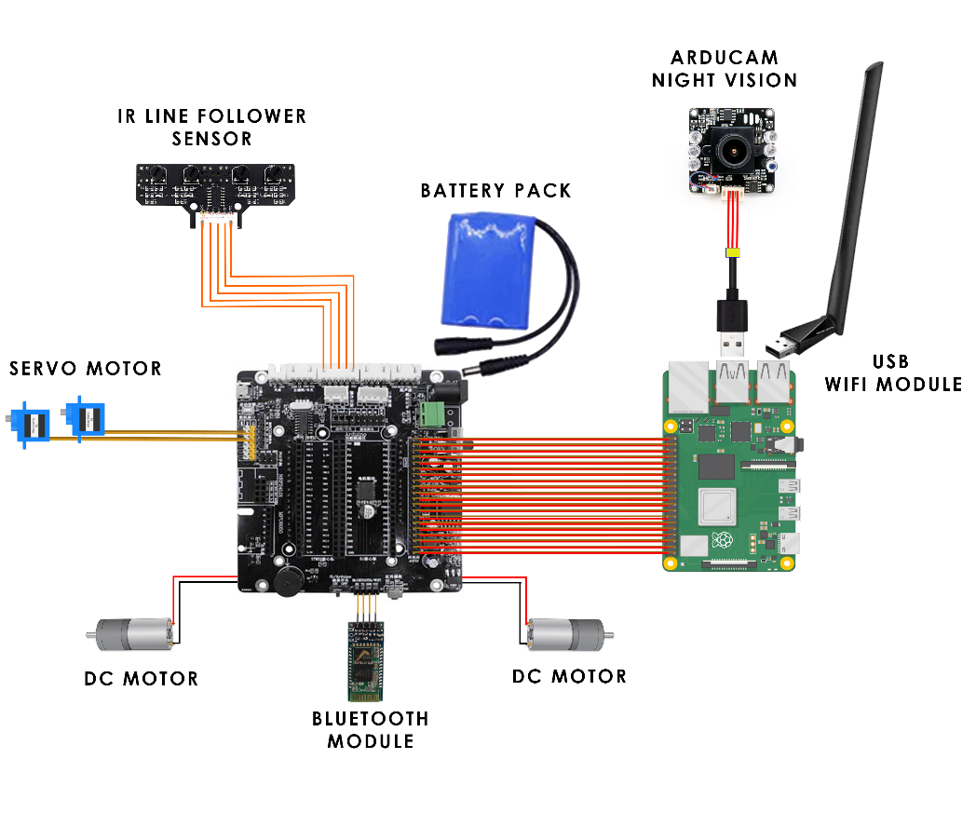

*Threat Detection*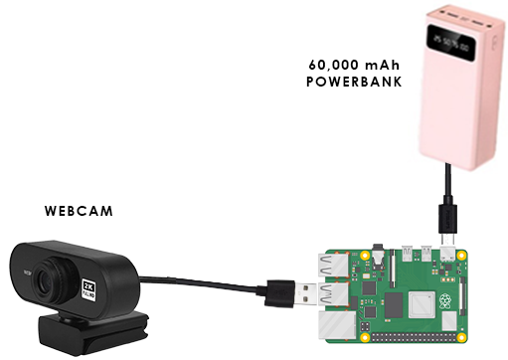

**APPENDIX D**

Evaluation Results



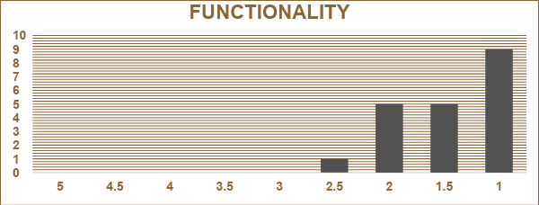

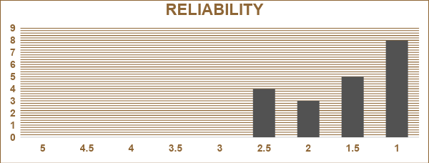

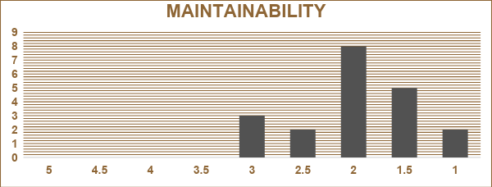

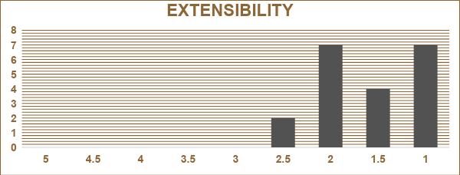

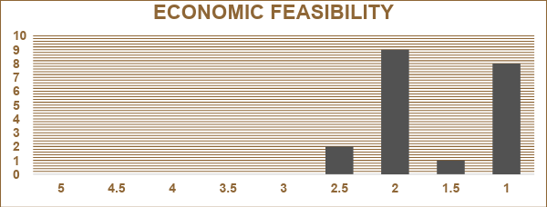

**APPENDIX E**

Bill of Materials

|  |  |  |  |
| --- | --- | --- | --- |
| **Description** | **Unit Price** | **Quantity** | **Total Price** |
| **Raspberry Pi 4B** | **₱5,811.00** | **2** | **₱11,622** |
| **4WD Expansion Board** | **₱1534.58** | **1** | **₱1534.58** |
| **Night Vision Arducam** | **₱1917.68** | **1** | **₱1917.68** |
| **Webcam** | **₱527.00** | **1** | **₱527.00** |
| **Chassis** | **₱3446.00** | **1** | **₱3446.00** |
| **DC Motor** | **₱468.00** | **2** | **₱936.00** |
| **Servo Motor** | **₱439.00** | **1** | **₱439.00** |
| **Bluetooth Module** | **₱276.00** | **1** | **₱276.00** |
| **IR Line Follower** | **₱300.00** | **1** | **₱300.00** |
| **Battery** | **₱157.00** | **1** | **₱157.00** |
| **Micro SD Card** | **₱185.00** | **2** | **₱370.00** |
| **USB External WIFI Module** | **₱578.00** | **1** | **₱578.00** |
| **Power Bank** | **₱1482.00** | **1** | **₱1482.00** |
| Total Cost: | | | **₱23,585.26** |

**APPENDIX F**

Evaluation Sheet



**APPENDIX G**

Sample Answered Evaluation Form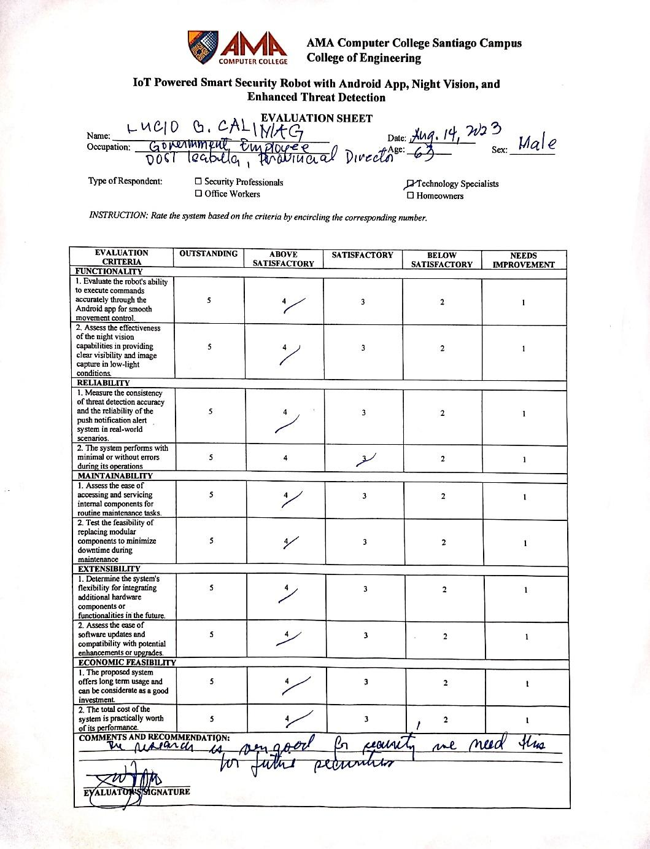

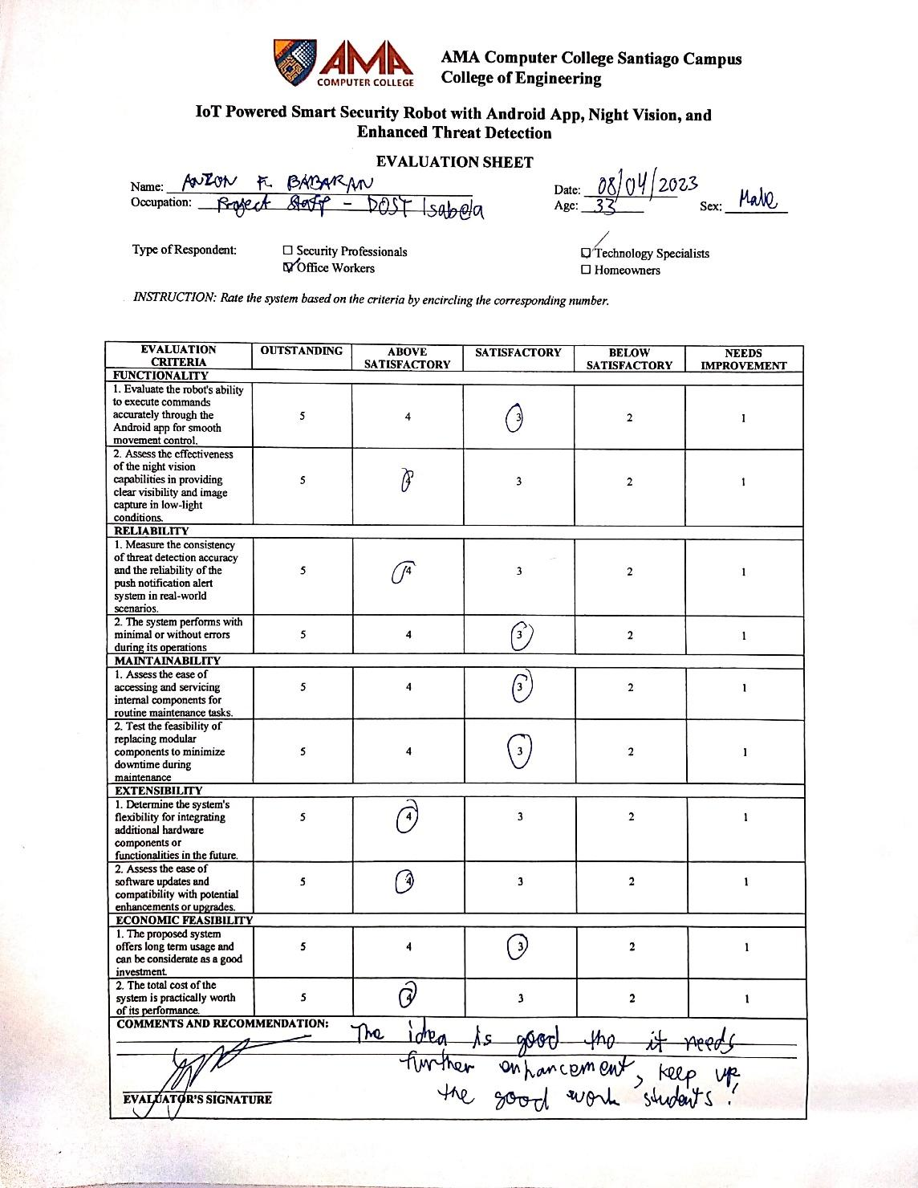

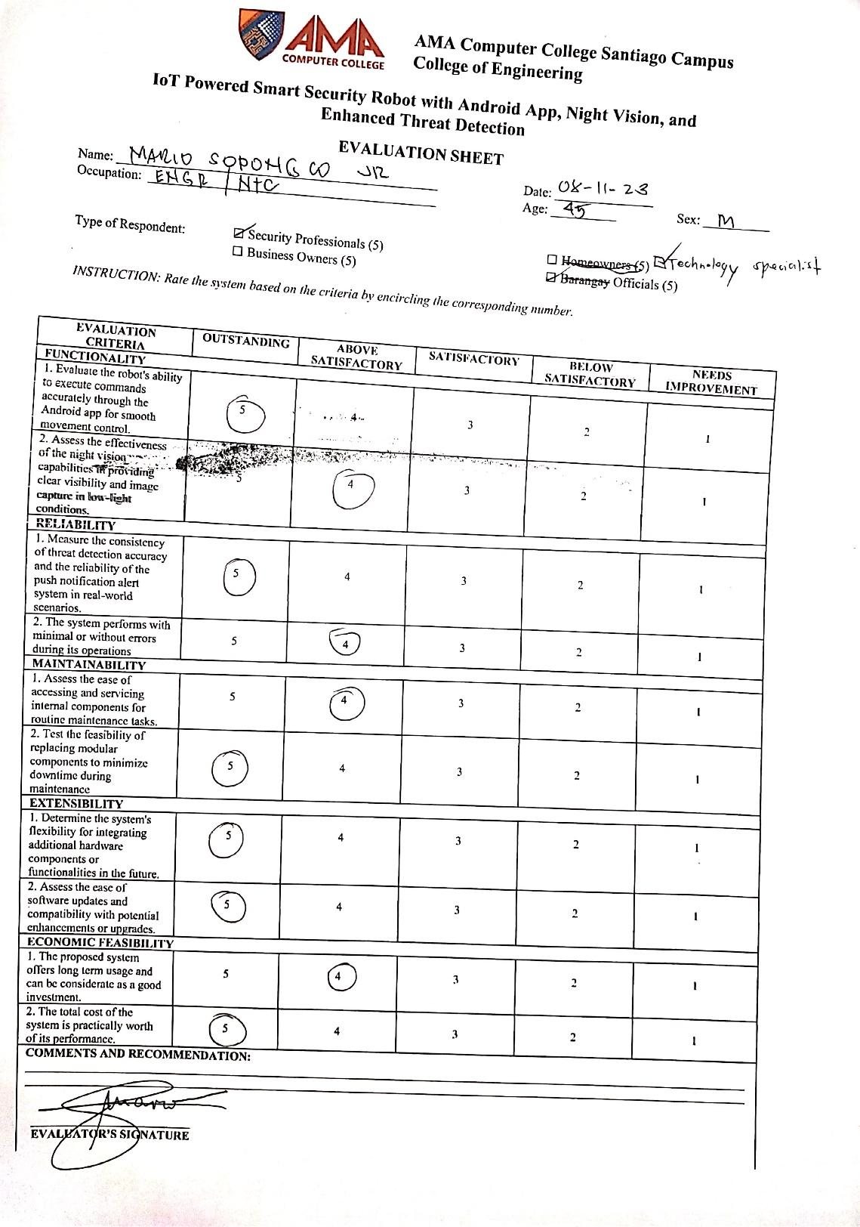

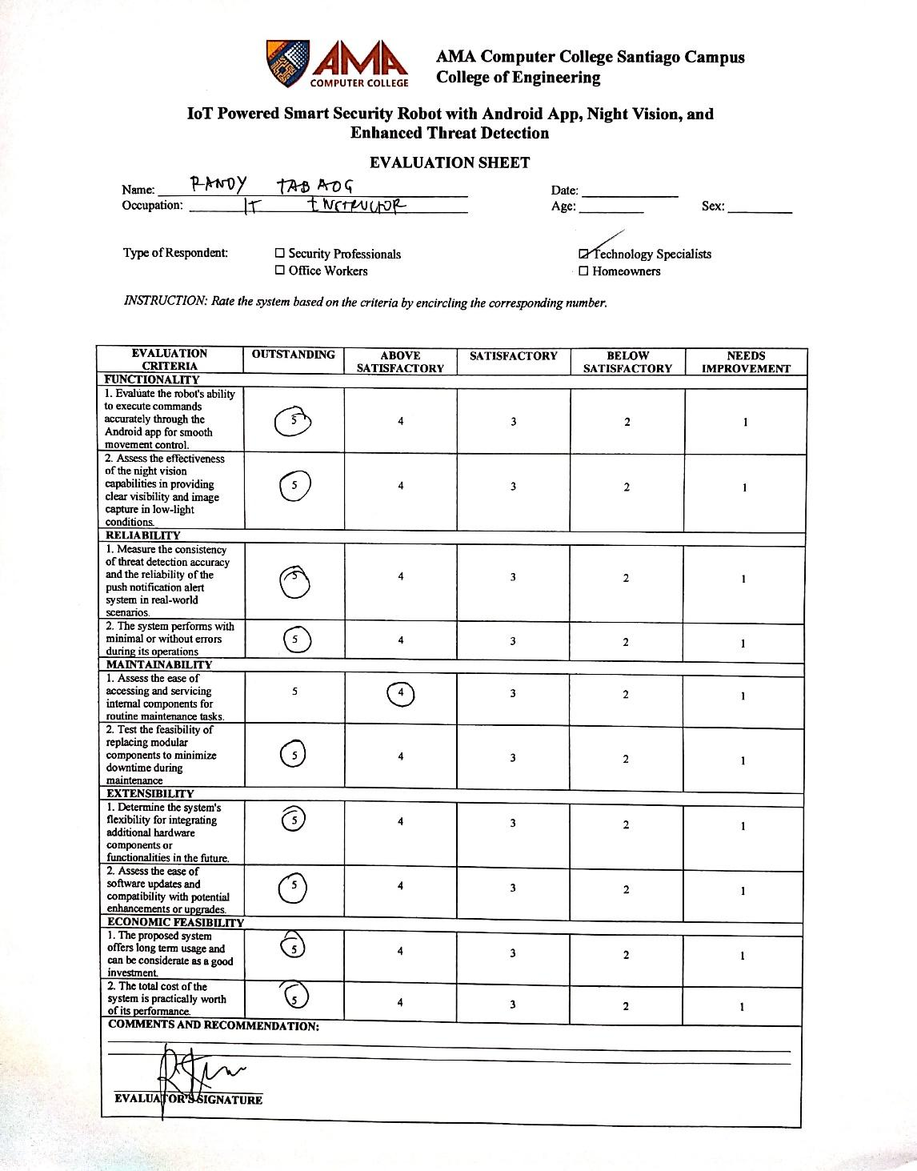

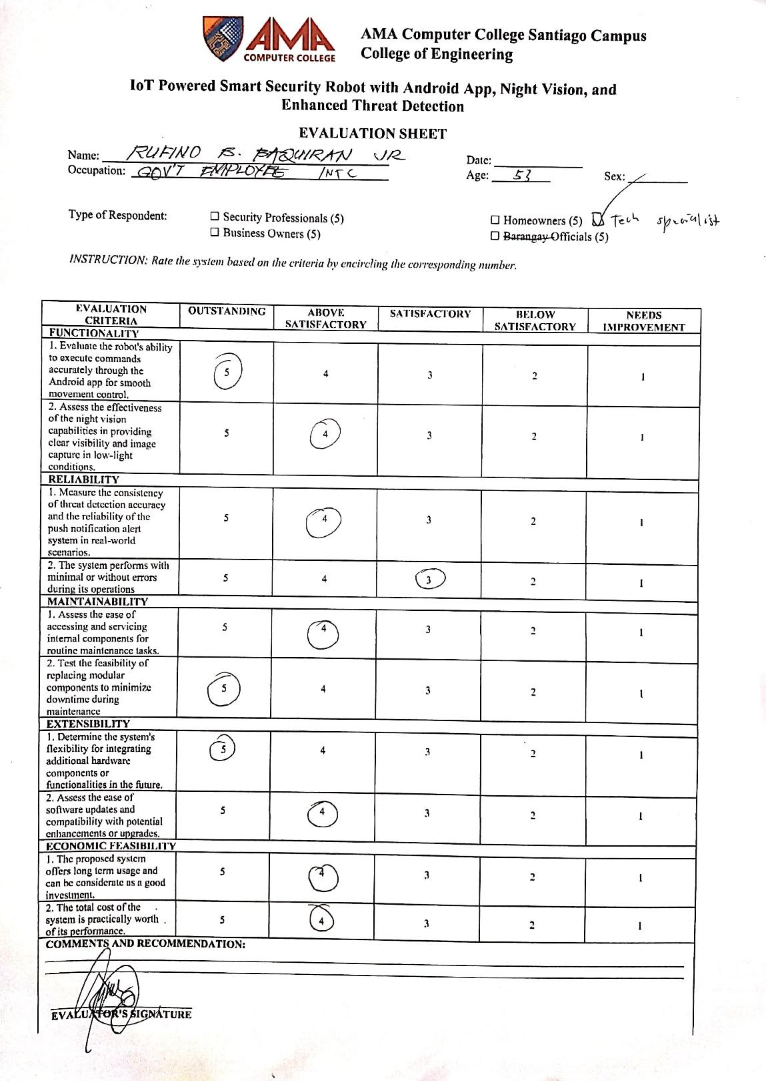

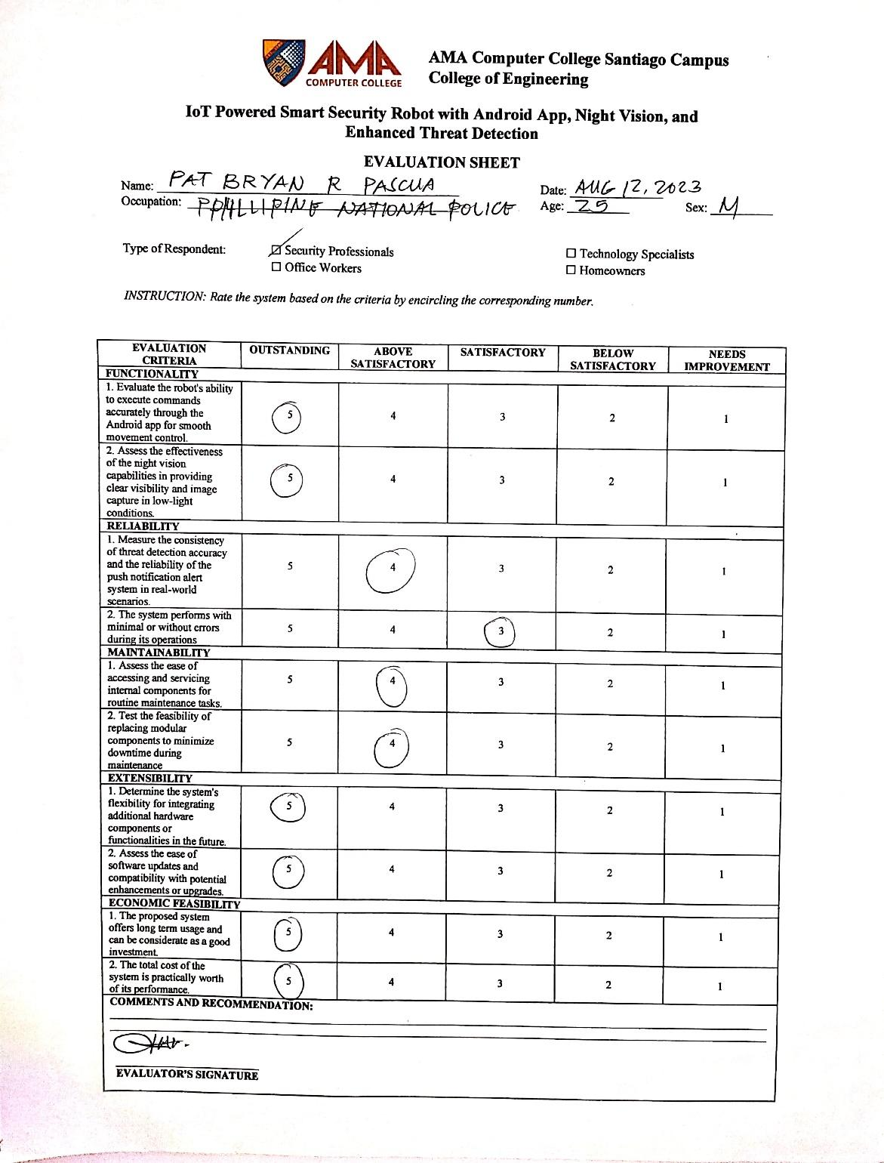

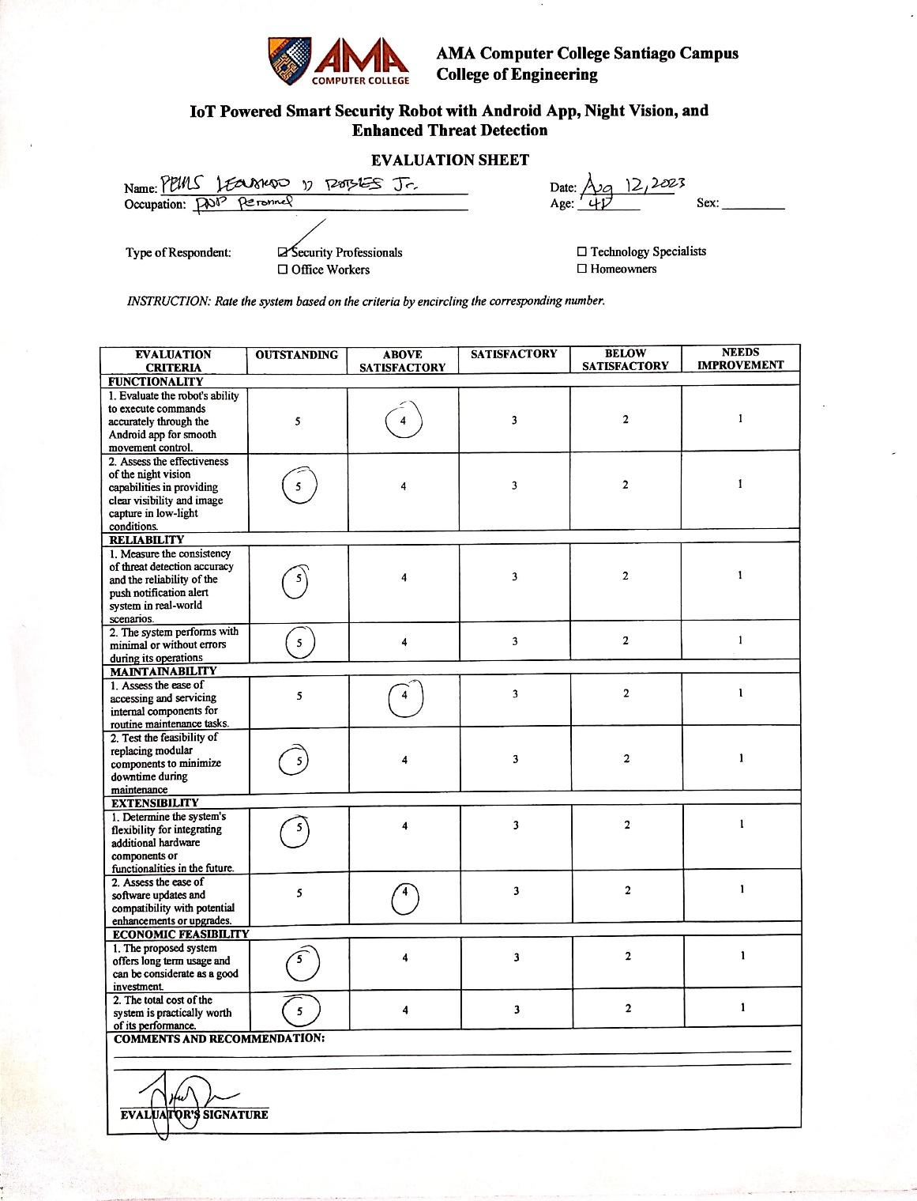

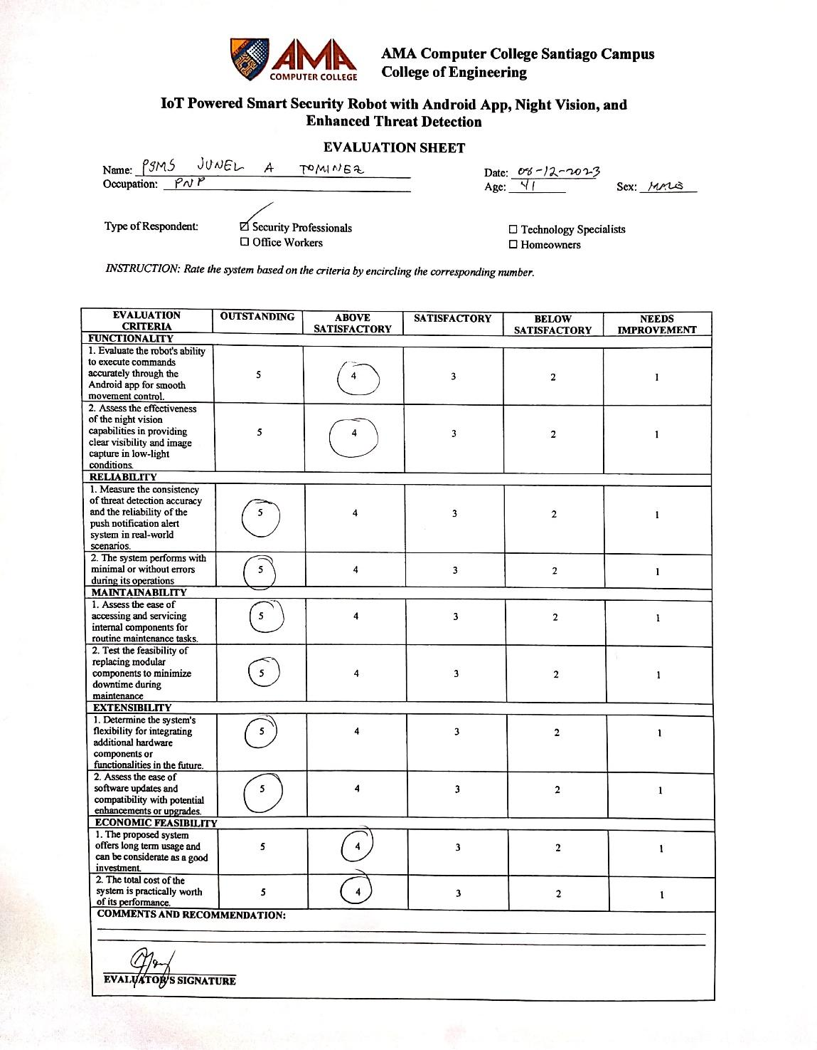

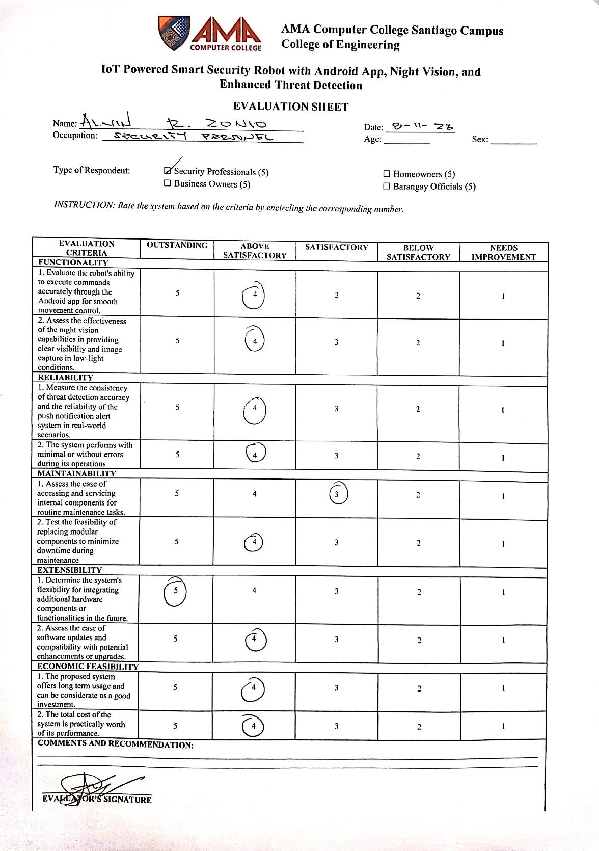

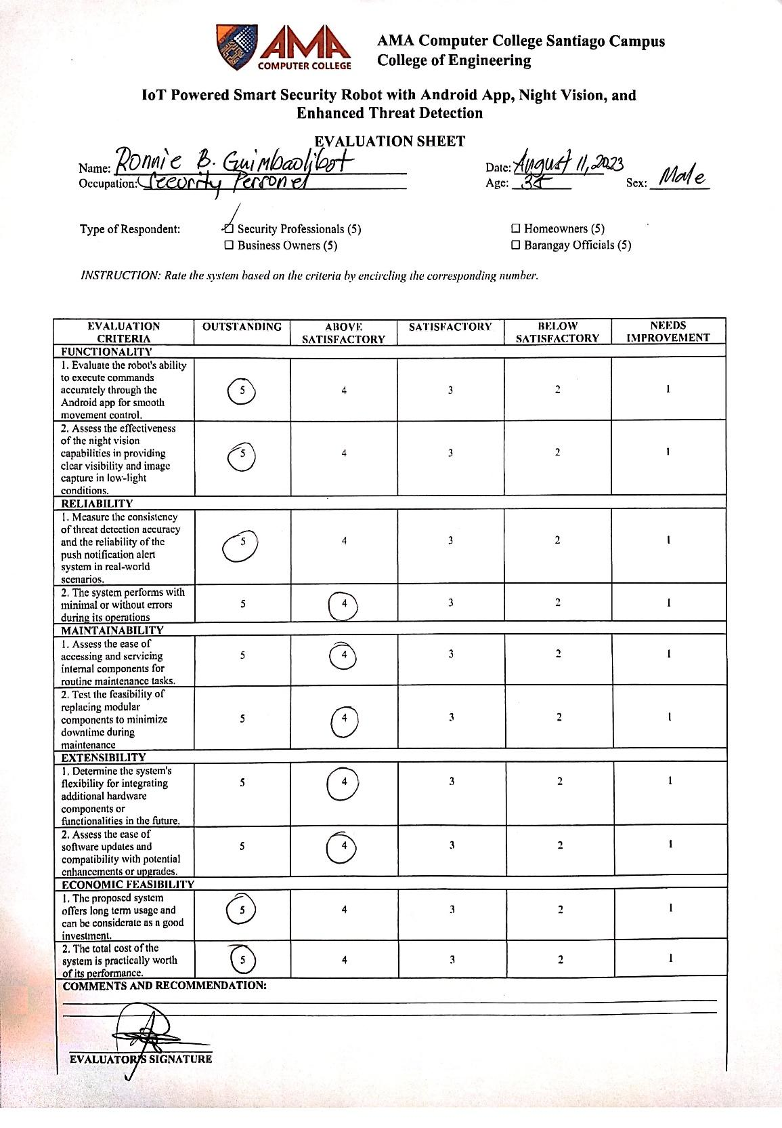

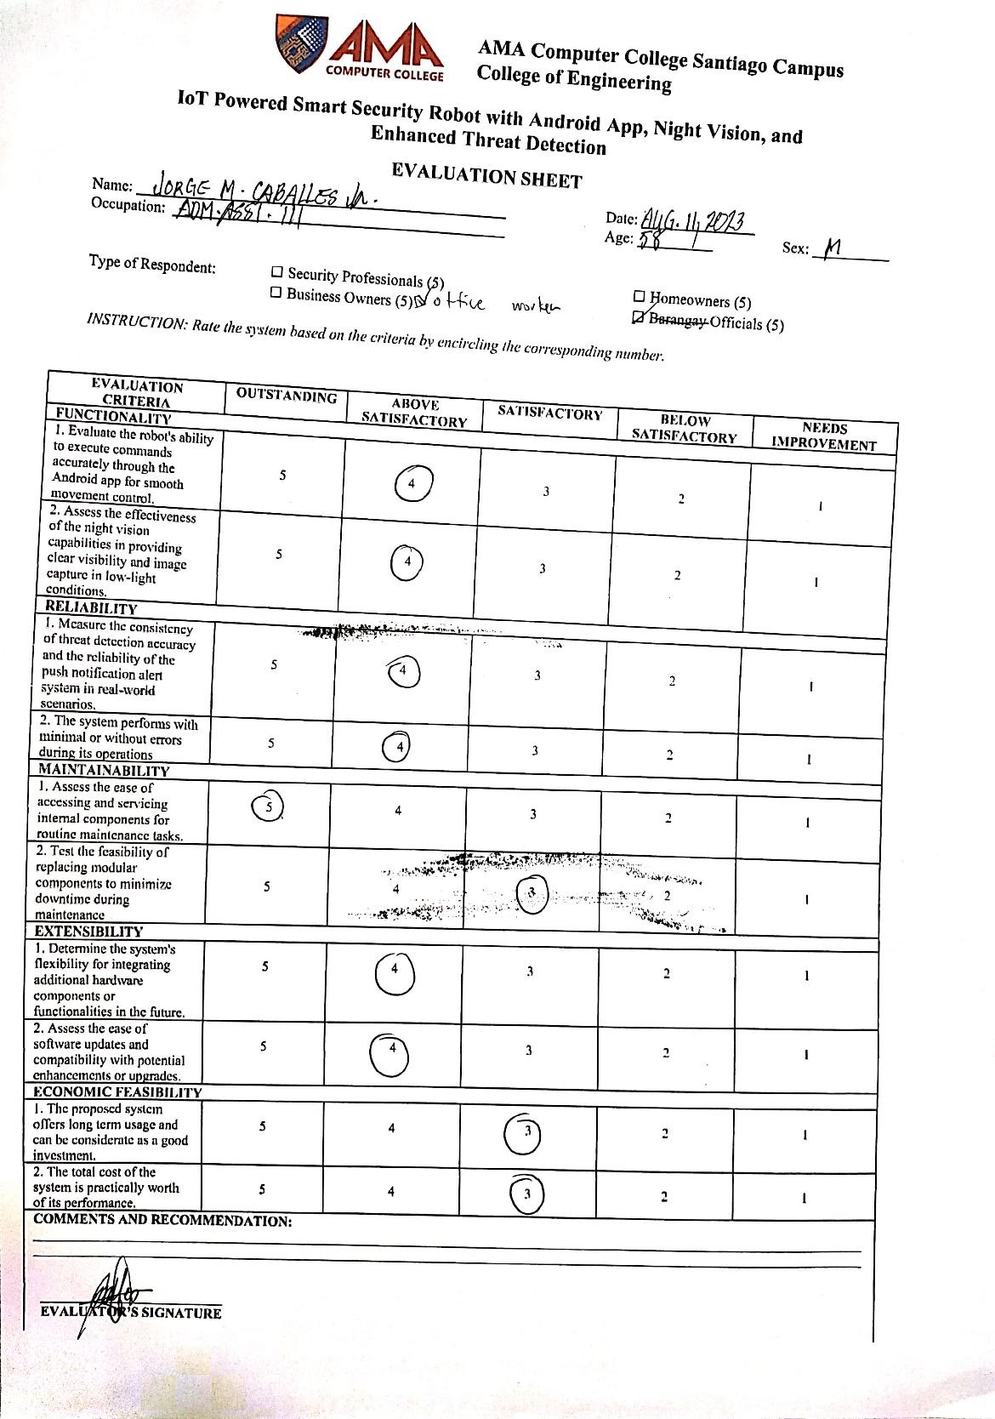

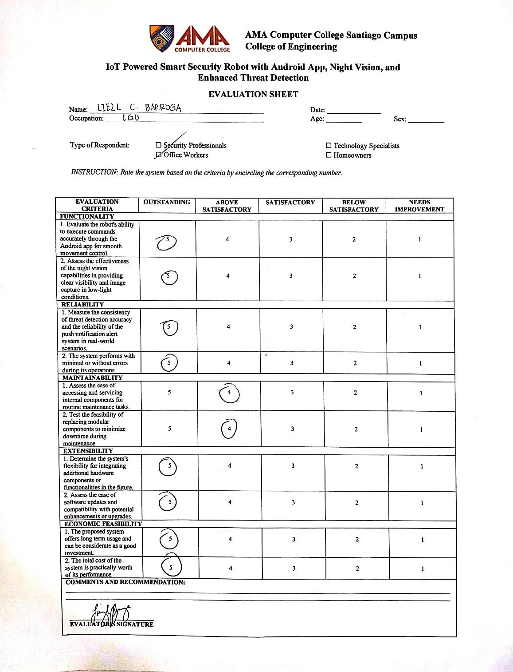

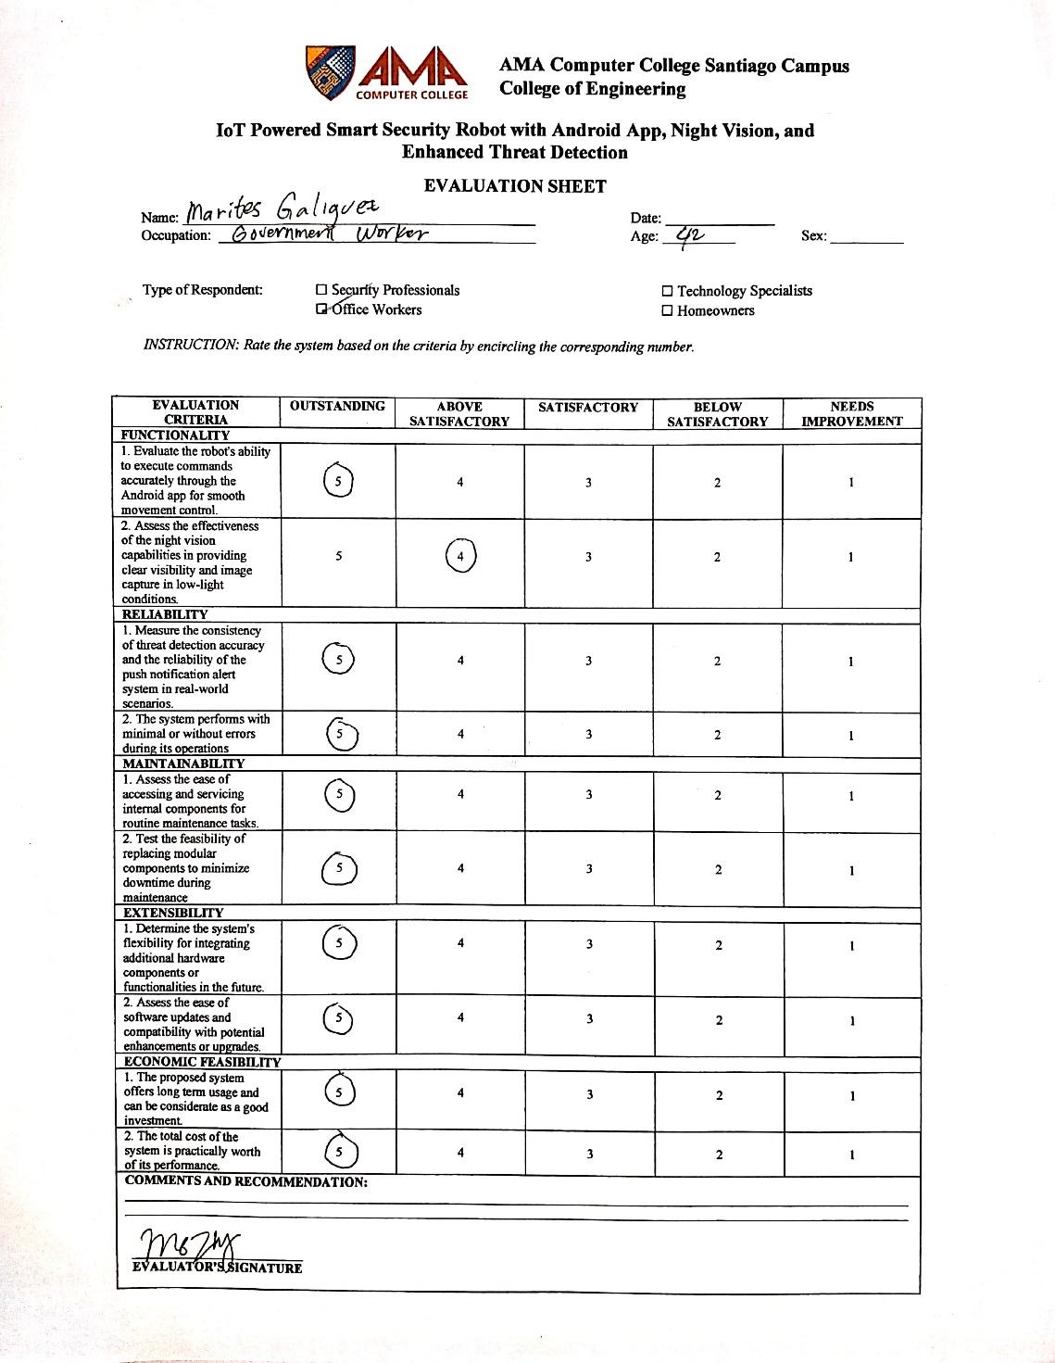

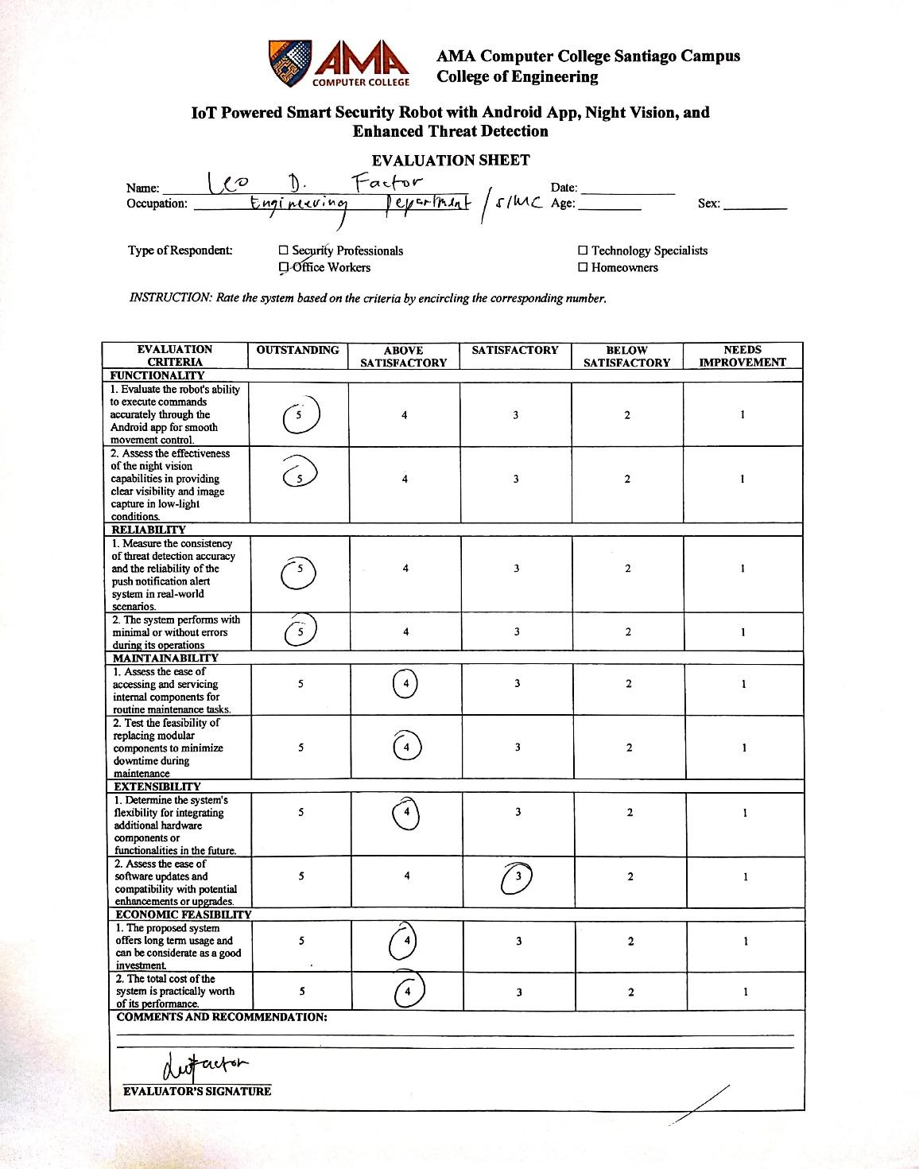

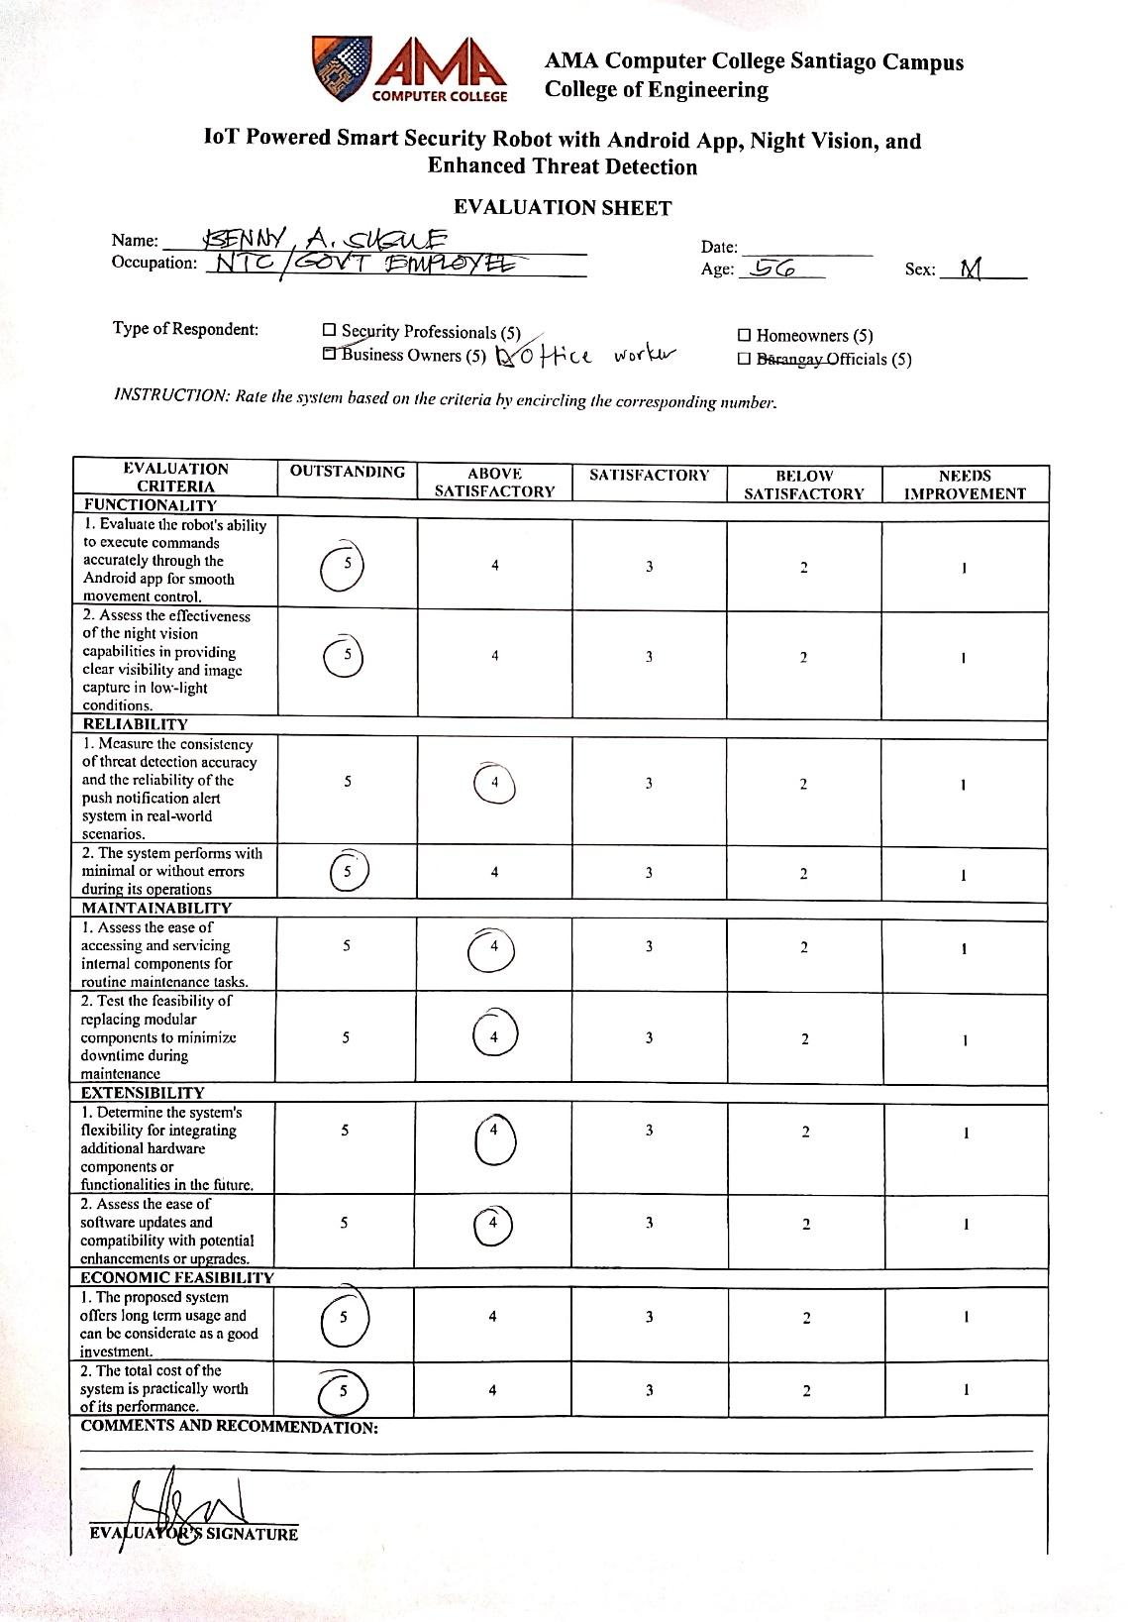

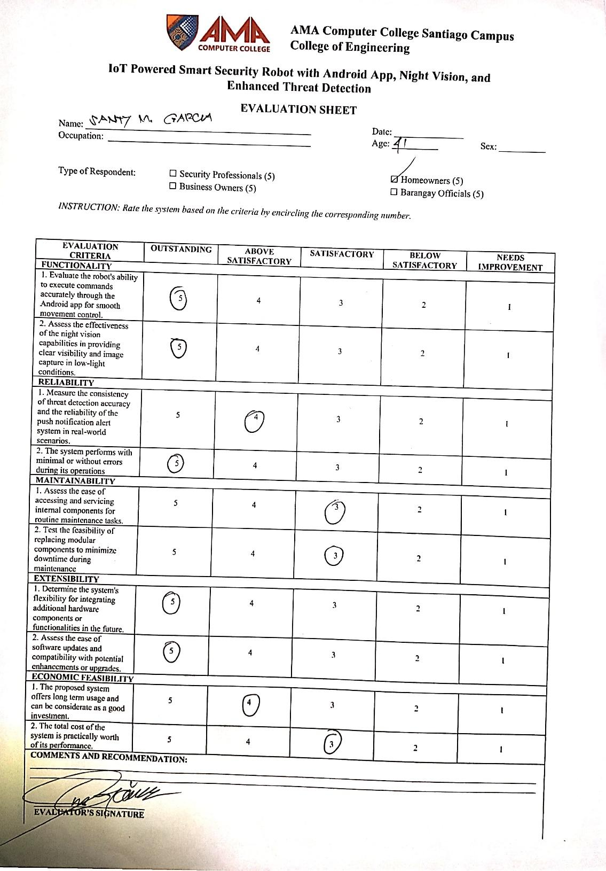

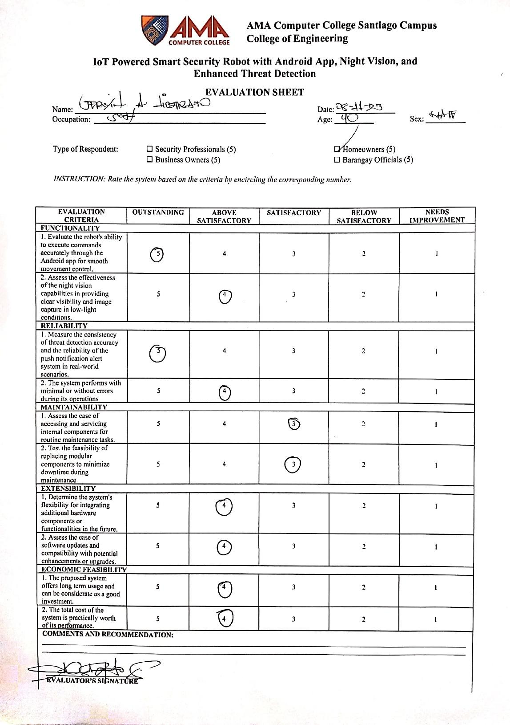

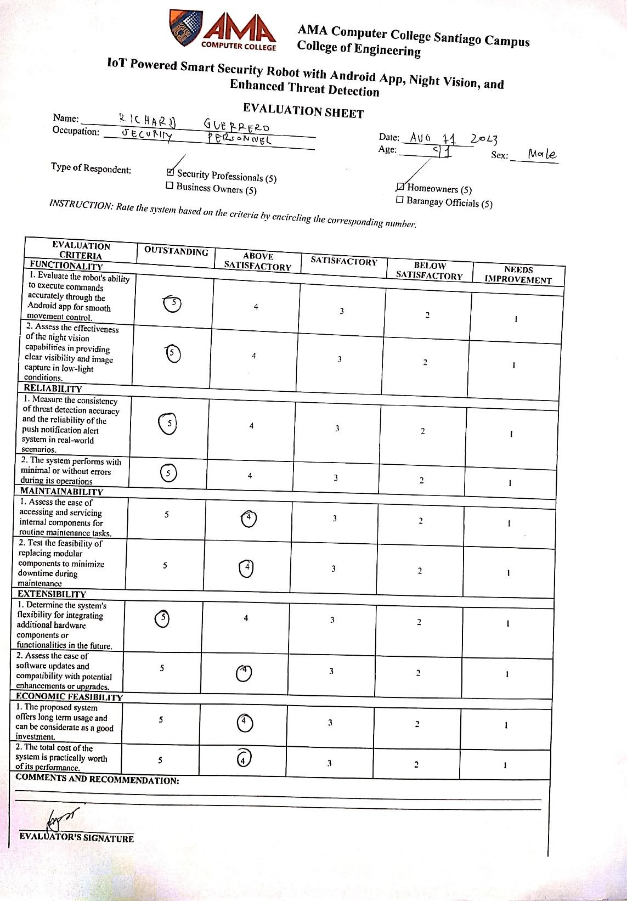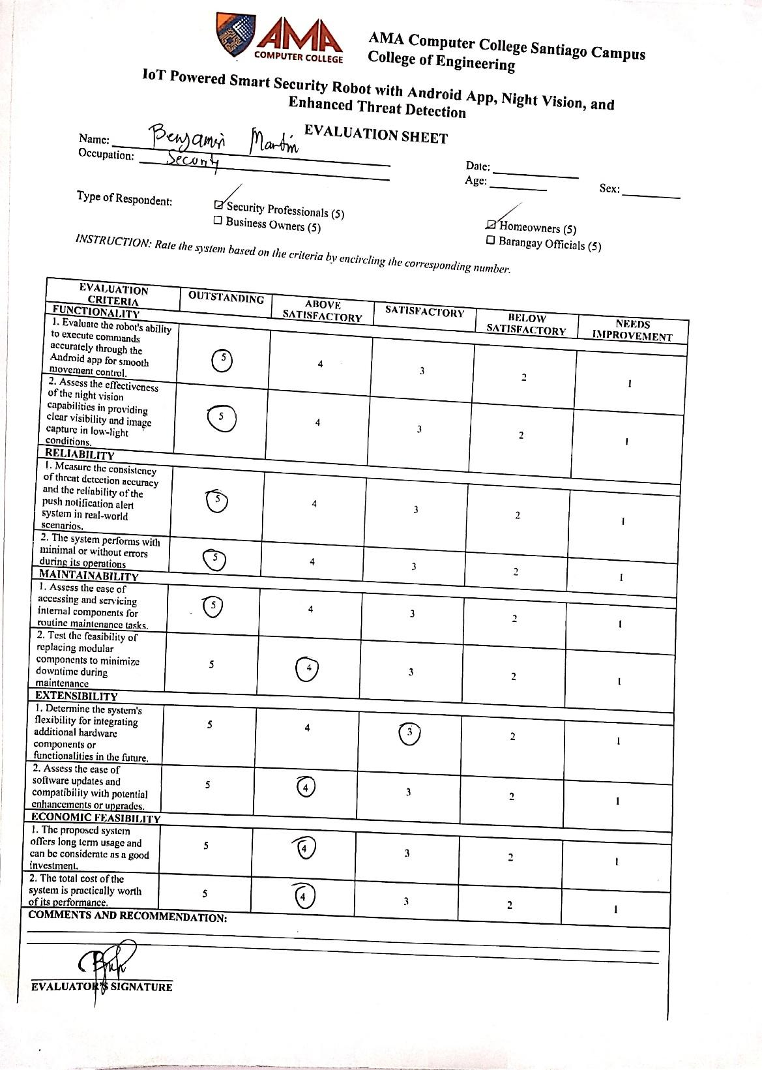

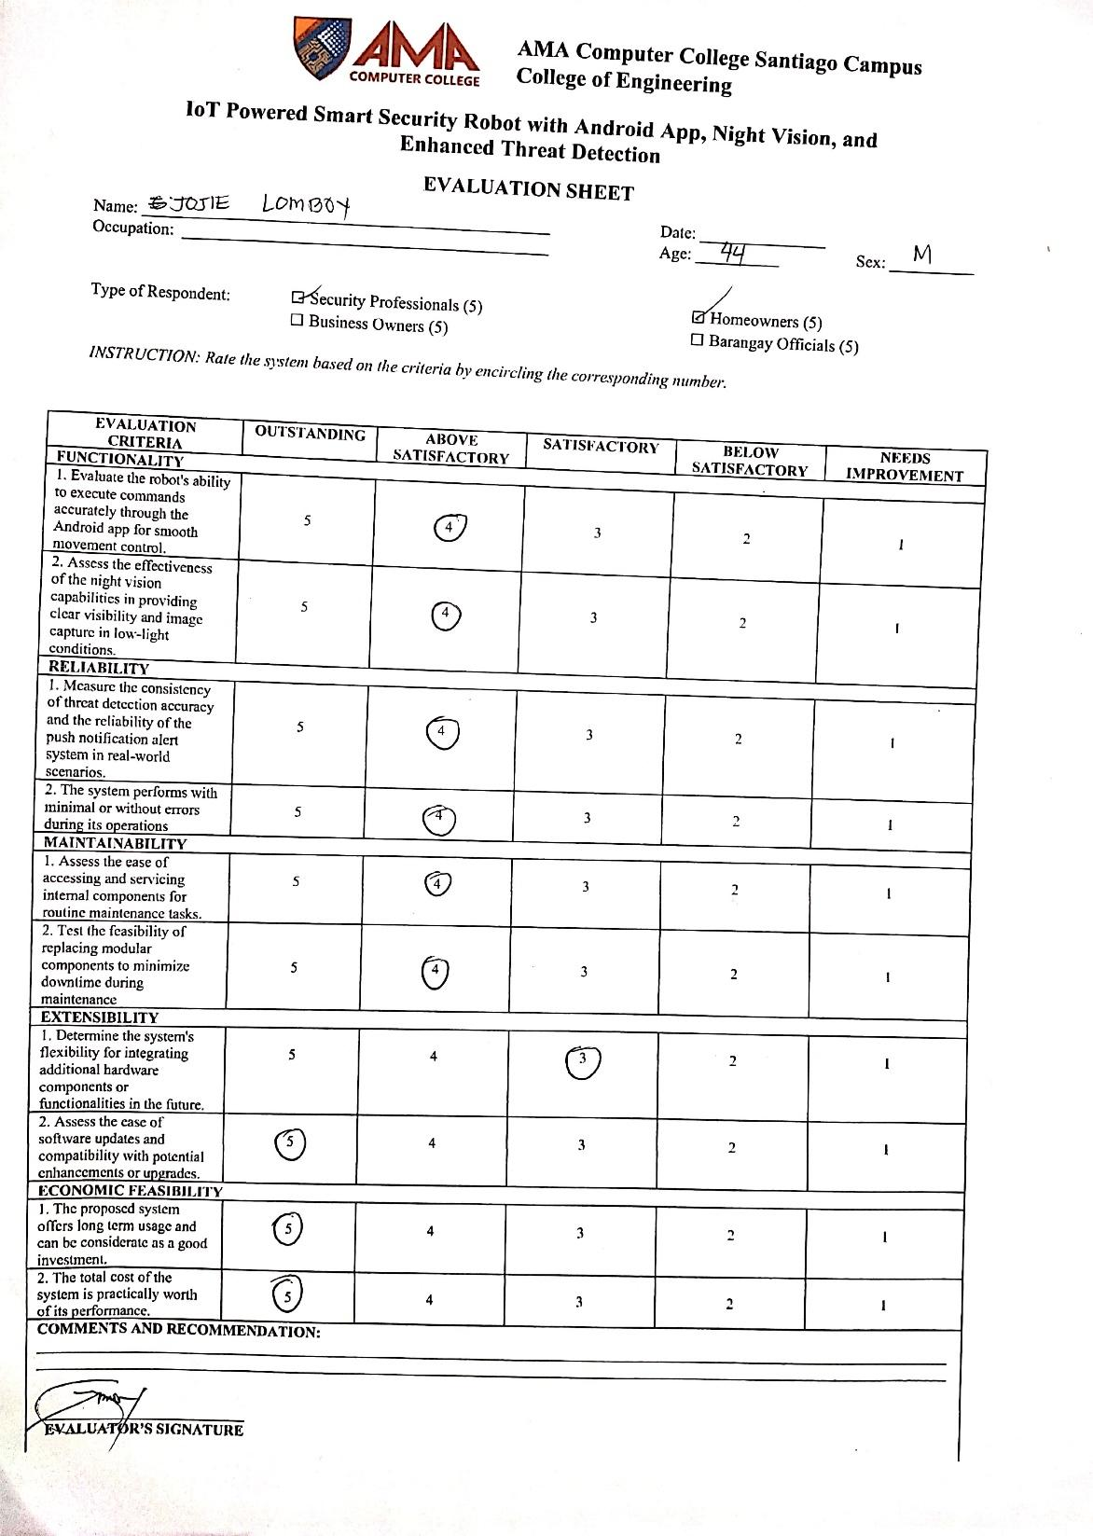

**APPENDIX H**

Robot Assembly

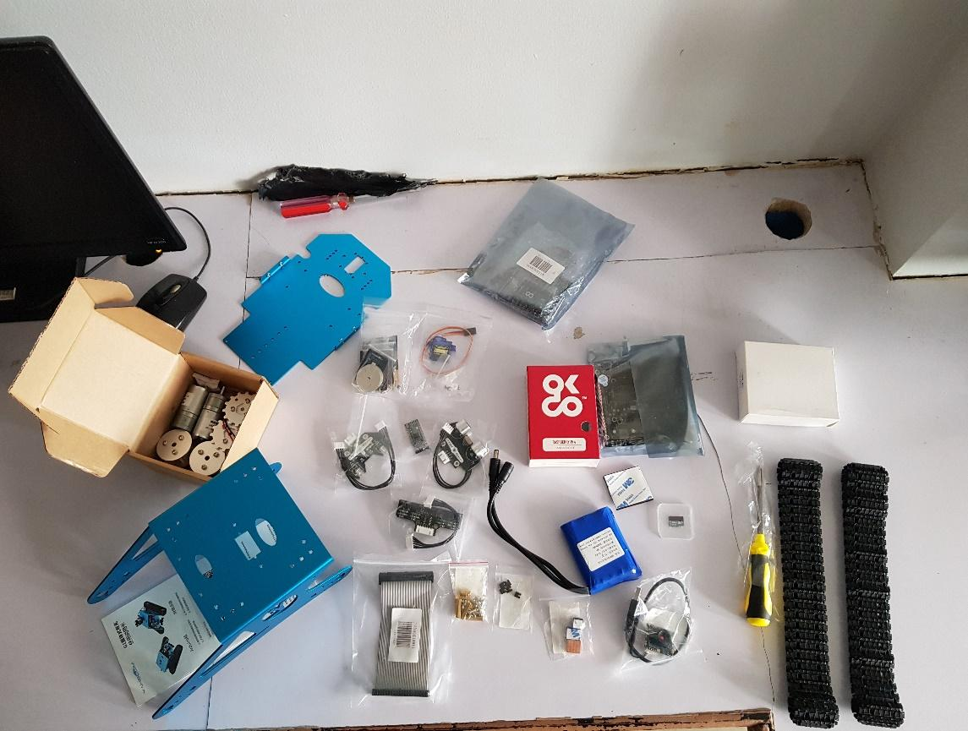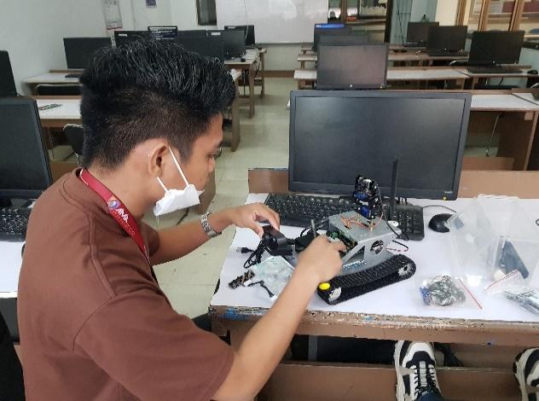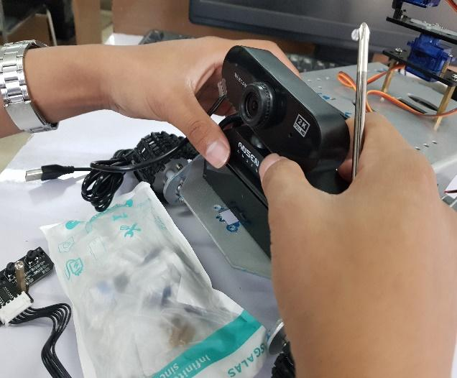

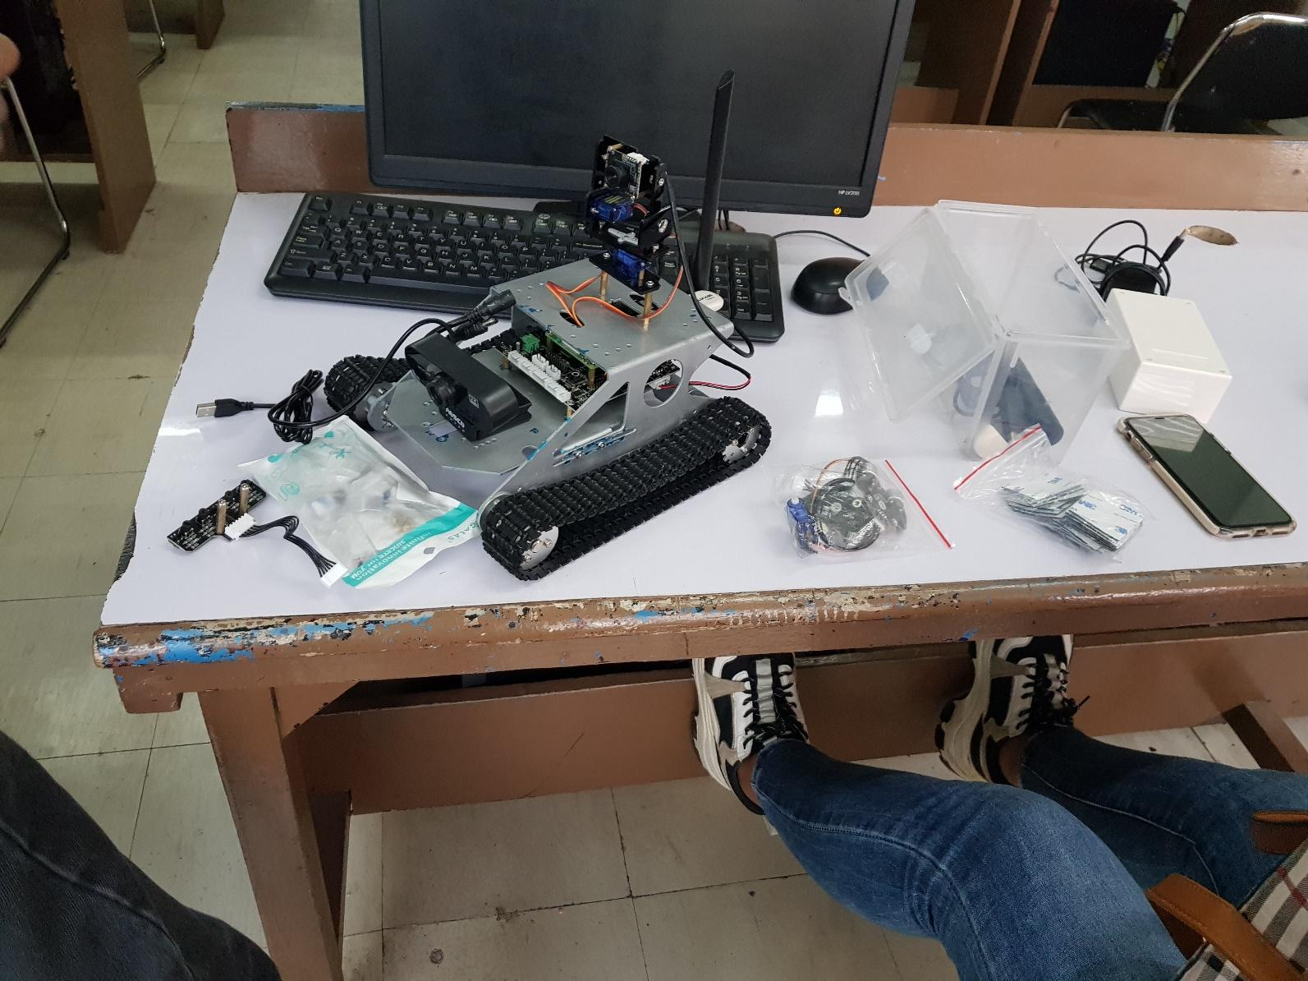

**APPENDIX I**

Android Application Development

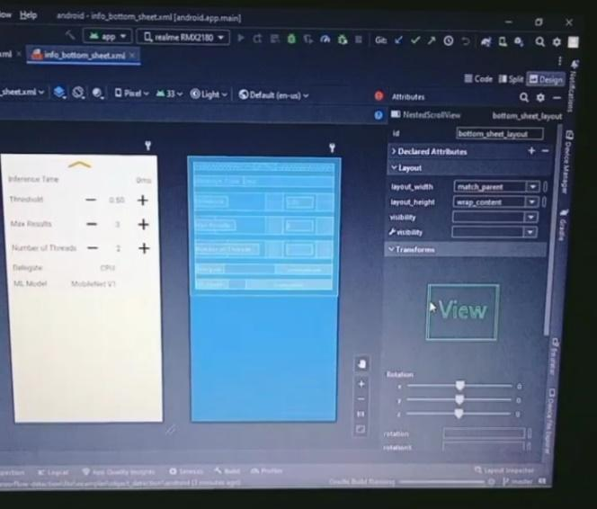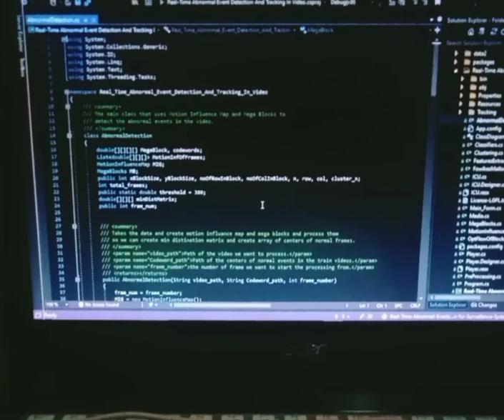

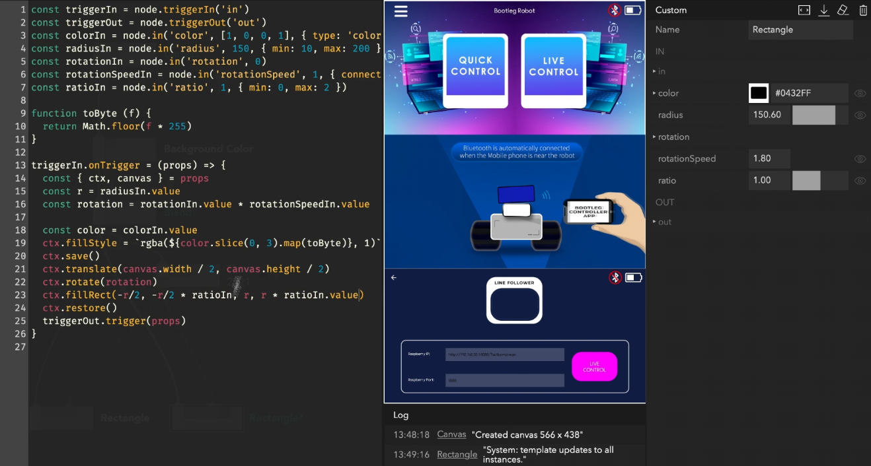

**APPENDIX J**

Threat Detection Model Training

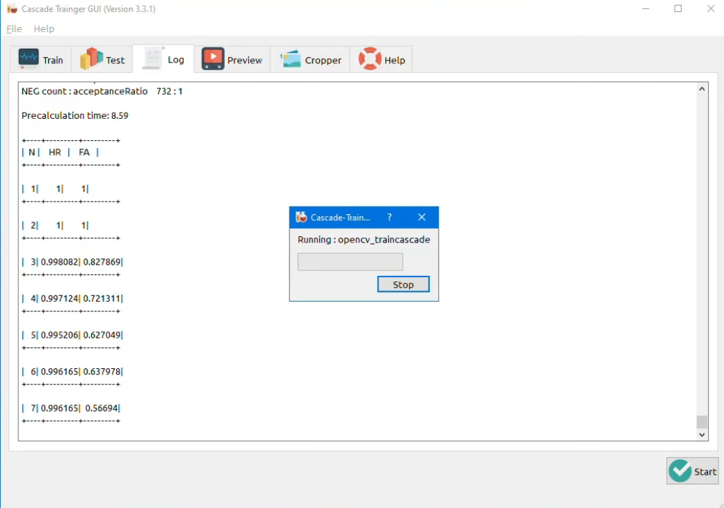

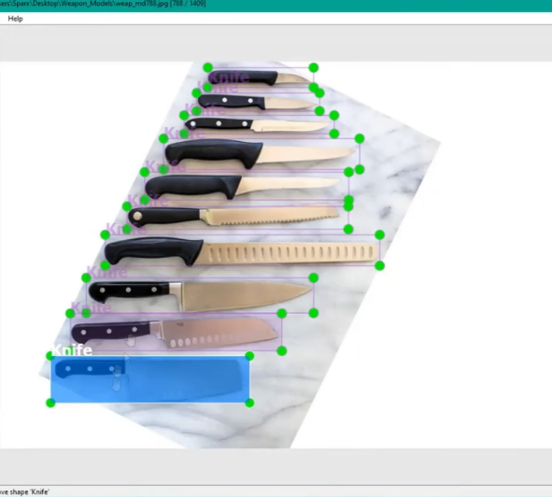

**APPENDIX K**

Raspberry Pi Coding Integration

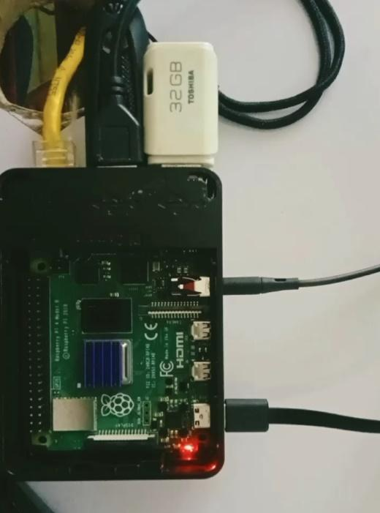

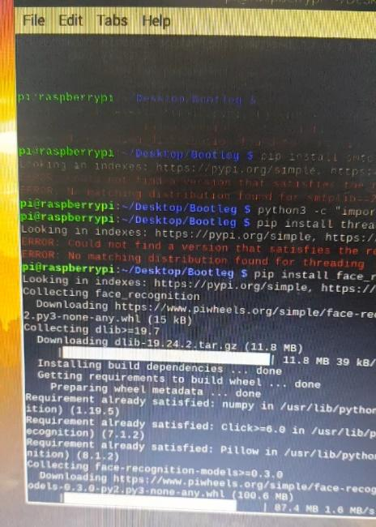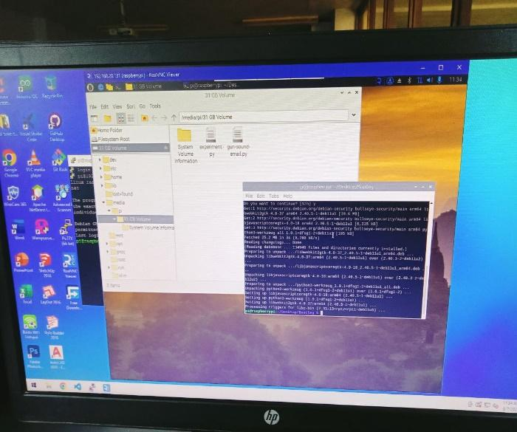

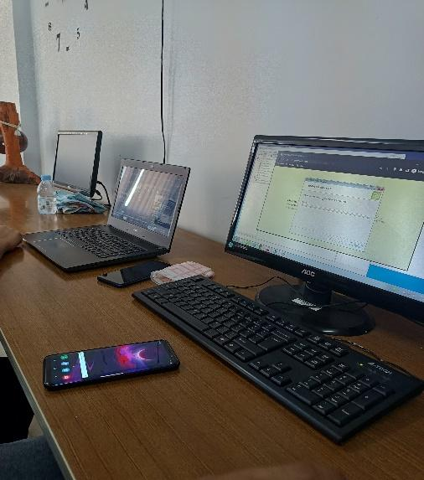

**APPENDIX L**

Threat Detection Testing Stage

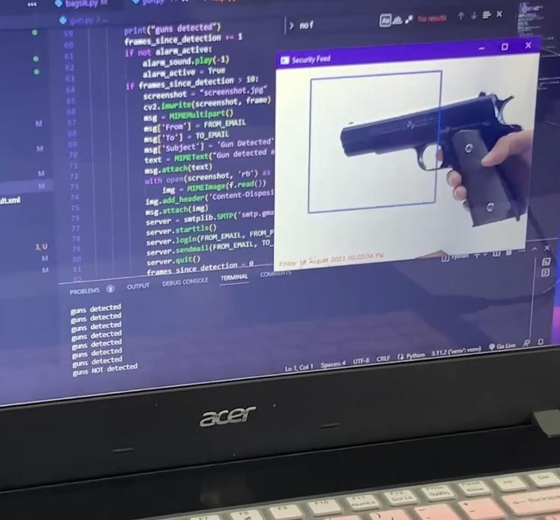

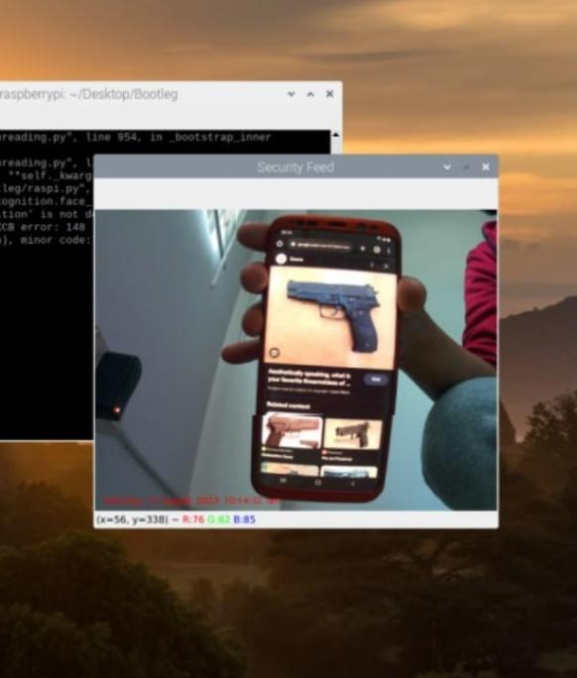

**APPENDIX M**

Geolocation Development

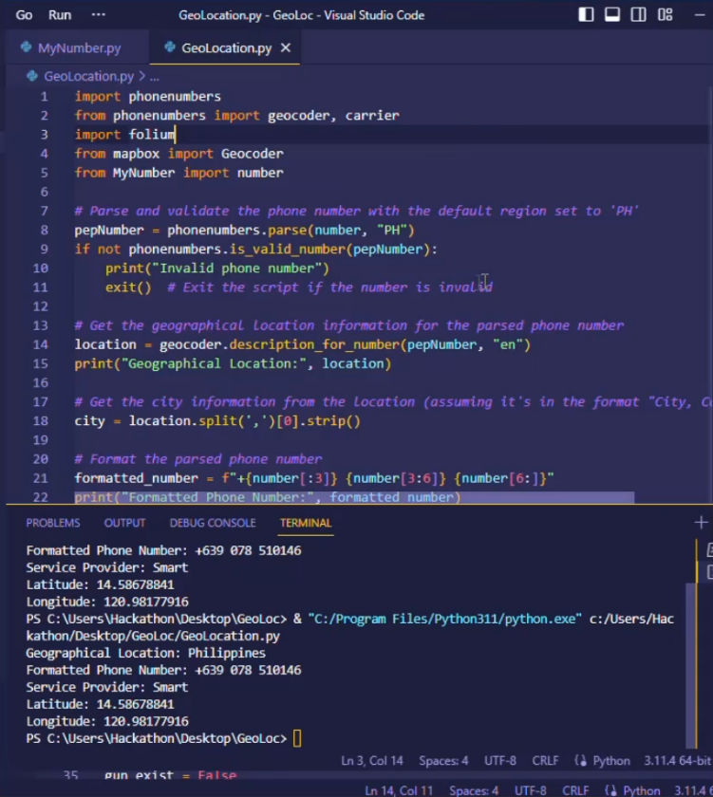

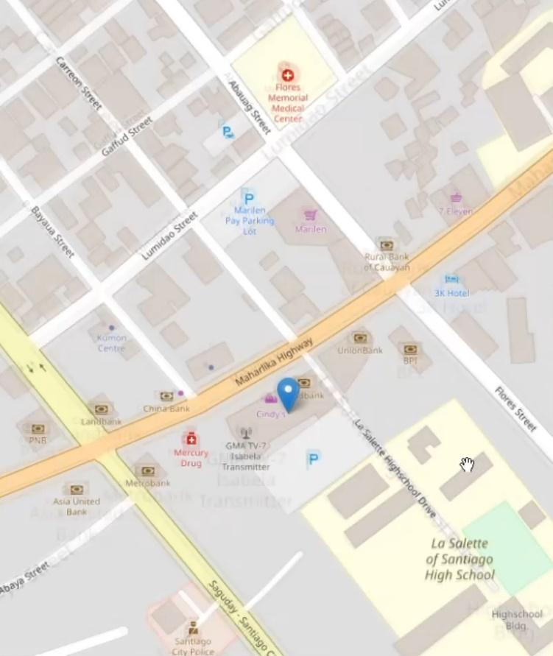

**APPENDIX N**

Robot’s Movement Demonstration

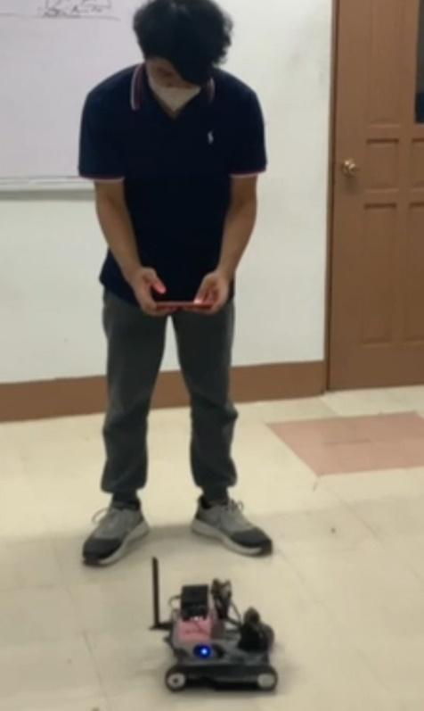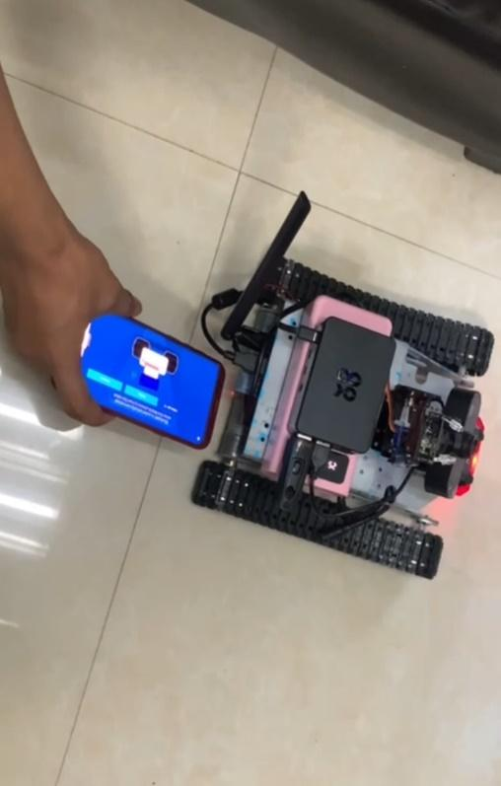

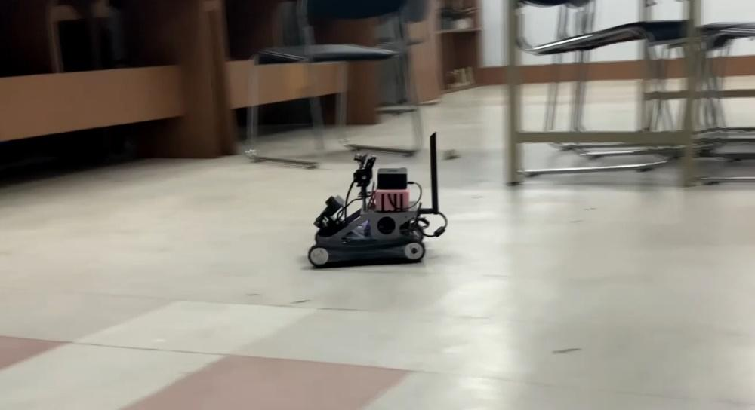

**APPENDIX O**

Robot’s Autonomous Demonstration

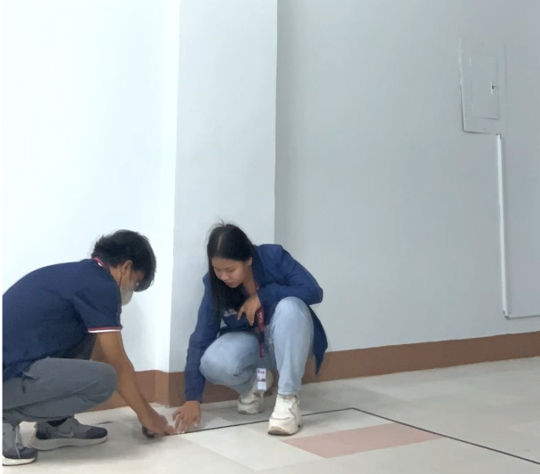

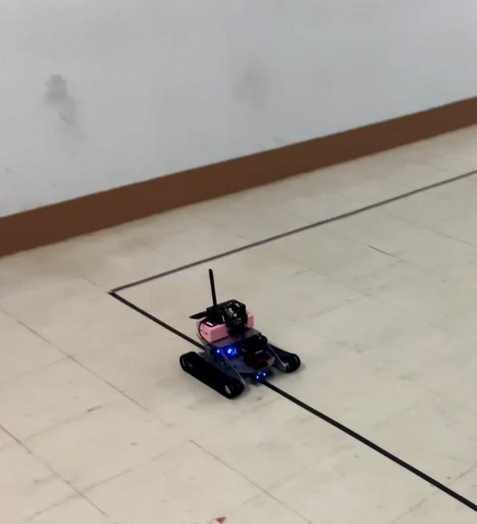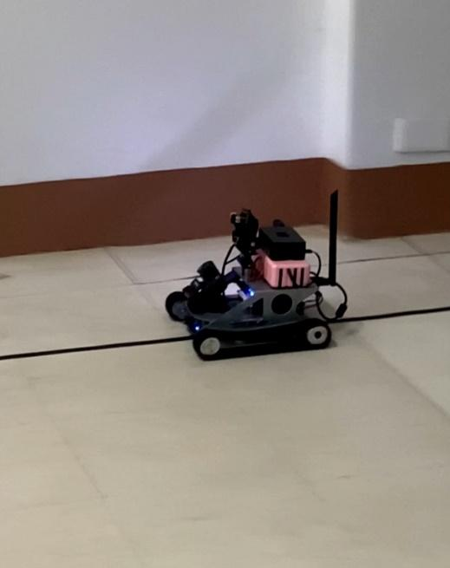

**APPENDIX P**

Robot’s Night Vision Feature

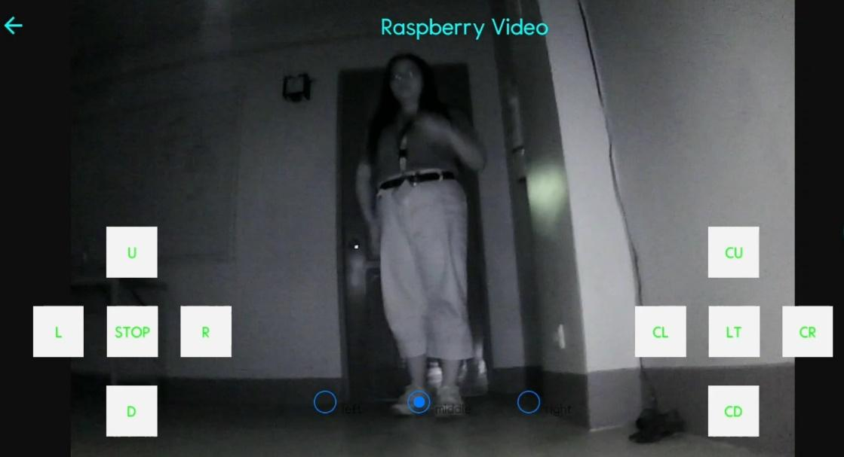

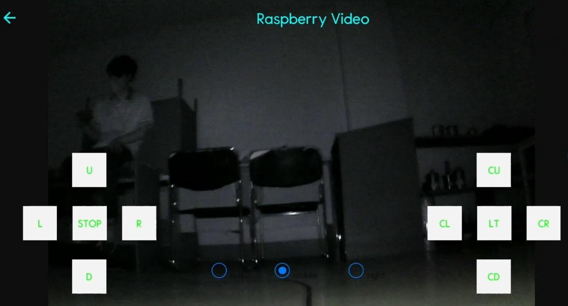

**APPENDIX Q**

Threat Detection Simulation

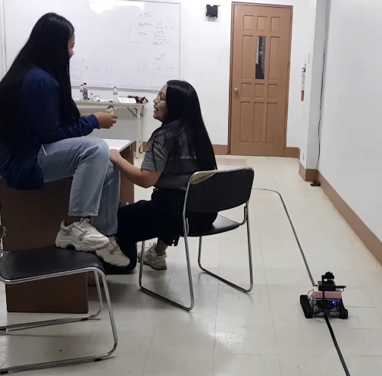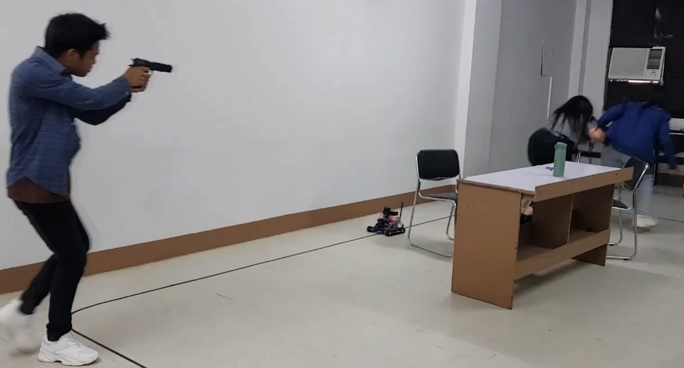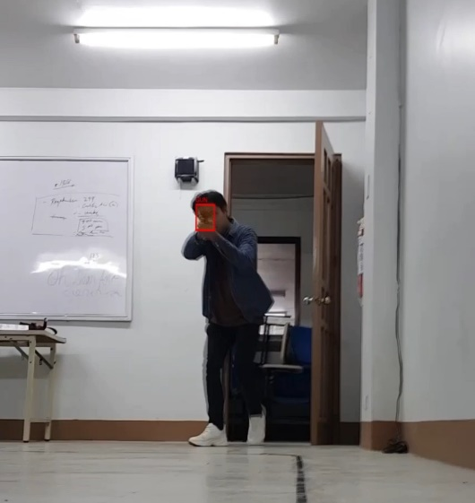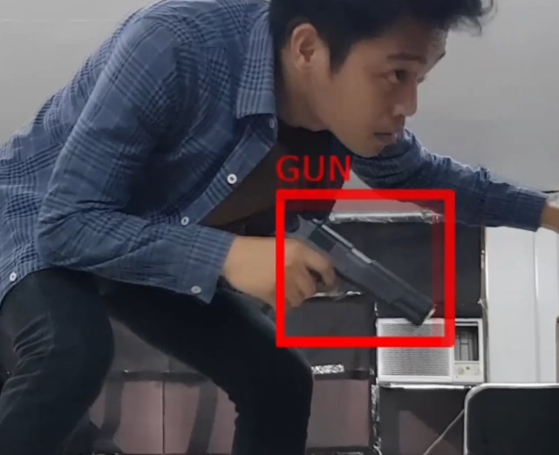

**APPENDIX R**

Push Notification Email Alert

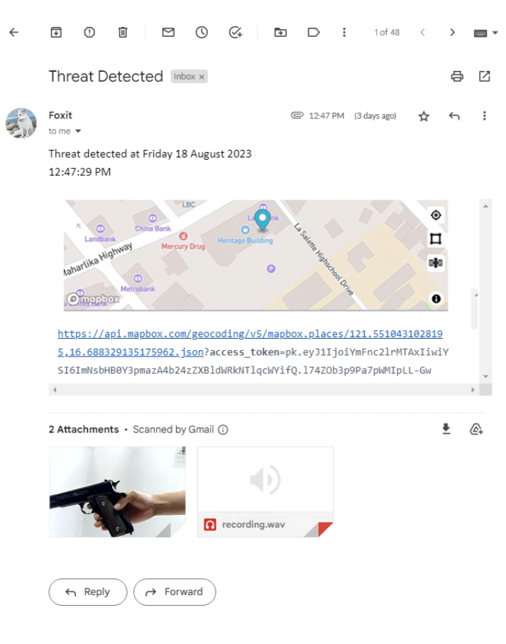

**APPENDIX S**

Evaluation Photos

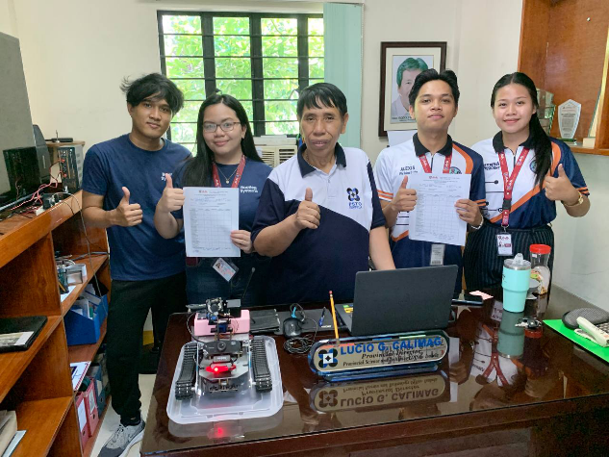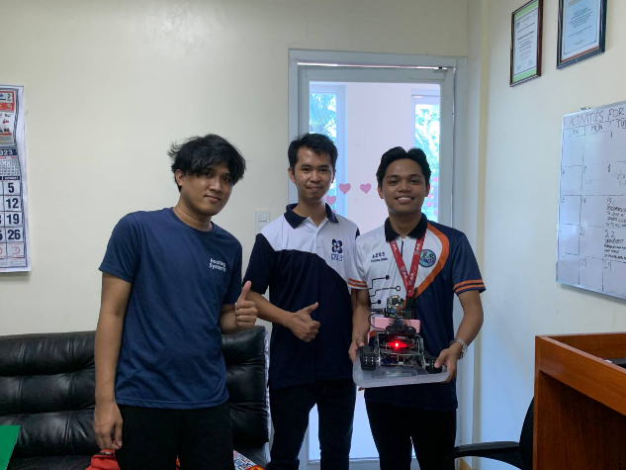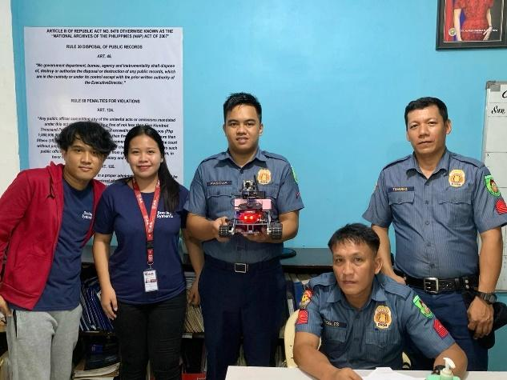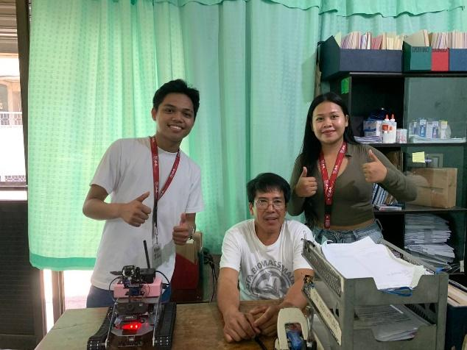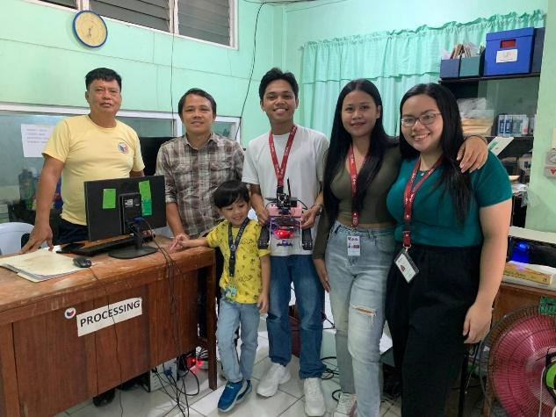

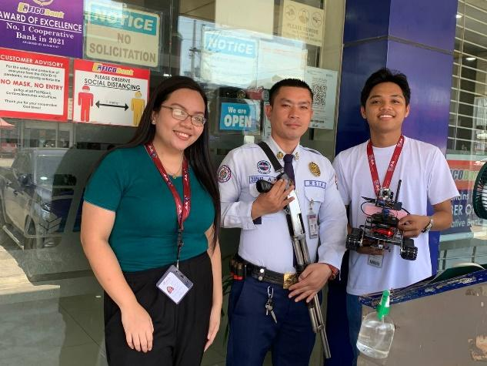

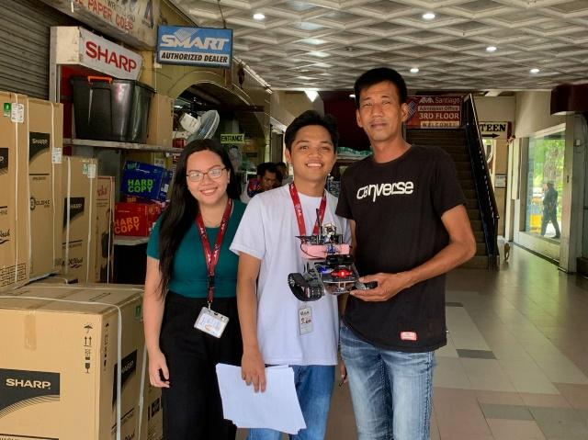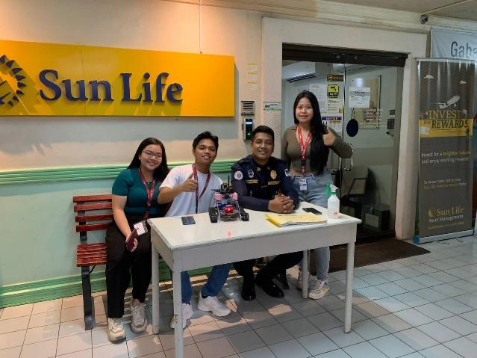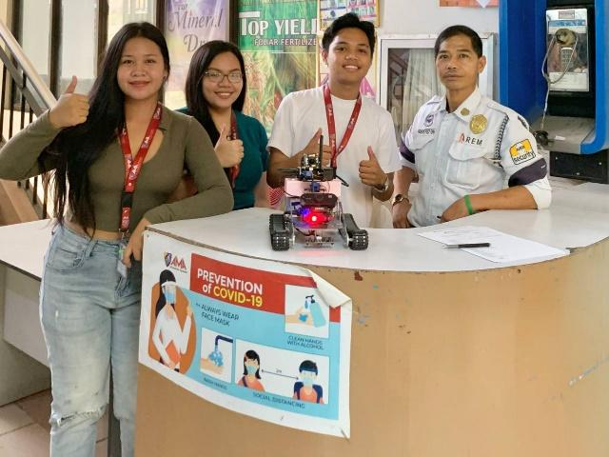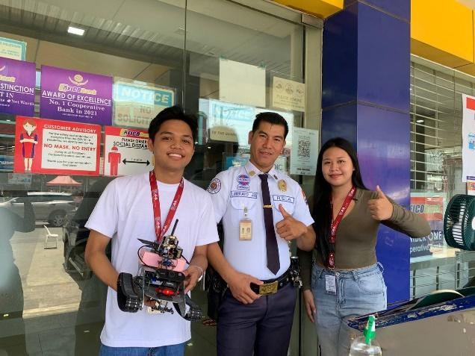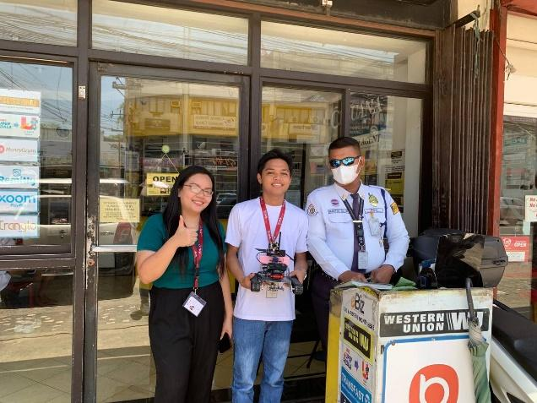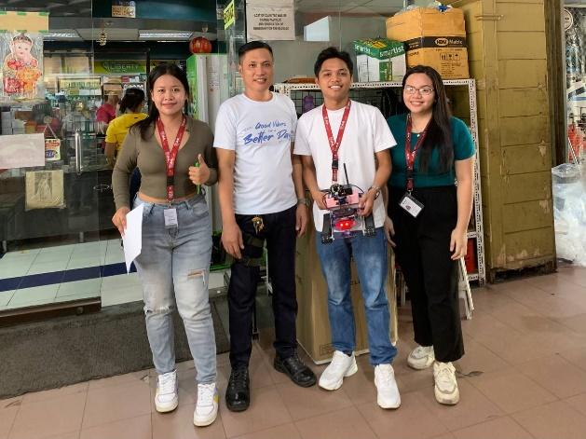

**APPENDIX T**

Initial Title Proposal Form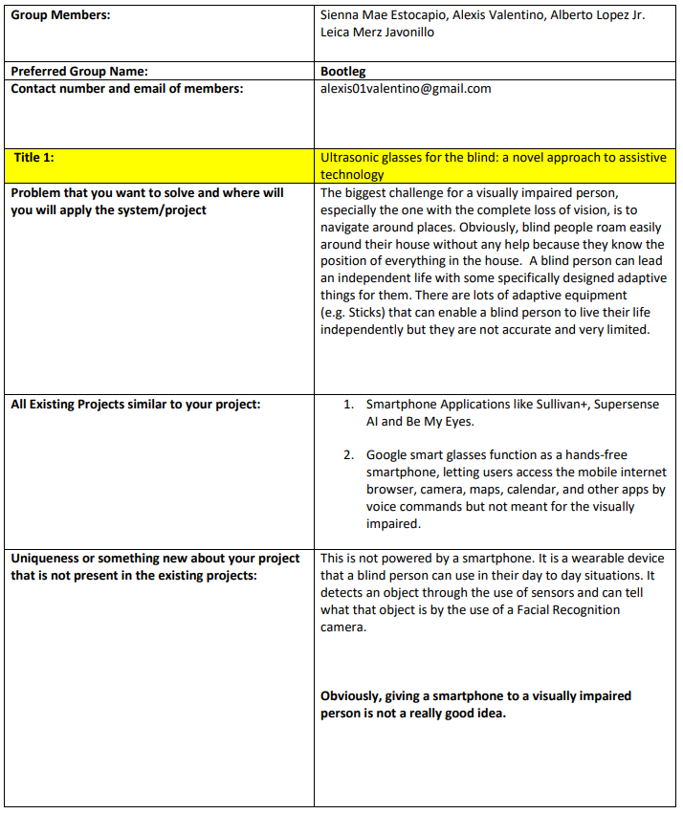

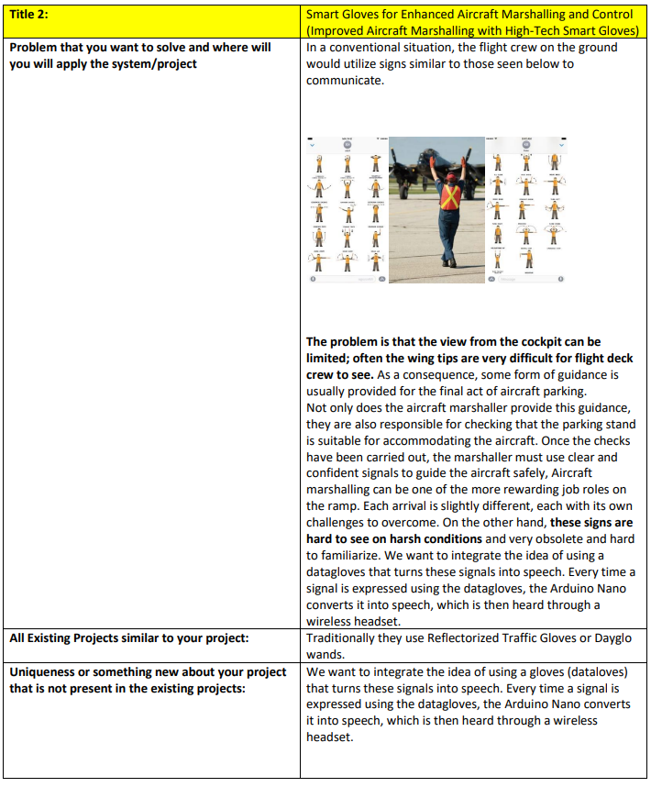



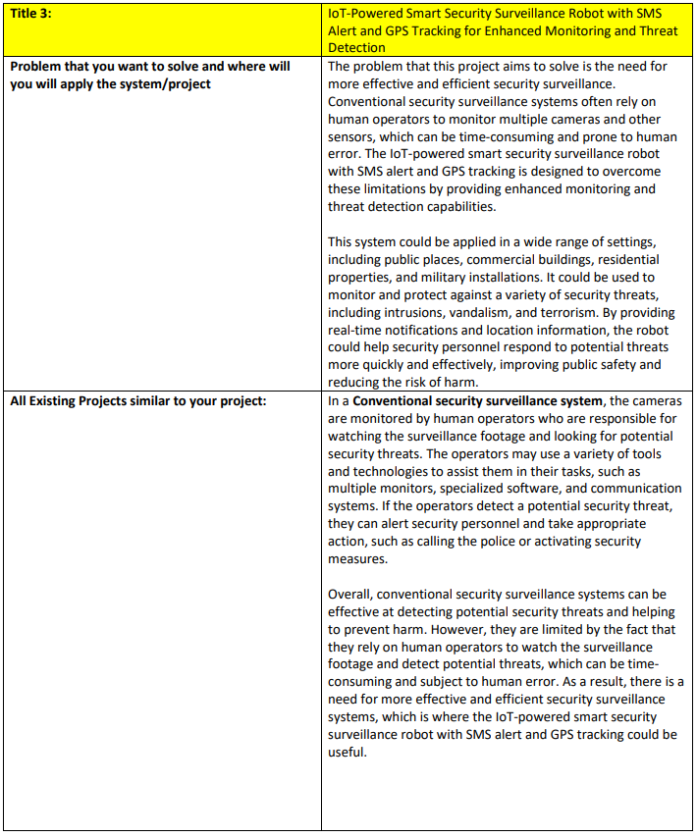



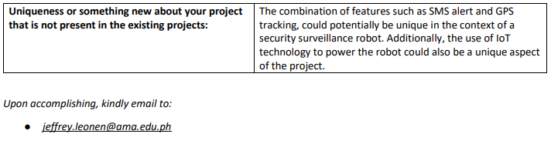

**APPENDIX U**

Research Topic Proposal Form

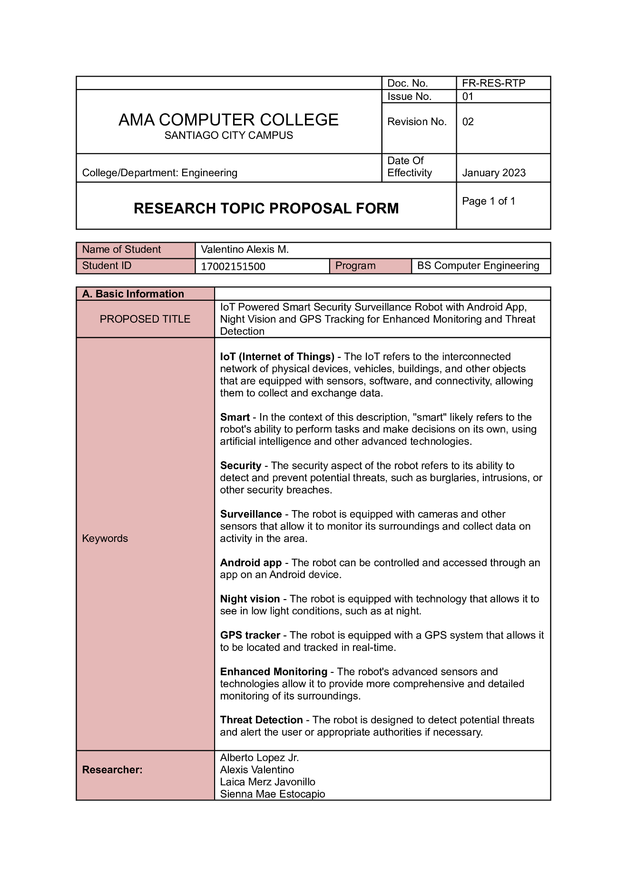

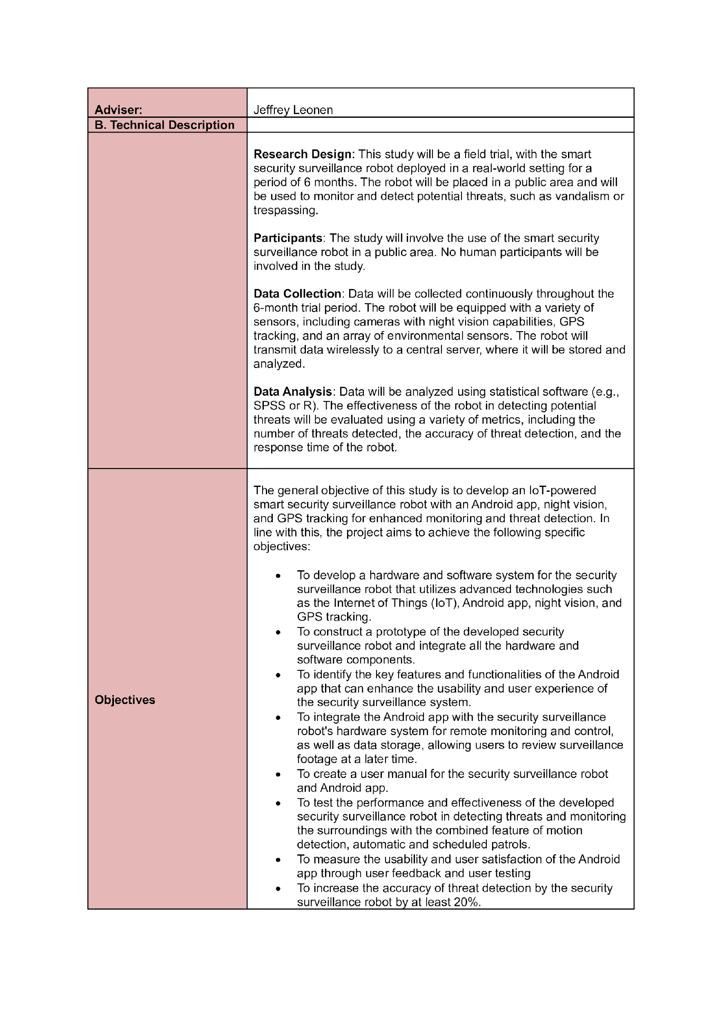

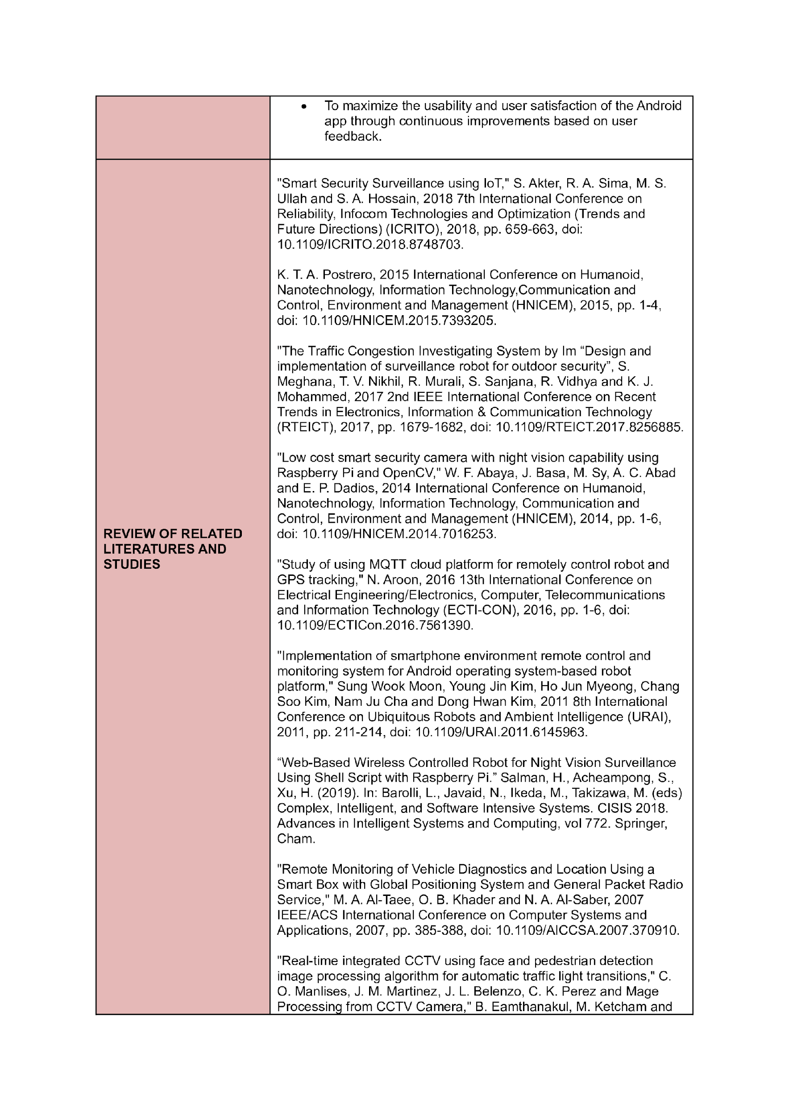

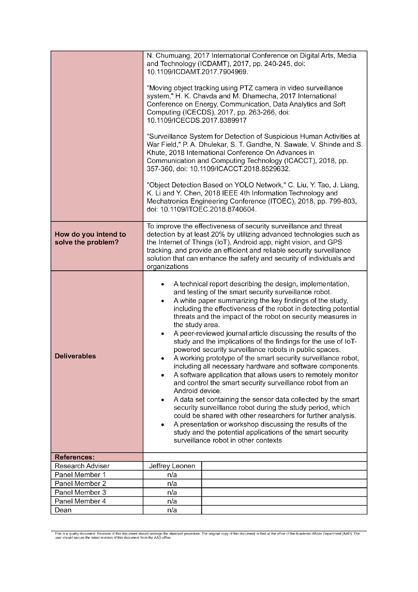

**APPENDIX V**

Final Defense

